PEACEBUILDING FUND
Project Title: Building peace through promoting inclusive and participatory transitional justice processes and mechanisms in South Sudan
DECEMBER 2023-MARCH 2024 REPORTING STATUS

- Organization Background
Name of CSO | Invisible Women Inclusion Network (I-WIN)
Location/s of implementation | State: Jonglei | County: Bor | Payam: Bor
Agreement duration (beginning – ending) | 1st December 2023 – 30th April 2024
Reporting Period: Month & Year | April 2024
Name of Reporting Officer | Muidie Justin Maziga
Email address | info@i-win-ssd.org
Telephone number | +211 917972241, +211925914488

- Summary of Monthly Activities

S. N | Current Month’s Output Activities | Planned from previous month/new/  Ongoing | Number of Beneficiaries / Participants (Specify if PWDs, IDPs)
S. N | Current Month’s Output Activities | Planned from previous month/new/  Ongoing | Adult Male (>36yrs) | Adult Female (>36yrs) | Male Youth (18-35 yrs) | Female Youth (18-35yrs) | Total
1 | Output 1.1: Consultative meeting with the Communities, local authorities, other stakeholders and beneficiaries  Activity 1.1.1 Conducting of an inception workshop to introduce the projects to stake holders, implementing partners and the project beneficiaries. | Successfully conducted the stakeholders consultative meeting in the month of December 2023 | 12 | 9 | 7 | 2 | 30
2 | Output 1.2: Identification of five networks/groups of PWD and meaningfully engage them in leadership of efforts to pursue truth, justice and accountability for human rights violations and abuses committed.  Activity 1.2.1: identification and registration of 5 networks/groups of PWD disability that will provide leadership and meaningful engagement in Pursuing truth, justice and accountability mechanisms and advocacy against human rights violations and abuses. in the locations of Makuach payam, Kondai IDP Camp, Hai referendum, suk zero, and  Activity 1.2.2 conducting of briefing meetings with beneficiaries at each payam upon group formation. | Successfully identified and formed five groups of PWDs in the five Payams of Bor County namely; Makuach, Kondai, Anyidi, Panbiar and Bor, in the month of December 2023 and briefed them. | 24 | 42 | 10 | 24 | 100
3. | Output 1.3 Developing the capacity of PWD through trainings to ensure their vital participation in the transitional justice processes  Activity 1.3.1 Conducting of trainings to PWD to enhance their understanding of the CTRH and transitional justice processes. | Successfully In the month of January and February, Five (5) PWD groups of Makuach, Hai Referendum, Kondai, Sug Zero and Panjak received trainings in their respective payams.  Each group consisted of twenty (20) participants. The primary focus of these trainings was to enhance the participants' advocacy skills, aiming to raise awareness about the CTRH process. | 35 | 49 | 10 | 6 | 100
4 | Output 1.4 Community outreach programs to reach out to over 2000 victims of PWD, to create awareness on the CTRH process as well as general tenets of transitional justice for PWDs in Jonlei state,  Activity 1.4.1 Conducting of outreaches and home visits to expand on the awareness on the CTRH processes and general concepts of the Transitional Justice.  Activity 1.4.2 Conducting of counseling to PWD for trauma healings during home visits. | In this month of April, I-WIN conducted twenty outreach sessions in various areas, of Bor County. The purpose of these sessions was to raise awareness about the Commission on Truth-telling, Reconciliation, and Healing (CTRH) process, the rule of law, and crime prevention, with a specific focus on transitional justice.  During the course of these outreach activities from January to April, a total of 2000 participants have been reached in different communities within Bor county.  There have been numerous cases and causes of insecurity reported also during these outreach activities, including Murle, targeting communities and looting their properties. Furthermore, there were instances of attacks on some villages but with no report of casualties but some valuable items such as money and phones were collected. | 153  549 | 191  668 | 138  471 | 98  312 | 580  2000
5 | Output 1.5 Monthly drama sessions with community members to raise awareness on truth telling, reconciliation and healing process in Jonglei state  Activity 1.5.1 Organizing and facilitating of drama sessions with PWD to enhance awareness on transitional justice and the CTRH process | Five drama sessions, one for each PWD group, were conducted with the aim of expanding coverage and simplifying understanding of transitional justice on CTRH within the communities of Jonglei State, mainly among people with disabilities (PWDs).  In Hai Referendum, a drama aimed at sensitizing women about speaking up and seeking justice when their rights are violated. It also sought to educate the community about the right to protection from the government, emphasizing justice in the court of law for all, regardless of status or age.  In Sug Zero, the drama focused on promoting the education of all children without discrimination, especially children with disabilities. It emphasized that every child has an equal right to education, and parents should not give up on their children simply because of a disability.  In Makuach, a drama session was performed to raise awareness in the community and among the general public about land grabbing, where the wealthy exploit their resources to seize land from the poor and PWDs.  In Kondai, dramatic scenes unfolded in an IDP camp, with gender-based violence (GBV) taking center stage. A civil servant, head of the household, neglects his family for alcohol, leaving his blind mother abandoned and his wife and children in turmoil.  In another thrilling scene in Panjak depicted the power of social justice in action, with PWDs taking center stage in a drama named "Land grabbing in a strategic place in town." It focused on the tale of a lame man's fight against corruption, reclaiming his rightful plot.  Note that beneficiary details were collected for the participants and not the audience. | 26 | 42 | 18 | 14 | 100
6 | Output 1.6 Monthly radio talk shows with messages on truth telling, reconciliation and healing in Jonglei state.  Activity 1.6.1 conducting of radio talk shows with messages on truth telling, reconciliation and healing | On Apr 26th 2024, I-WIN conducted a radio talk show on Voice of Reconciliation 98.4 FM Bor. The show featured insightful discussions covering the CTRH process, PWDs' rights, and how to enhance the meaningful participation of PWDs in public participation, and also engage women in the community participation.  During the talk show, Project Coordinator Mr Muidie Justin Maziga, highlighted the importance of transitional Justice and the efforts it makes to raise awareness about effective responses to past abuses and the prevention of future similar occurrences. He also emphasized the responsibility of accommodating PWDs in the community’s activities, even if they are not associated to us; they are created in the likeness of God.  The radio host was Chol Makol Riak and the guests include I-WIN's Project Officer (Justin Muidie), I-WIN's Field Officer (Philip Mabior), Director General from The Ministry of Gender, Child & Social Welfare Mr. Lam Gatdek and the Head of Legal Administrator, the Attorney General in the Ministry of Justice Maulona Deng Akuot Machar | Radio KPIs (can’t segregate the gender of the listeners | Radio KPIs (can’t segregate the gender of the listeners | Radio KPIs (can’t segregate the gender of the listeners | Radio KPIs (can’t segregate the gender of the listeners | Radio KPIs (can’t segregate the gender of the listeners

Output: | Results achieved
Output 1.1: Consultative meeting with the Communities, local authorities, other stakeholders and beneficiaries  Activity 1.1.1 Conducting of an inception workshop to introduce the projects to stake holders, implementing partners and the project beneficiaries. | - Stakeholders, implementing partners, and beneficiaries gain a clear understanding of the project's goals, objectives, and expected outcomes.  - Stakeholders and partners expressed their commitment and support for the project, fostering a sense of ownership.  - The meeting strengthened relationships between the project team, implementing partners, and stakeholders.
Output 1.2: Identification of five networks/groups of PWD and meaningfully engage them in leadership of efforts to pursue truth, justice and accountability for human rights violations and abuses committed.  Activity 1.2.1: identification and registration of 5 networks/groups of PWD disability that will provide leadership and meaningful engagement in Pursuing truth, justice and accountability mechanisms and advocacy against human rights violations and abuses. in the locations of Makuach payam, Kondai IDP Camp, Hai referendum, suk zero, and  Activity 1.2.2 conducting of briefing meetings with beneficiaries at each payam upon group formation. | In the month of December, I-WIN, in collaboration with dedicated area chiefs and youth leaders, achieved a significant milestone by successfully establishing five distinct groups of Persons With Disabilities (PWD) across various locations in the payams of Bor County. The following communities have now become focal points for inclusive initiatives: Makuach, Kondai IDP Camp, Suk zero, Hai-referendum, and Panjak.  While the Makuach group had already been in existence, I-WIN took the lead in forming the remaining four groups. Through meticulous identification and registration processes, I-WIN brought together 20 participants in each location, fostering the creation of diverse groups that encompassed not only PWD but also youths, women representatives, area chiefs, and religious leaders, ensuring a holistic and inclusive approach.  The identified groups of disability spanned a spectrum, incorporating individuals with hearing impairment, physical impairment, visual impairment, and other vulnerable members of the community, such as the elderly.  At the formation stage of each group, comprehensive briefings were conducted, elucidating the purpose behind the group formation and outlining the various activities I-WIN plans to engage in with the members. These activities include but are not limited to training sessions, awareness campaigns on Community-Based Rehabilitation and Humanitarian (CTRH) processes, impactful drama sessions, and the provision of counseling and psychosocial support.  This achievement stands as a testament to I-WIN's commitment to fostering diversity, inclusion, and community empowerment in Bor County. Through these efforts, a foundation has been laid for meaningful engagement and support, ensuring that the voices of all community members, especially those with disabilities, are heard and valued.
Output 1.3 Developing the capacity of PWD through trainings to ensure their vital participation in the transitional justice processes  Activity 1.3.1 Conducting of trainings to PWD to enhance their understanding of the CTRH and transitional justice processes. | In January and February, five groups of Persons with Disabilities (PWDs) were successfully trained in five respective payams: Makuach Payam, Hai Referendum Panbiar Payam, Kondai Payam PWDs Group, Sug Zero PWD Group, and Panjak PWD Group. The training, facilitated by community leaders and PWD Community Volunteers, took place in the five Payams of Bor County, with each group consisting of twenty participants. The purpose of these sessions was to enhance the capacities of the members and promote awareness of the CTRH process, particularly within the state. The trained groups included individuals with physical impairment, visual impairment, and vulnerable persons such as the elderly. It is noteworthy that these PWDs were trained by staff from the Invisible Women Inclusion Network (I-WIN).
Output 1.4 Community outreach programs to reach out to over 2000 victims of PWD, to create awareness on the CTRH process as well as general tenets of transitional justice for PWDs in Jonglei state,  Activity 1.4.1 Conducting of outreaches and home visits to expand on the awareness on the CTRH processes and general concepts of the Transitional Justice.  Activity 1.4.2 Conducting of counseling to PWD for trauma healings during home visits. | From January to April, 2024, I-WIN has conducted more than ninety eight outreach sessions in various areas within Bor county. (Twenty this month of April)  The aim is to raise awareness about the Commission for Truth-telling, Reconciliation and Healing. (CTRH) process, rule of law, crime prevention, and transitional justice to the areas where there are no PWD groups with the aim of extending the awareness to the rest of communities within Jonglei State.  During these outreach sessions, the major crime cases and causes of insecurities highlighted were attacks from neighboring tribes, mainly the Murle, who targeted communities, looted properties, attacked and killed young men, and perpetrated rape against women and girls during activities like fetching water and firewood. Additionally, displacement due to flooding adversely affected food production, the increase of young gang groups (Niggers) health conditions, and overall social welfare.  A Women representative from Pakwau Ms. Akuol Dut called for government, I-WIN and international bodies’ intervention to address conflicts and protect the rights and security of women, children and Persons with Disabilities (PWDs). she emphasized the need for support, including mobility devices for children with disabilities  Mathuc Ayuen from Thara-Agok village said the economic hardship in the State is alarming and now it is beyond PWDs to bear even PWDs’ personal assistances cannot do anything about it, therefore, the organization and the government should do something faster to regulate the situation befor it worsen. Our PWDs need food assistance otherwise people are going to die.  All appreciated the organization and the donors for such a nice project in the state.  Anei Akon during training in Kondai IDP centre voiced her appreciation to I-WIN for the project of transitional justice through UNDP and UNMISS for the great support to the people of Bor and for peace in the state. She emphasized the challenges people face in the state, including a lack of peace of mind, insufficient food, and inadequate educational facilities. Susan Akech from Mading Bor raised concerns about daily expensive items due to increase of prices of commodities in the market. she urgues government intervention for the survival of the local communities, PWDs and for the success of transitional justice.  During the period of this project in Bor county, a number of 17 households have been reached (9 in Makuach payam, 4 in Sug Zero, 3 in Hai Referendum and 1 in Hai Panjak) by the PWD community volunteer together with some PWD group leaders to offer counseling services on different cases such as family affairs between husband and wife, SGBVs, Neighbor and neighbor, poor relationship or duty neglegence towards elderly/PWDs in the home, (23F & 8M) from January to April. There have been positive testimonials statements as a result of these One on one counseling and group counseling to the victims. Also some PWD members said there are so many cases that they sometimes attend without notifying the organization because it's there duties in the communities to solve all calm down some differences.
Output 1.5 Monthly drama sessions with community members to raise awareness on truth telling, reconciliation and healing process in Jonglei state  Activity 1.5.1 Organizing of drama sessions with PWD to enhance awareness on transitional justice and the CTRH process | Five drama sessions, one for each PWD group, were conducted with the aim of expanding coverage and simplifying understanding of transitional justice on CTRH within the communities of Jonglei State, mainly among people with disabilities (PWDs).  In Hai Referendum, a drama aimed at sensitizing women about speaking up and seeking justice when their rights are violated. It also sought to educate the community about the right to protection from the government, emphasizing justice in the court of law for all, regardless of status or age.  In Sug Zero, the drama focused on promoting the education of all children without discrimination, especially children with disabilities. It emphasized that every child has an equal right to education, and parents should not give up on their children simply because of a disability.  In Makuach, a drama session was performed to raise awareness in the community and among the general public about land grabbing, where the wealthy exploit their resources to seize land from the poor and PWDs.  In Kondai, dramatic scenes unfolded in an IDP camp, with gender-based violence (GBV) taking center stage. A civil servant, head of the household, neglects his family for alcohol, leaving his blind mother abandoned and his wife and children in turmoil.  In another thrilling scene in Panjak depicted the power of social justice in action, with PWDs taking center stage in a drama named "Land grabbing in a strategic place in town." It focused on the tale of a lame man's fight against corruption, reclaiming his rightful plot.  Note that beneficiary details were collected for the participants and not the audience.
Output 1.6 Monthly radio talk shows with messages on truth telling, reconciliation and healing in Jonglei state.  Activity 1.6.1 conducting of radio talk shows with messages on truth telling, reconciliation and healing | The radio talk show on Voice Of Reconciliation 98.4 FM Bor County. was to adapt the Commission for Truth telling, Reconciliation and Healing processes and community-based dialogues for community leaders and Elders to encourage and enhancing the meaningful participation of Person With Disability (PWDs) to come forward to stake their stories as means of giving voice to full scope and breathe of the atrocity in Jonglei State, the radio talk program was conducted on Weekend Saturday 30th March 2024 from morning 6:00 pm to 7:00 pm, this was because most audience requested the organization (I-WIN) and the head of legal Administrator for such program to be discussed in the evening when people are at home listening to radios,  The radio host Chol Makol Riak, featured panelists such as I-WIN's Project Officer (Muidie Justin Maziga), Field Officer (Philip Mabior), DG from the State Ministry of Gender Child and Social Welfare (Mr. Lam Gatdet) and the Head of legal Administrator Mr. Deng Akuot Machar from the Ministry of Justice.  For the duration of the talk show, Project Coordinator Mr Muidie Justin Maziga, emphasized the importance of transitional Justice and the efforts it styles to raise awareness about effective responses to previous abuses and the prevention of future similar occurrences. Justin also emphasized the responsibility of accommodating PWDs in the community’s activities, even if they are not associated to us; they are formed in likeness of God.  Director from the MoGC&S Mr. Lam stresses on the Commission for truth telling, reconciliation and healing saying respect to PWDs, one another and to the rules of law is very significant in the communities when people observe law and orders there won’t be crimes in the communities.  While speaking on voice of Reconciliation 98.4 FM Lam thanks I-WIN for initiating this project in Bor Jonglei State and promises to support the project (transitional justice) in the state while the head of legal admin said since we have peace in the country, one is free to seek legal procedures in the court when he or she feels hurts other than revenging and any person with disability is free to go to the Ministry of Gender and Social Welfare at any time for any clarification because the ministry belongs to them.  The following were the key messages discussed by facilitators of I-WIN over Voice of Reconciliation 98.4 FM.  - Peace is a collective responsibility that all South Sudanese play a key role in achieving  - For communities to reconcile, everyone must have a voice and all communities and individuals must participate in reconciliation.  - Transitional justice has the power to contribute to just societies and peaceful coexistence.  - Traditional and Religious leaders can support healing and reconciliation.  - Transitional justice can repair and restore communal relationships.  - Forgive not to change the past but to change the future.  - Forgive to free yourself from anger and feeling of revenge.  - Forgive to find peace  - To be strong is to forgive  - Anger brings violence, forgiveness brings peace  - To heal, you must forgive so that there must be no more victims.  Achievements  - The radio talk was very interactive as listeners participated through phone calls.  - The radio talk was in the morning hours when all people are at home listening to radio meaning the time was convenience to the listeners.  First caller, Mading appreciated the organization and the guests for the program however, his question was How does I-WIN and the MoGC&SW support person with disabilities in the state so that they achieve their goals in life?  Challenges  - The network was very poor that we did not get what our listeners wanted to say.  - The time was not enough to elaborate more on the talking point  - Some listeners complain of the time, that at least two hours program time would be better so that they can contribute to the program

- Lessons in the Reporting Month

What lessons have you learnt as an organization during the implementation of the activities you have conducted this month? (this can be a positive or negative thing that happened, or you did that had impact on your activity)
Lesson 1: There is an opportunity for public participation and consultations in collaboration with other stakeholders and Civil Society to ensure that the experiences women, men, girls and boys are incorporated in the CTRH work.

Lesson 2: There is willingness by PWDs and other community members in Bor to carry out public Education, awareness raising and civic engagement activities to inform the public in particular women, and youths about Transitional Justice

Lesson 3: By assigning women leadership roles within PWD groups and emphasizing their active participation in various activities, it became evident that empowering women in leadership positions contributes significantly to the effectiveness and inclusivity of the initiatives.
- Beneficiaries
 | Name of your beneficiaries/groups who have benefited from your activities/Project (indicate which activity they benefited) | Activities undertaken involving these beneficiaries (Beneficiaries can be from your activities this month or previous months under the project and indicate if any has a disability challenge)
 | Women and girls, SGBV Survivors, youths, elderly, | In the groups identified, there are mixed categories of persons and group orientation was done on CTRH and transitional justice tenancies.
 | Persons With Disability (PWD) groups | In order to bridge the gap in creating awareness to these different groups of disabilities, I-WIN has incorporated the idea of acting dramas to cater for the blind and the deaf simply because those with hearing impairments can follow the actions and the blind can directly listen to scenes as they unfold.  Individuals with special skills in translating sign languages have been required locally within the community to assist during sessions. These are persons recommended by community leaders based on their capacity assessments.  Pictorial images have also been used during these awareness sessions, pointing at effects of war, land grabbing, GBV, forced marriage with aims of building a clear image of what peace entails and what responsibility every individual bear when it comes to promoting peace within the community.
 | Church leaders, Community leaders and traditional chiefs | They are always part of the community outreach sessions on transitional justice, awareness on commission for truth-telling, reconciliation and healing (CTRH) and meetings on the meaningful participation of PWDs in the transitional justice organized within their areas.
 | Other Stakeholders i.e Government Officials | Occasionally visiting some line Ministries such as Ministry of Justice, Ministry of Information & Communication, Ministry of Gender Child & Social Welfare, UNDP and UNMISS to alert them about our no-going activities on the ground.
- Results on Gender, Human Rights and Other Cross Cutting Issues
Gender |  | Indicate response below
What role did women play in your activities this month? |  | In our field activities, we consistently emphasize the significance of gender equality by assigning both men and women equal roles. For instance, women take on leadership positions in the groups formed for Persons with Disabilities (PWD). Going on radio talk show, They actively participate in mobilizing participants for training sessions, demonstrating an equal commitment to the tasks undertaken by men. Our sessions prioritize the empowerment of women and girls, placing a greater emphasis on their needs.  This commitment to equal participation obliges as a practical response to the principles of Gender Equality and Women's Rights in our program. The Transitional Justice and Committee for Truth and Reconciliation (CTRH) assume crucial roles in addressing gender-based violations during conflicts and authoritarian rule. This is instrumental in ensuring justice for victims, combating the marginalization of women, and preventing future violations against individuals targeted based on their gender.
What gender issues were highlighted in your activities this month? |  | Throughout I-WIN's regular operations in the field, gender-related issues consistently arise as significant challenges. Examples of these concerns include the perception that short girls bring lower income to their families, as their bride price is often considered less than that of taller girls. Additionally, problems such as neglect of family responsibilities due to excessive alcohol consumption, early marriage of girls, forced marriages, and ongoing gender-based violence and discrimination against women and persons with disabilities persist.  Nevertheless, these issues remain at the forefront of I-WIN's attention, and concerted efforts have been made to address them. Awareness sessions have been conducted to combat gender-based violence (GBV), with a specific focus on advocating for equal participation of both men and women in all activities undertaken by the organization.
What challenges related to gender and women’s issues did you face during implementation of your activities this month? |  | Early girl child marriage, forced marriage and discrimination towards children with disability and girls in sending them to school by parents.
What solutions were presented to address these gender related challenges. |  | During radio talk show, drama, community outreach sessions with community leaders, we consistently advocate for young girls’ education as well as a meaningful and equal participation of Persons with Disabilities (PWDs) and women, irrespective of their gender or disability.
Any recommendations to address these challenges in the future activities |  | As an implementing partner, I-WIN, in collaboration with existing partners, stakeholders, and line ministries, have a key role to play in jointly addressing challenges related to GBV, insecurity threats, morbidities devices for PWDs and other criminal acts in Jonglei State until these cases are completely minimized.
Human Rights
What human rights issues were addressed by your activities this month? |  | I-WIN ensured that, during radio talk shows, community outreach sessions, and meetings, different stakeholders and partners were reminded of human rights concerns because Transitional Justice is deeply rooted in Human Rights law. States have an commitment to provide effective remedies, especially for victims of human rights violations such as Persons with Disabilities (PWD), satisfying their rights to truth, justice, and reparation. For these obligations to be fulfilled and for Transitional Justice to effectively contribute to sustainable peace and reconciliation, the necessary steps must be taken.
Other Cross Cutting Issues
What other issues were addressed by your activities this month? |  | - Uncertainty of insecurity continues on the suburbs of Bor, with community members reporting constant attacks by armed folks from the neighboring Murle community. Government and international intervention are deemed necessary though this month there seems to be two murder cases in the Bor county one deceased from Western Equatoria State and the other deceased from Bor, while there were some women beaten and looted their properties. This incidents was confirmed by the head of legal administrator during the rule of law review workshop. The fact remains that women and farmers don’t go far out for their activities.  - Focus on Youth Engagement and Intergenerational Equity: The youth often find themselves as primary participants in conflicts, experiencing violence, and driving efforts for justice and transformative structural change. Whether as former child soldiers, recruits in armed groups, targets of security force abuses, or voluntary participants in protests, the youth play a crucial role. They contribute to societal transformation through meaningful participation, creativity, and agency, potentially improving transitional justice processes, practices, and outcomes.  - Resistance from some members to join the group stems from the perception that non-food items (NFIs) and cash are not being distributed to members.  - Economic hardship, the organization (I-WIN) encourages people to resort to farming when rain season starts to reduce over depending on market commodities.  - Accessibility challenges for some Persons with Disabilities (PWDs) who use wheelchairs arise due to poor road conditions at the training center. Additionally, PWDs residing far from the center need to move with personal assistants during training, emphasizing the importance of considering the assistants equally.  - Poor time management is observed, with some beneficiaries arriving late for sessions. Additionally, language barriers exist, as some beneficiaries do not understand Arabic, necessitating translation into local languages like Denga, Nuer, and Anyuak.
What human rights concerns/issues remain pending |  | Freedom of interstate movements and within counties still poses a challenge due to the fear of being attacked by unknown armed men. Men and women, who earn their livelihoods by going to the bush to collect firewood and grass, often face difficulty as they are frequently attacked by these unknown armed individuals in the bush. Incidents of raiding herds of cattle and the abduction of children by other neighboring communities remain high at times.

- Communication and Media

 | Were your activities this month covered in any online platforms like in radio websites or TV websites, your own websites or other websites? If yes, please include the online link/links here. E.g. | Yes: I-WIN successful conducted a talk show over the radio which is a popular media platform listened to in BOR,  Activities were also published on I-WIN’s media platform i.e Facebook (Invisible Women Inclusion Network) and on Twitter @I-WINetwork. Attached are some of the links to activities shared on media  https://x.com/I_WINetork/status/1783146798254633106 https://www.facebook.com/1000945427049/posts/pfbid02XN8ZM6ychfyvcVkTD8RDqjhngjjXsQNY4tpEhJhprw99nkRwxNx7JbpjvrD3MdI https://x.com/I_WINetwork/status/1778058663082500366?t=wCF1144vd5mZ1due43cZ8g&s=08 https://x.comI_WINetwork/status/1767196408577216942?s=20
 | Were your activities this month covered in any newspapers? If yes, please scan the page and send it with the report as a separate attachment. | NO
 | Please send photos of the activities as a separate attachment to the report. Please ensure you name your photos with the name of the activity to avoid confusion. | Find attached activity photos below
- Challenges faced by CSO this Month and action taken by CSO

Briefly explain any challenges you have faced this month and any actions you have taken to address these challenges
 | Challenge | Actions taken | Follow up action required
1 | High Expectation from the beneficiaries | Taking the beneficiaries through the project activities to help them better understand the project
2 | Insecurity | Been addressed to the relevant authorities
3 | More number of PWDs still want to join the group | They have been explained the maximum numbers needed per group | Those who are not in the groups will benefit from the outreach sessions and capacity trainings that will be organized within the project period.
4 | Heavy rainfall (flooding) | Need safety boots, rain coat and we have told those who have way of transferring should do so in high land areas. | Gotten safety boots and rain coat. Precaution measures have told about rain.

- Working with other partners/institutions.

 | Partner | Nature of partnership/Outcome
 | Line Ministries | Consultation and Meetings
 | CSOs | Consultation
 | Communities Leaders | Outreach sessions, Awareness and meetings
 | Partners | Meetings

- Planned Activities for the next month to be implemented by the CSO receiving funding

 | Activity Name | Tentative Date | Location
1 | Activity 1.1:1
2 | Activity 1.3:1 Carry out community outreach programs to create awareness on the CTRH process and as well as general tenets of transitional justice for PWDs with the support of the 20 trained communities volunteers. | Done | Bor County
3 | Activity 1.4:1 Carry out trainings for over 50% of the victims of PWD about rights, leadership, advocacy skills, public speaking in Jonglei state | Done | Bor County
4 | Activity 1.5:1 Facilitate a drama session for each of with person with disability groups to raise awareness on truth telling, reconciliation and healing process. | Done | Bor County
5 | Review sessions on Commission for Truth telling, Reconciliation and Healing processes to encourage and enhancing the meaningful participation of Person With Disability (PWDs) | Done | Bor County
6 | Activity 1.6:1 Conduct one radio talk show on local FM radio with messages on truth telling, reconciliation and healing and disability inclusion | Done | Bor County

A success story during monthly meetings to improve collaboration, coordination, and cooperation amongst PWD groups to pursue truth, justice, and accountability.

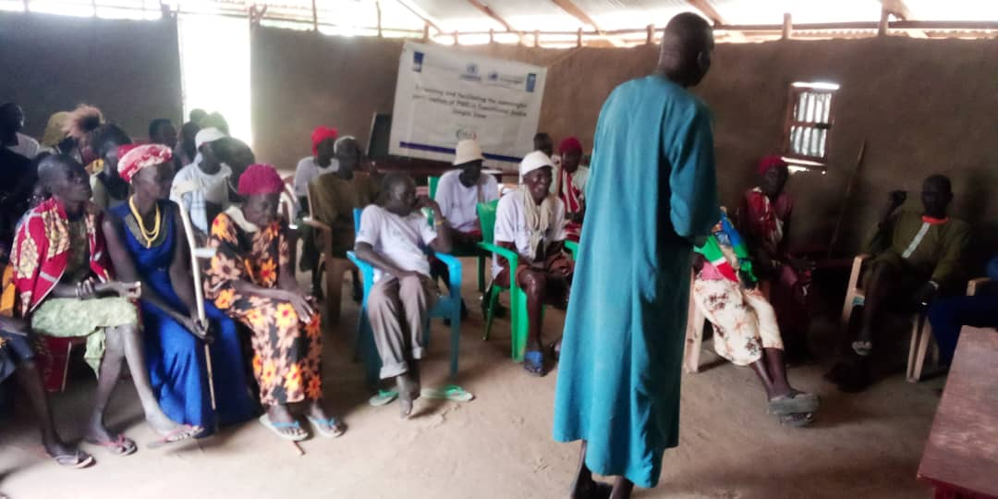
Michael Garang a church leader in Makuach expressed gratitude during PWD training sessions, acknowledging I-WIN and UNDP for initiating a project that advocates for the interest of PWDs and women's rights. He stressed on the antiquity of fierceness and abductions in the state, stressing ongoing insecurity caused by neighboring communities. However, Michael voiced his happiness that I-WIN is now on the ground supporting peaceful coexistence, inspiring hope for justice to prevail in these communities
At the same training, Anei Gugui, expressed appreciation for the program, she found hope through the support of friends and encouraging words. Anei highlighted the need for sustenance and encouragement from the community members to Persons with Disabilities such as, counseling, and trauma healing. He highlighted the worth of the training in stirring peaceful coexistence and understanding, stressing the importance of spreading awareness on transitional justice to prevent future conflicts in the state.
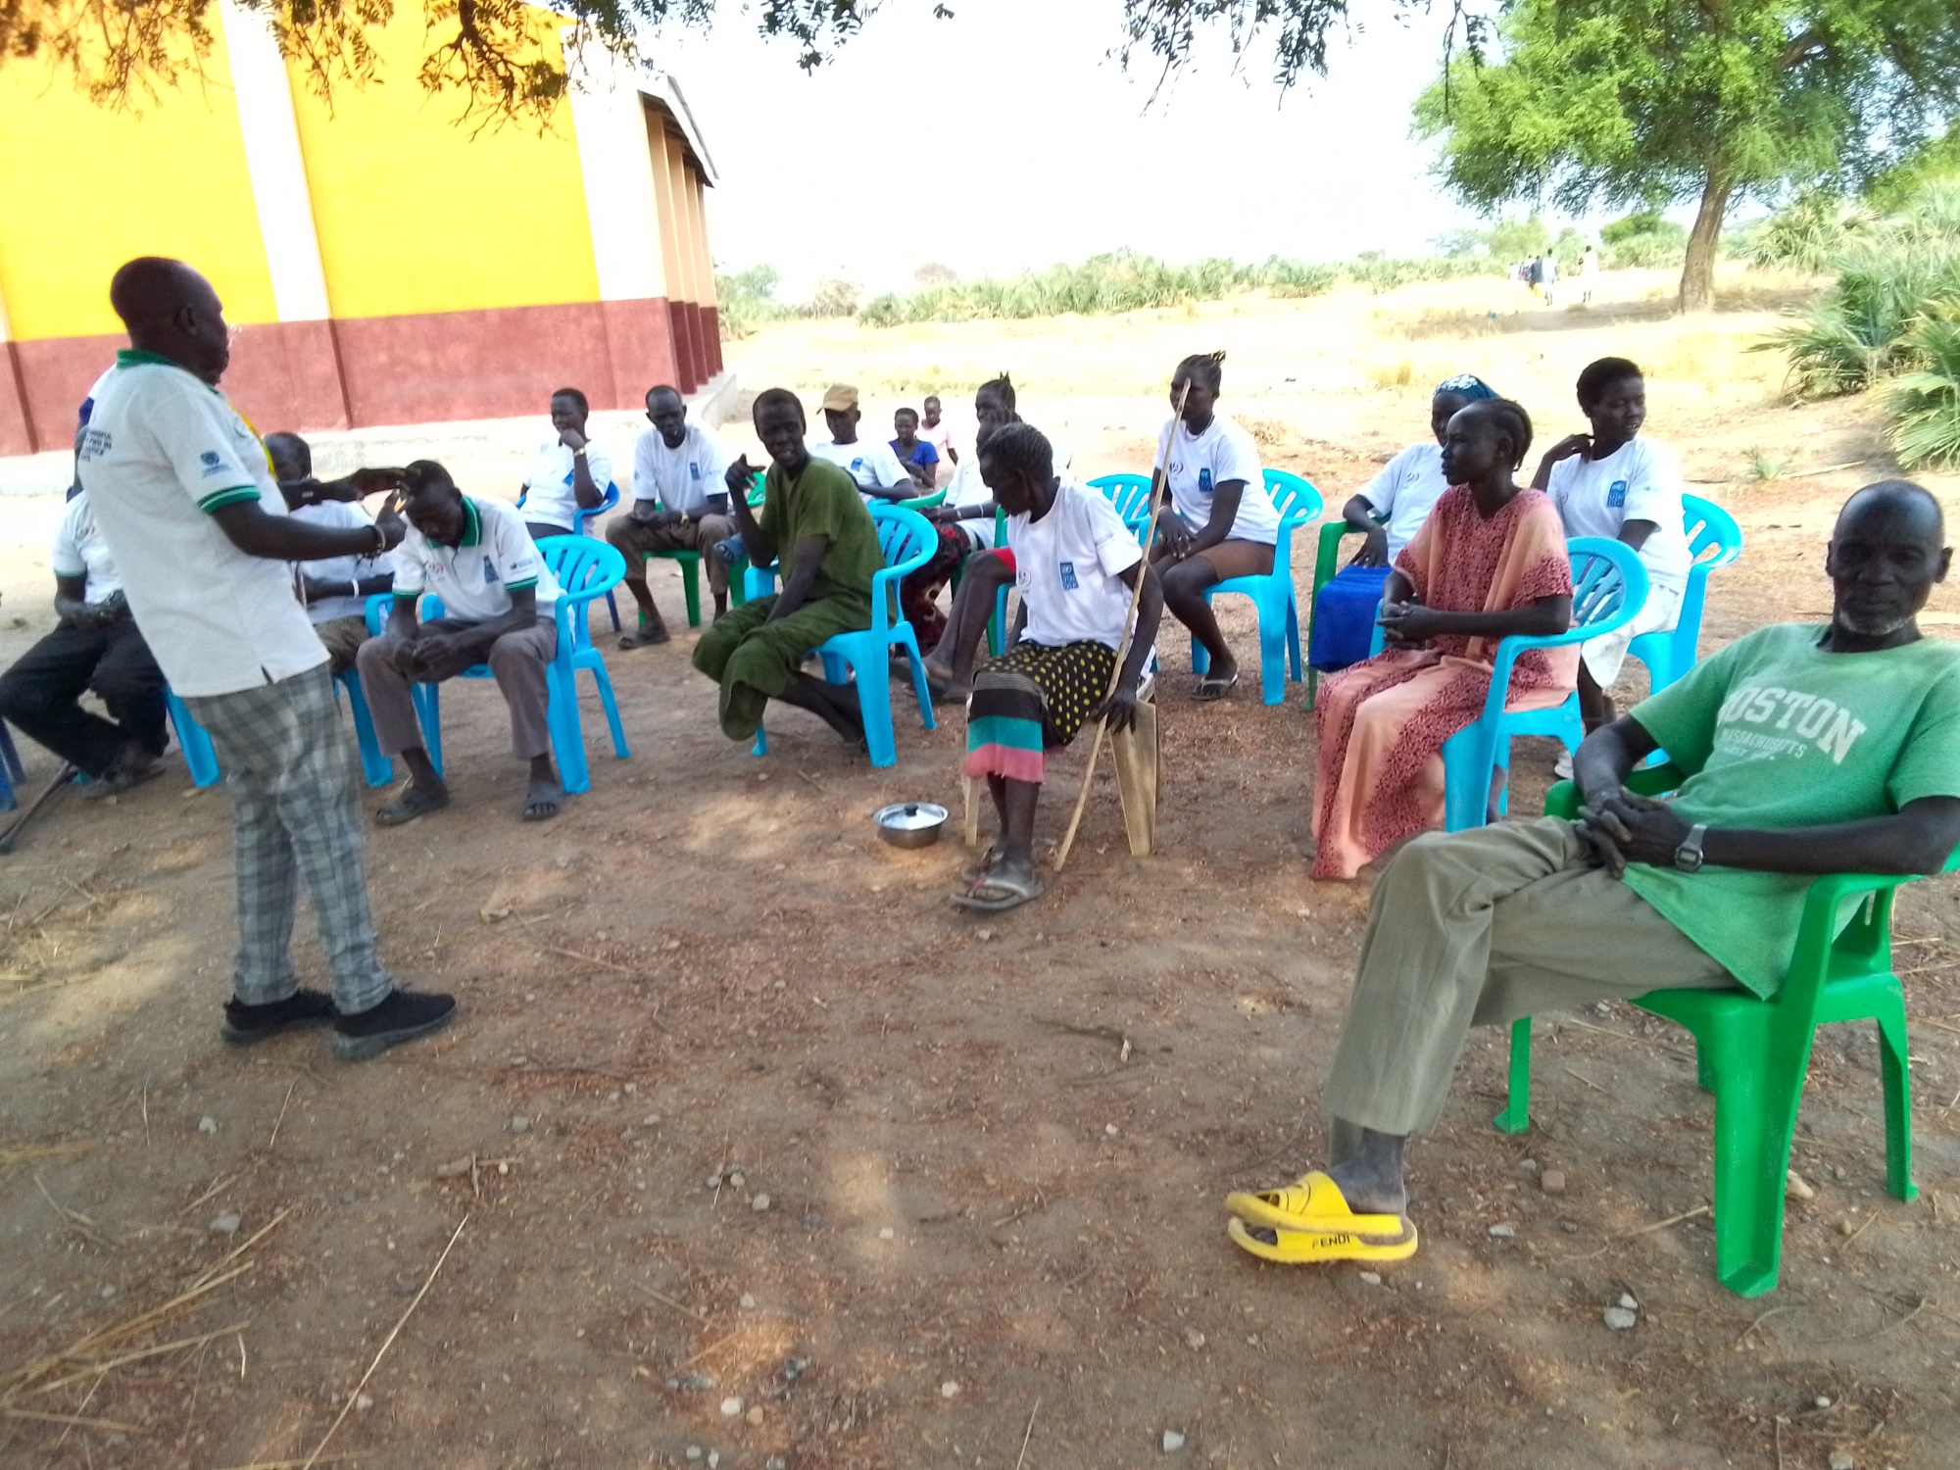
Phillip Mabior Achiek, a PWD Volunteer during the outreach session in Hai Panjak expressed gratitude to the attendees of PWDs for their presence at the meeting and assured them of the support from I-WIN, UNDP, and UNMISS in enhancing the capacities of local Persons with Disabilities (PWDs) for the benefit of the communities. Phillip applauded the members for the resourcefulness of contributing to a reduction in crimes within communities and nurturing a demand for peaceful coexistence.
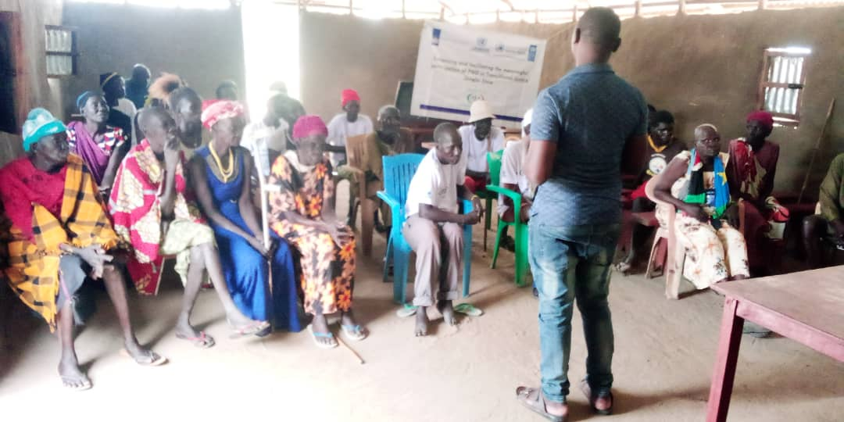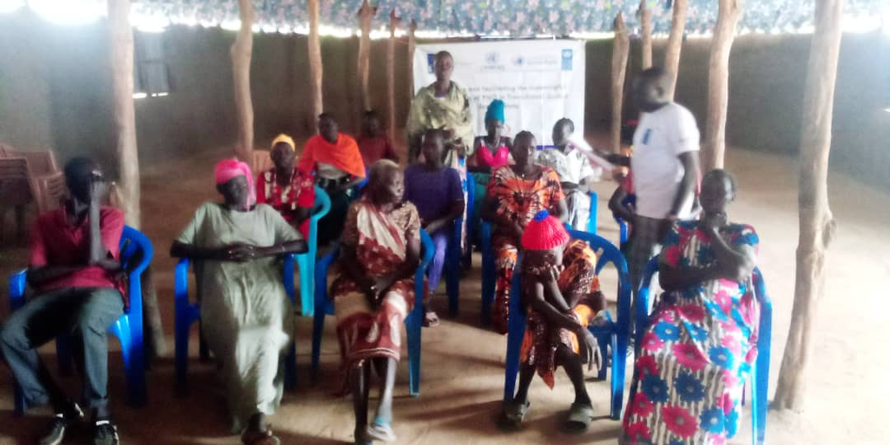
During the community outreach in Block 7 Makuach, Justin a project coordinator expressed high praise for the members, he highly praised the wonderful participation of Persons with Disabilities (PWDs), expressing his readiness to support the communities with regular awareness on TJ and the CTRH processes. Justin also said that I-WIN is considering extending its activities to other communities and other counties with similar programs in future if they get enough funding.
Similarly in Hai Referendum, Josephine Yar, a community member conveyed gratitude to I-WIN during a comparable outreach in Referendum. she thanked the organization for bringing a program that matters to convert the lives of PWDs, seeing it as a substance for peace and the beginning of stability in the state. Josephine stated eagerness to collaborate for lasting peace.

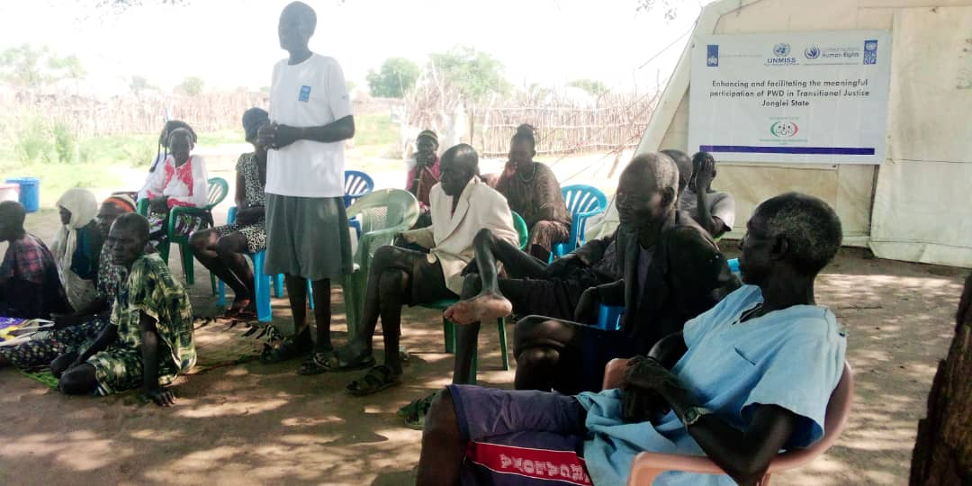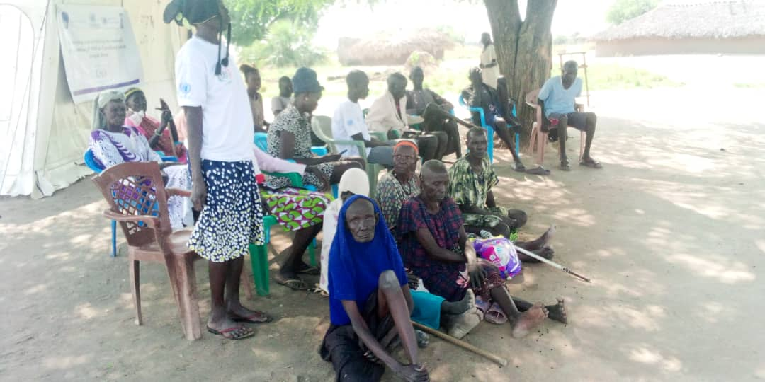
Rachel Aluel in Kondai IDP camp conveyed happiness for the productive organization that focuses on assisting impoverished individuals, particularly Persons with Disabilities. She expressed equal pleasure for the organization's presence in their community through this program, emphasizing that such initiatives are rare. Organizations rarely visit, and their school is in ruins, leaving their children's future unattended
During the same outreach, Elizabeth, a member of the Persons with Disability group, stressed the importance of the sensitization in promoting peace and fostering reconciliation. She emphasized the significance of a third party intervening to address issues facing the communities within Bor especially the attack from the Murle.
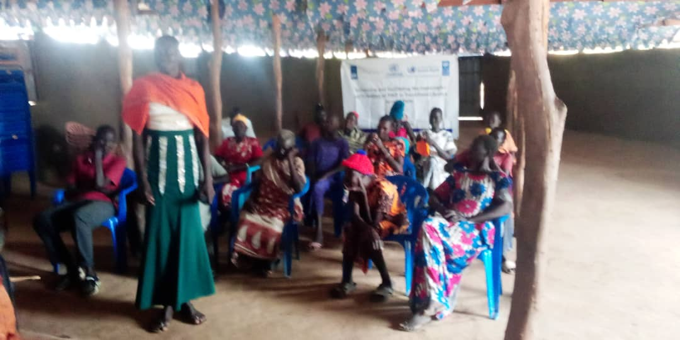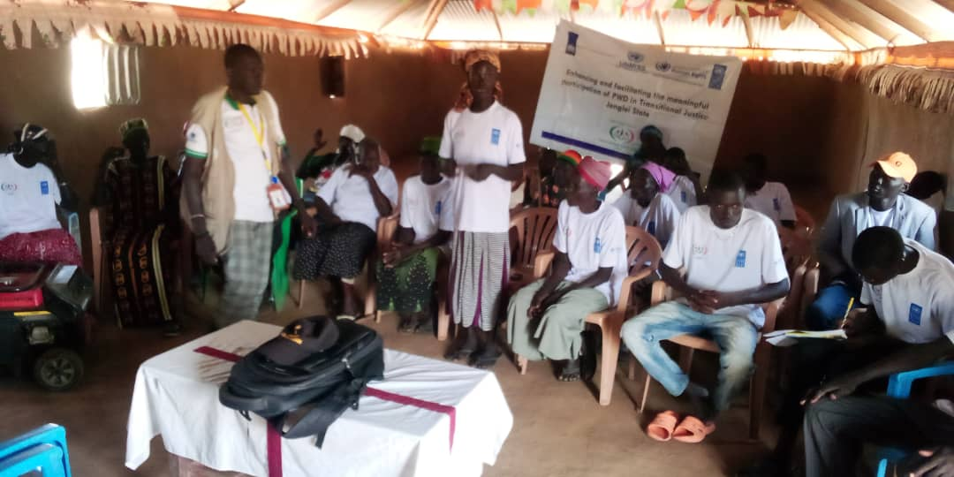
Philip Mabior Achiek, I-WIN Field Officer who is Persons with Disabilities (PWD, facilitating during the outreach session in Thara Agok on various occasions. He expressed appreciation to I-WIN, UNDP, and UNMISS for their support in enhancing the capacities of National Non-Governmental Organizations (NGOs), particularly in creating a beneficial project for PWDs in Jonglei State. Philip mentioned that the outreach session will be extended to all communities in Bor county to ensure that individuals outside the PWD group also receive the important messages..

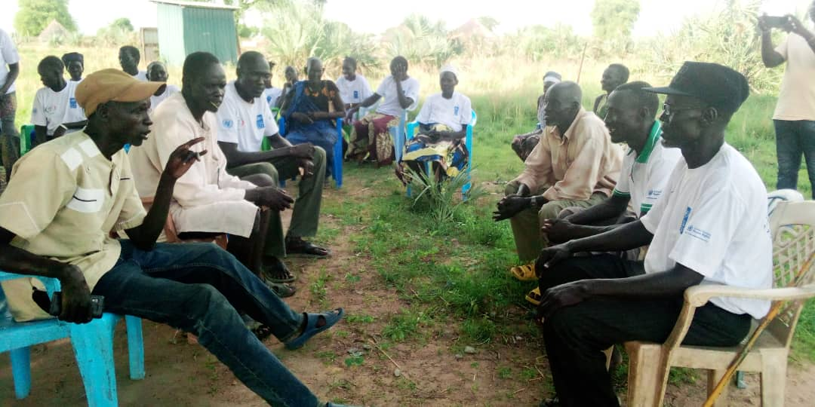
Deng Ayuen during a drama performance in sug Zero expressed gratitude to I-WIN, UNDP for their support in strengthening the capacities of National Non-Governmental Organizations (NGOs), particularly in implementing a helpful project for Persons with Disabilities (PWDs) in Jonglei State. He emphasized the importance of the drama and outreach sessions conducted by I-WIN for the people of Jonglei State, advocating for these initiatives to be extended to all communities in Bor county so that individuals outside the PWD group can also receive the valuable messages. Mr. Simon promised ongoing support for I-WIN throughout their project period and urged communities to respect humanitarian staff and provide them with the necessary support. Additionally

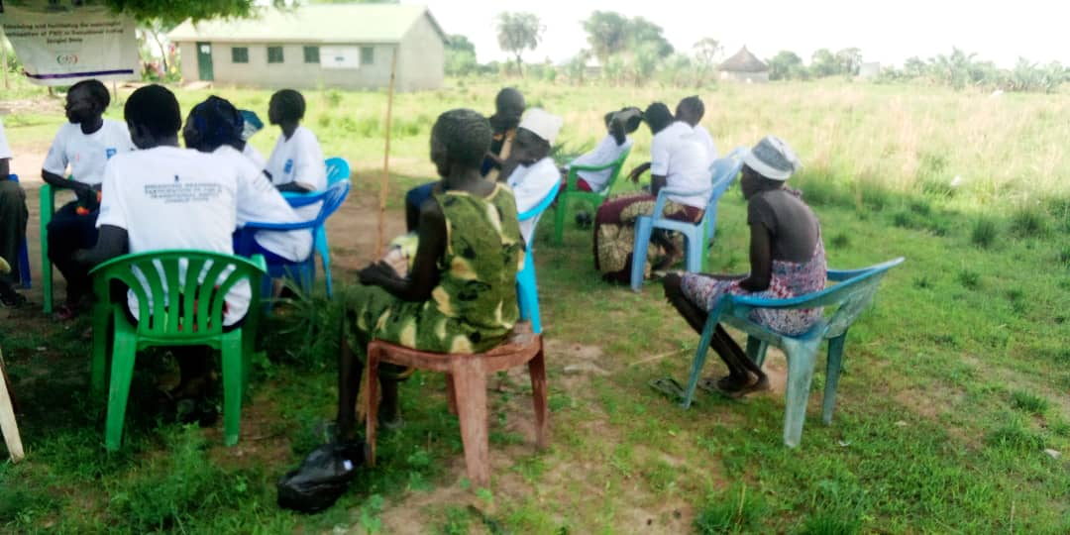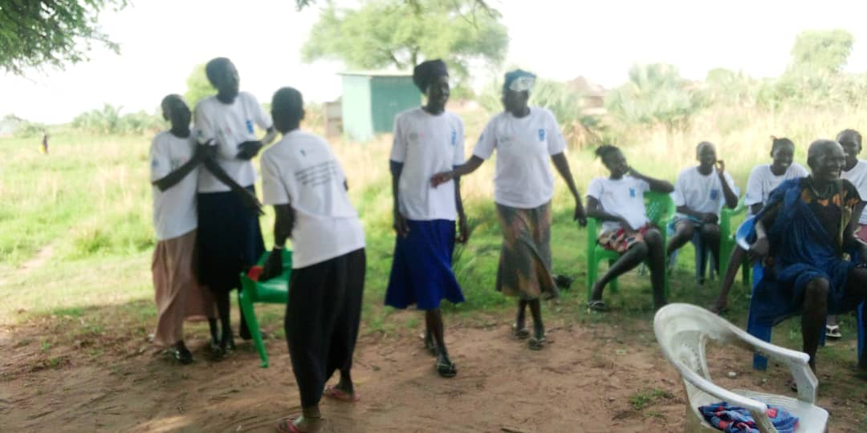
The above photo during a drama in Sug zero showing lack of proper care to elderly

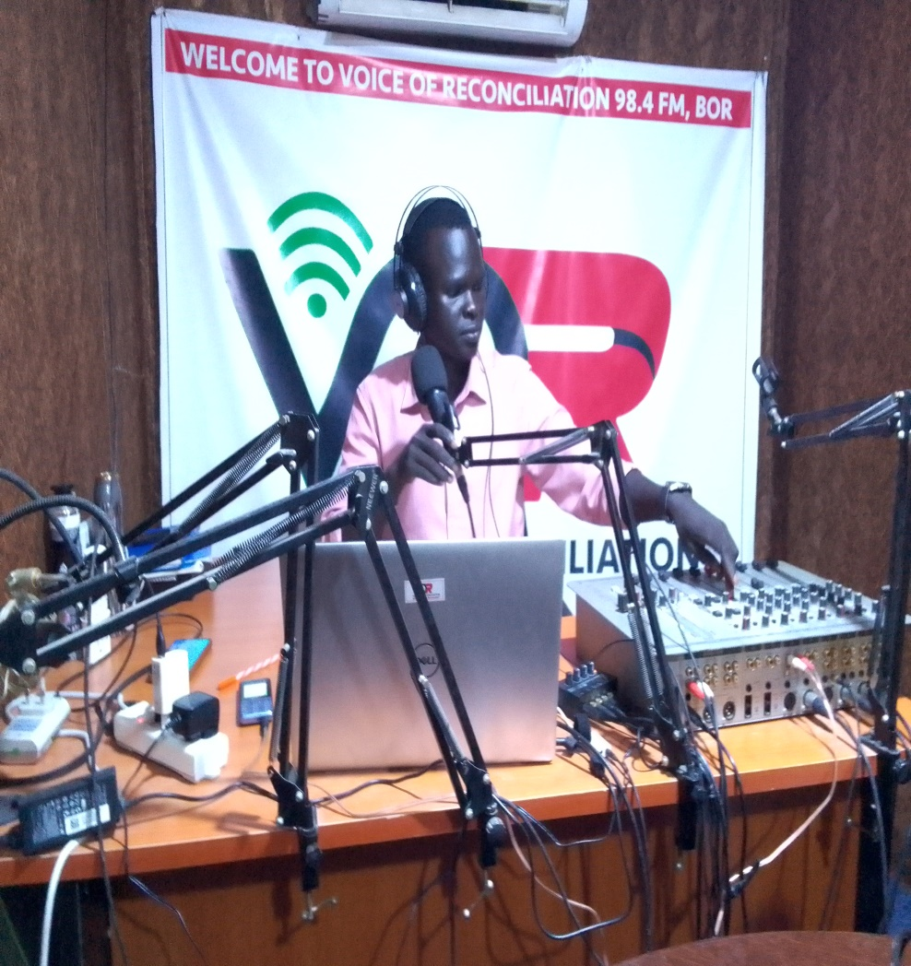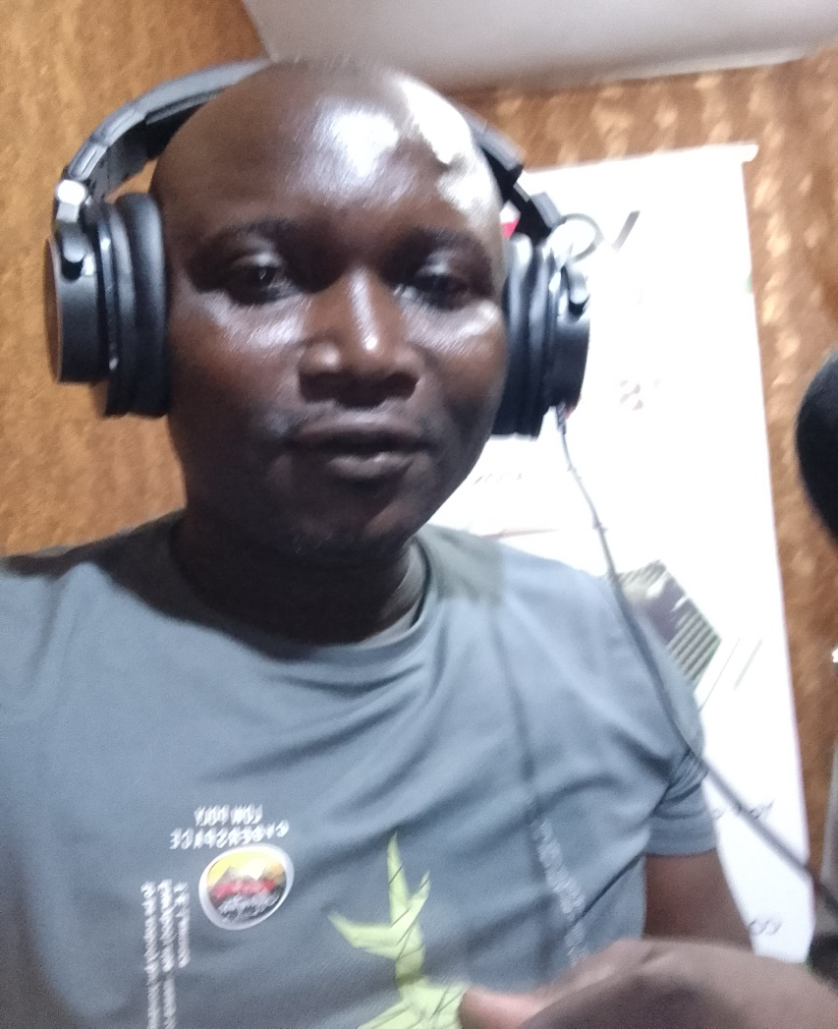
Voice of Reconciliation Host Mr. Chol Makol Riak and I-WIN Project Coordinator Muidie Justin Maziga on VoR 98.4 FM Bor,

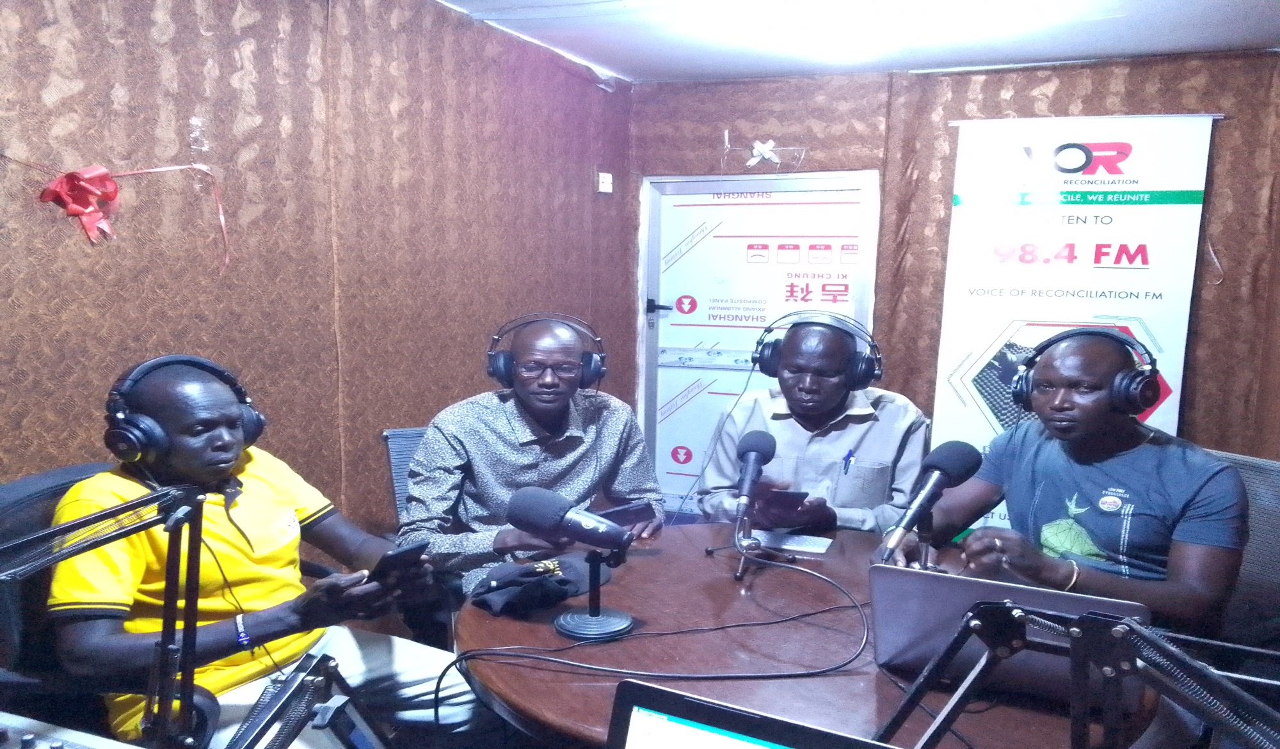
Fm left, Mr. Phillip Mabior Achiek Field Officer , Mr. Lam Gatdet Director General from the Ministry of Gender Child & Social Welfare, Mr. Deng Kuot Machar Head of Legal Administrator and Attorney General Jonglei State and Muidie Justin Maziga I-WIN's Project Coordinator during a radio talk show on Voice of Reconciliation 98.4 FM.

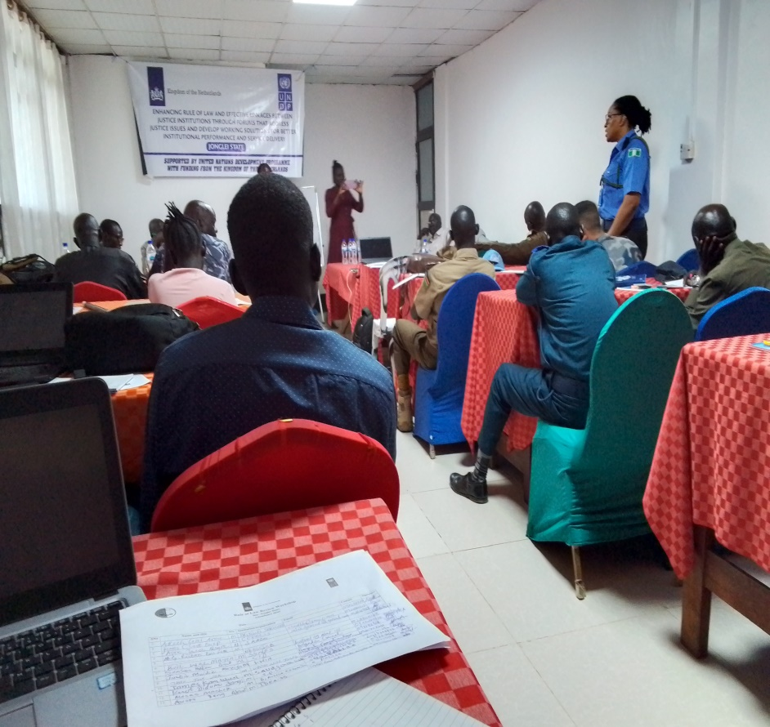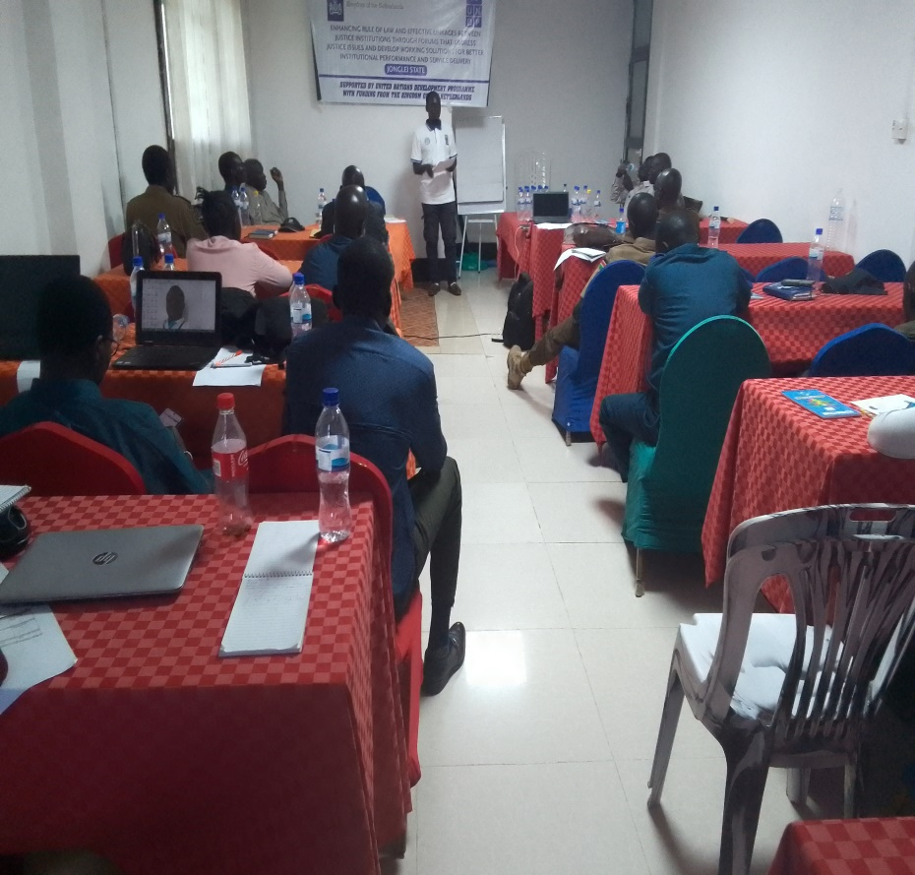

Members of Rule of Law Review Workshop organized by UNDP at Ariop Hotel Bor County

