Project Title: implementing a justice and confidence center in Warrap state

 | Overview: Your details (Most of the information is available in the PRODOC)

Name of CSO | INVISIBLE WOMEN INCLUSION NETWORK (I-WIN)
Location of implementation | WARRAP STATE, KUAJOK
Grant duration (beginning – ending) | 1ST MAY-31ST OCTOBER 2023
Reporting dates: month/year | 1ST JULY-31st JULY
Name of reporting officer | ANGELO MAYAR WOL
  Reporting to
  Agang Judith Executive Director
Email contact | info@i-win-ssd.org, wol.iwin2023@gmail.com
Telephone number | +211 927640607/ +211 922 329 911

- Context/Background (Word Limit: 1500 characters)
South Sudan attained its independence in 2011; before the independence, South Sudan promulgated Transitional Constitution of Republic of South Sudan 2011 as will of people which sets standards and rules how they can be governed under the principle of rule of law.
Part II of the Transitional Constitution of South Sudan, 2011 (as amended) provides for the Bill of Rights starting from Article 9-34. The fundamental rights are enshrined in the constitution and among the Article provided in the Constitution are: Equality before law, right to litigation and fair hearing. These provision revolves around the notion of access to justice. Despite of the fundamental rights enshrined in the Constitution, Access to Justice still remains a hard rock because of lack of proper legal policy framework in order to administer justice to every persons regardless of their sex, gender, ethnic origin, religious and political affiliation, race, color and social status. https://ssrn.com/abstract=4437931
Access to Justice challenges in Warrap state
During an inception/ consultative meeting with the community members, traditional leaders and authorities, a number of obstacles/ challenges to Access to justice in Warrap State were shared. These challenges include:
Legal Empowerment and Awareness:
There is a lack of legal awareness and empowerment among the population, particularly vulnerable groups. Many individuals are unaware of their rights, legal processes and proceedings, and available avenues for seeking justice. This knowledge gap hampers their ability to address legal issues effectively.
Limited Legal Aid Services:
The availability and accessibility of legal aid services are limited in Warrap State. Vulnerable groups often lack financial resources to access legal representation, impeding their ability to navigate the justice system and seek redress for the violations committed against themselves and their rights. As a result, many cases go unaddressed, perpetuating impunity and a sense of powerlessness. This has resulted in lack of confidence and trust in the legal system which they see as an alien system to them.
Psychosocial Support and Counseling:
The psychosocial needs of vulnerable groups, especially survivors of SGBV and returnees, are often overlooked. The lack of specialized support and counseling services leaves survivors without proper healing and reintegration mechanisms, hindering their recovery and impeding their access to justice.
Establishing a justice and confidence center in Warrap State, South Sudan is a significant project aimed at promoting the rule of law, ensuring access to justice, and restoring confidence in the judicial system within the region. This center would serve as a central hub for legal services, dispute resolution, and community engagement, addressing the pressing issues faced by the local population.
Objectives and Importance:
The primary objectives of the justice and confidence center include:
- Enhancing access to justice: The center would provide legal assistance, advice, and representation to individuals who lack resources or knowledge to navigate the legal system effectively.
- Resolving disputes: By offering alternative dispute resolution mechanisms, such as mediation and arbitration, the center can help resolve conflicts in a timely and fair manner, reducing the burden on the formal justice system.
- Building public trust: By providing transparent and impartial services, the center would work towards restoring public confidence in the justice system, which has been affected by years of conflict and instability.
- Creating awareness on legal proceedings and private rights of the beneficiaries: by offering trainings on human rights, women rights and the child rights, the general public would be enhanced with sufficient knowledge on legal issues, rights and legal procedures before the courts of law.
Services Offered:
The justice and confidence center offered a range of services to meet the diverse needs of the community. These services include:
- Legal advice and assistance: Trained legal professionals provided guidance on legal rights, obligations, and procedures to individuals seeking assistance.
- Court facilitation: The center assisted individuals in preparing and filing legal documents, navigating court processes, and representing themselves in court if necessary.
- Mediation and arbitration: Trained mediators facilitated negotiations between parties involved in disputes, aiming to reach mutually acceptable agreements outside of court.
- Legal awareness and education: The center conducted outreach programs, workshops, and training sessions to educate the community about their legal rights and responsibilities.
- Victim support services: Specialized support e provided to victims of GBV/SGBV, included counseling, referrals to other support agencies, and assistance in accessing justice.
Rationale for Establishing a JCC:
Recognizing the urgent need to address these challenges, the United Nations Development Programme (UNDP) in partnership with Invisible Women Inclusion Network (I-WIN) works towards establishing a Justice and Confidence Centre (JCC) in Warrap State. The JCC aims to provide a comprehensive range of services to vulnerable groups, promoting access to justice, psychosocial support, and legal empowerment.

Progress (summary) on Indicators for the month

Indicator: (Pick these indictors from the assigned project Log frame) | Baseline (disaggregate by gender, disability, age, location, type…as appropriate. | This month’s Target (disaggregate by gender, disability, age, location, type…as appropriate) | This month’s actual (disaggregate by gender, disability, age, location, type…as appropriate. | Comment/Remarks (Comment can be on qualitative, quantitative, or complex indicators. In case of under/over achievement, please provide a brief explanation
Conducted a launch and Project brief with stakeholders on Justice Confidence Centre in Warrap | 0 | 50Pax (18M, 32F) | 50Pax (18M, 32F | A launch was conducted to brief stakeholders, community chiefs and targeted beneficiaries on the nature of project to be conducted.
Legal advice and representation /counseling/referral services at the JCC in Warrap | 0 | 100Pax (55F, 45M) | 100Pax (55F, 45M) | Legal advice was provided to the GBV/SGBV survivors, and further addressed the legal proceedings and any other minor legal procedures before the court.
Training of 50 SGBV survivors on victim redress mechanisms, including on courts, transitional justice and reparations | 0 | 50 PAX (28F, 22M) | 50 PAX (28F, 22M) | SGBV survivors were trained on victim redress mechanisms, including on courts, transitional justice and reparations. The training touched the Bill of Rights, Women Rights to property and other international conventions such as UDHR and CEDAW respectively.
Probono legal aid services to 50 SGBV survivors’ elderly, women, and girls and other minority groups and ensure the cases are completed. | 0 | 4 PAX (1F, 3M) | 4 PAX (1F, 3M) | Awet aged 32, case number 222/2023 accused that his cattle damaged farm products.  Mou aged 28, case number 75/2023 accused for stealing of three cows  Ring aged 23, case number 181/2023 accused of also stealing a cattle  Agulat aged 16, case number 165/2023, charged for child labor and heavy beating
Conduct a Legal awareness on GBV, property rights, legal rights, available services at the JCC and human rights Warrap outreach campaigns. | 0 | 150 PAX (90F, 60M) | 150 PAX (90F,60M) | An outreach was done in areas of Gogrial East, Tong North and Tong North to to raise awareness on GBV, property rights, legal rights, available services

- Key results/Achievement observed from your intervention (Please report on key achievements for the reporting month: Note: Have a Serious reflection on where the project should be at this point of reporting, at least reporting on one achievement under each activity implement that month. Should be Evidence-based identification of the overarching results achieved = Bring data to back up your assessment on the results achieved. Be clear about WHO the project reached, WHERE, HOW MANY people were involved, WHAT the project has cleared delivered and, most importantly: The RESULTS of such deliveries, which leads to the SO WHAT question e.g., for a training a training activity “The project trained the youth and capacitated the local authorities…SO WHAT? What has happened with all these trainings? What is the main purpose of all of this, the bigger level change?
Activity1: Conducted a launch and Project brief with stakeholders on Justice Confidence Centre in Warrap
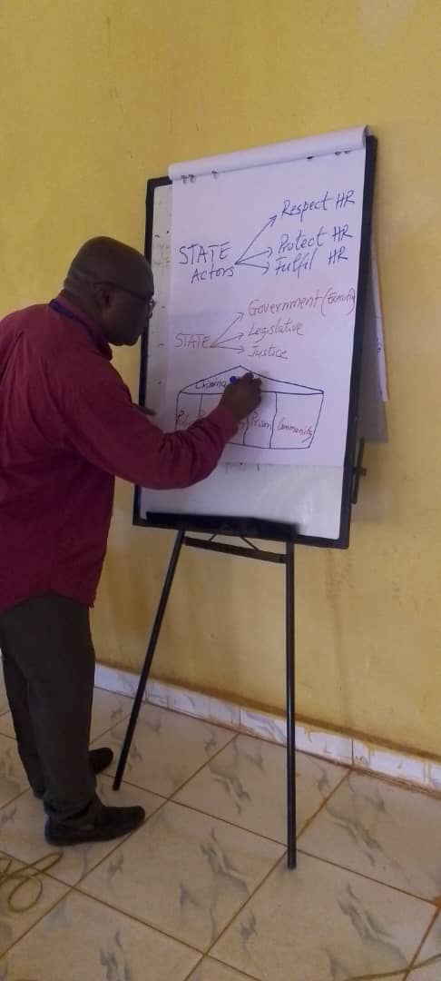
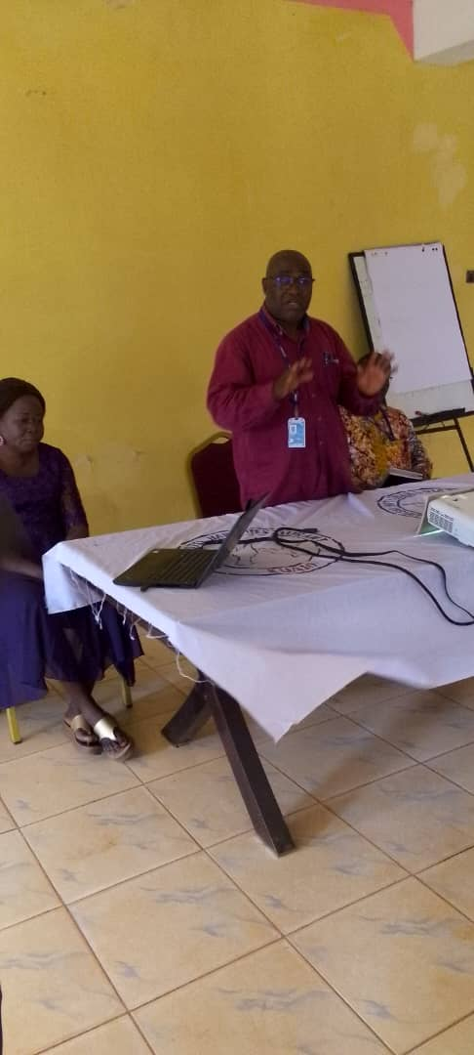
The project launch was conducted to brief the community and stakeholders about the nature of the project. The launch was conducted on the 8^{th of} July 2023 at Naivasha Hotel-Kuajok and in attendance were government officials from the State Ministry of Gender, Child and Social Welfare, representatives of RRC, UNMISS Rule of Law and Human Rights representatives, chiefs of Kuajok South Payam and other blocks of Kuajok as well as other participants. The State Director of Legal Administration was also invited though did not turn up.

Mr. Marcel from UNMISS conducting a session on Human Rights during the inception workshop.

Achievements;
- The project brief provided a forum for the local authorities and beneficiaries to understand the concept of the project.
- Mr. Marcel Zinsou, the Human Rights Officer-UNMISS was very resourceful since he took the participants through the concepts of Human Rights and how it is of importance for the team to be agents of promoting human rights in the community and helping them understand referral pathways where they experience such human abuses.
- It also improved understanding of legal rights and options among the community members.
- Enhanced capacity to address legal issues and navigate the justice system effectively.

Activity 2: Training of 50 SGBV survivors on victim redress mechanisms, including on courts, transitional justice and reparations.

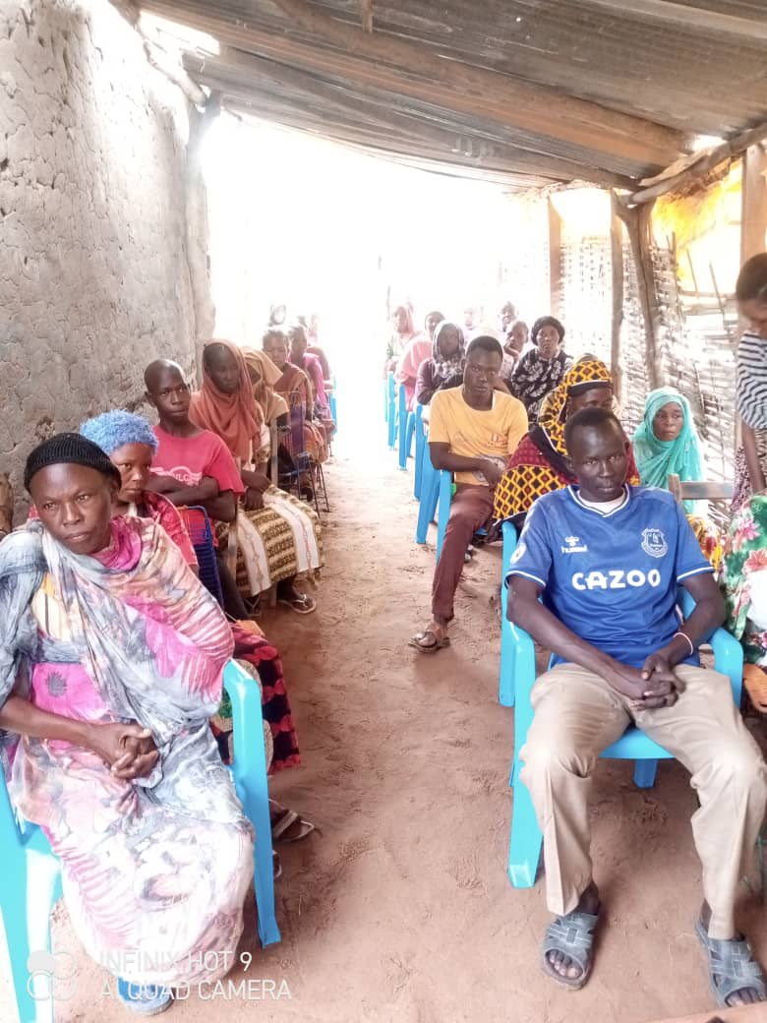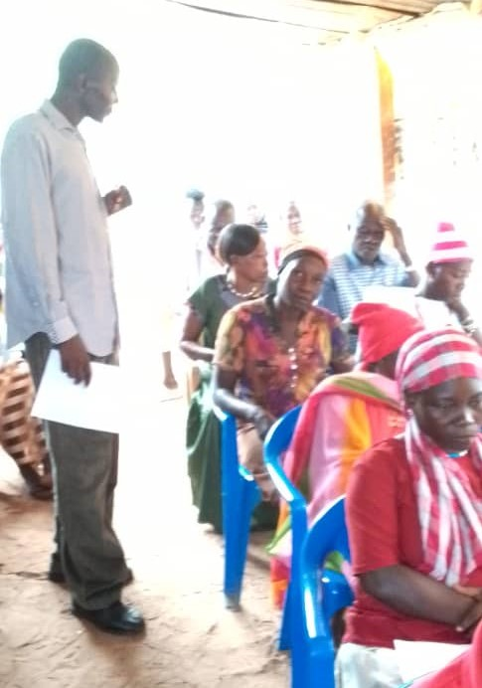
Training of SGBV survivors in Kuajok South Payam on SGBV redress mechanisms.
The aim of the training was to equip the SGBV victims with appropriate information on reporting of cases, enlightenment on Human Rights from the Universal Declaration of Human Rights, 1948, the Bill of Rights under Article 9 of the Transitional constitution of South Sudan, 2011 as amended, rights of Litigation and presumption of innocent in summary, the fair trial procedures.
Achievements included.
- Participants understood clearly the concepts and principles of access to justice and it components on the rule of law ( fair trial l rights and due process of the law) which describes how citizens should have an equal access to the legal system.
- It also provided legal advise to beneficiaries on how to seek and obtain a legal remedy through formal or informal justice system for the grievances in line with international human rights standards.
- The session emphasized on article 9 of the Transitional Constitution of South Sudan, 2011 and Article 14 which calls for equality before the Law.
- Survivors are empowered with knowledge about victim redress mechanisms, including the use of the formal and informal justice system and alternative dispute resolution mechanisms. Strengthened survivors’ ability to seek justice and redress for abused they experienced
- Increased awareness of available support system and resources for survivors

It also created an open Forum for participation from the public through asking questions for example Malual asked; The issues of citizens being detained illegally in the prisons and police cell is common, there are prisoners that have been there for years without any trial so what is I-WIN going to do about that since the Project is talking about Human Rights?
Angela asked- For cases that deal with divorce and land ownership as well as child marriages, the traditional chiefs normally preside over it and sometimes they unjust decisions tends to favor the male than the female litigants. How will I-WIN influence the traditional system of ruling and attain justice for such victims?
Added
Responses from I-WIN to the questions?
The Access to Justice Officer thanked the participants for their questions and said the project is not aimed at eliminating the role of chiefs and traditional leaders in the community to seek for a just way of resolving conflicts as supported by the Transitional Constitution of South Sudan, the constitution also gives power to traditional rulings but only on basis where human rights are not violated. Therefore, the main purpose of I-WIN inviting the traditional leaders for the session is to enlighten them on some of these laws and how they are expected to pass judgements on an informed point of view without violating the rights of anyone.
Activity 3: Conduct a Legal awareness on GBV, property rights, legal rights, available services at the JCC and human rights Warrap outreach campaigns.
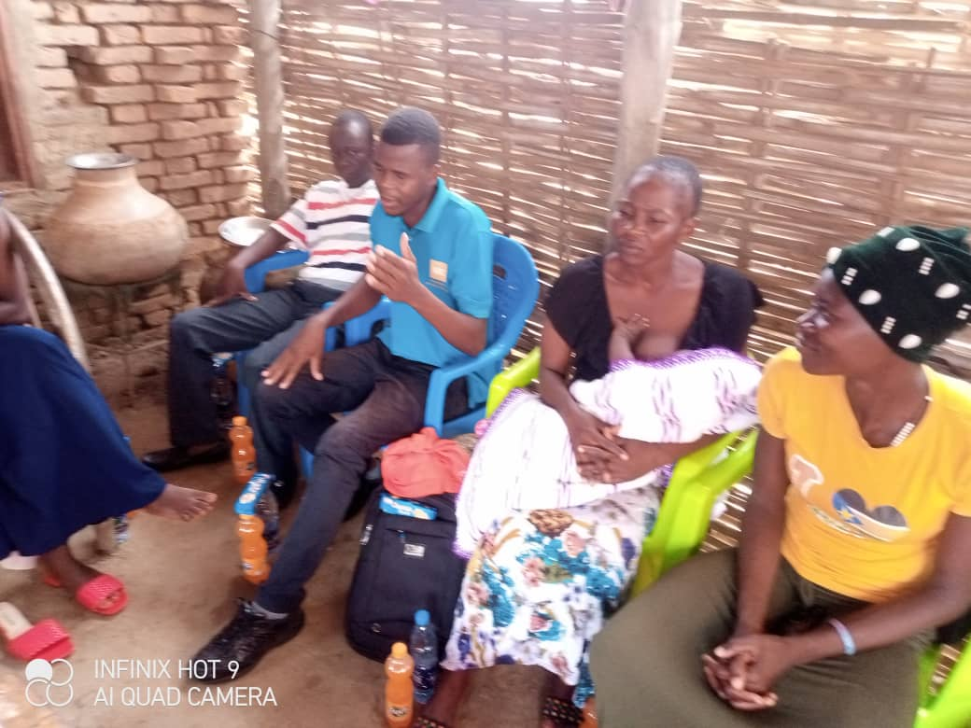
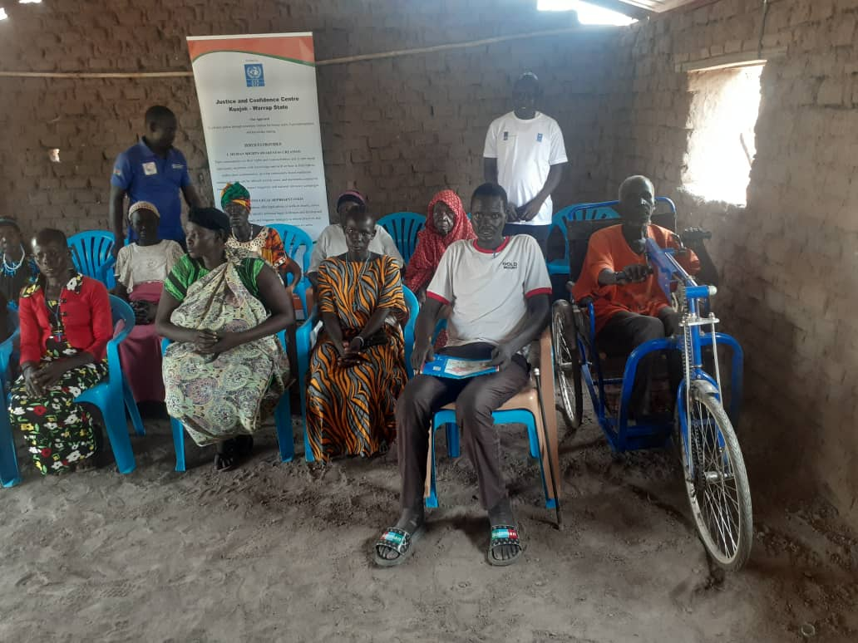
Participants giving their views on access to Justice during an Outreach to Tong North and Gogrial East respectively.
Key achievements are;
- Improved public awareness capacity to handle cases related to SGBV and ensure effective victim redress
- Increased awareness of traditional chiefs’ roles and their integration with formal justice system
- Strengthened collaboration and coordination between the high court, police force and traditional chiefs for better victim redress.

- Challenges (Please state key challenges for the reporting month and the mitigation measure applied or planned to handle the challenges)

 | Challenges of the month | Mitigation measures applied/proposed
 | Cultural and linguistic barriers | I-WIN employed staffs who are fluent in local languages and familiar with local customs
 | Gaining the trust and awareness among the community can be a challenge | I-WIN collaborated with local leaders, to gain their support and involvement.
 | Delayed approval of the Access to Justice Project from the Local Authorities (RRC and State Legal Administration) | The I-WIN access to Justice Officer having been a licensed lawyer, has taken some cases and provided pro bono legal services and awareness on how to follow up the legal procedure in the proceedings before the court. Some of the cases have been appealed while others are in the hearing stages currently.

- Cross-cutting Issues: Please describe briefly any cross-cutting consideration as may be applicable to the project including but not limited to Gender, Disability, Environment, Partnership etc. (1500 characters). Note: Please undertake brief analysis on the cross-cutting that are applicable to your location/project.

1. Gender Equality and Women's Empowerment:
The JCC promotes gender equality and addresses the specific legal needs and challenges faced by women. It provides equal access to justice, prioritize services for survivors of gender-based violence, and empower women to assert their rights and participate fully in the justice system.
Created awareness on the bill of rights, right to litigation, right to fair trial as well as women rights to own the properties and to participate on daily aspect of life.
2. Child Protection:
I-WIN has incorporated child-friendly practices and procedures within the JCC to ensure the protection and well-being of children accessing its services. This includes maintaining privacy, sensitivity, and specialized support for child victims, witnesses, or offenders involved in legal processes.
3. Accessibility and Inclusivity:
I-WIN Ensured that the JCC is physically accessible to people with disabilities, accommodating their specific needs. Implementing inclusive practices to make the center welcoming and sensitive to the needs of individuals from different ethnic, religious, linguistic, and cultural backgrounds.
4. Conflict Sensitivity:
This includes incorporating conflict sensitivity into the design and implementation of the JCC. Considering the local context, dynamics, and potential conflicts within the community to ensure that the center's activities do not unintentionally exacerbate tensions or contribute to further disputes.
5. Community Participation and Ownership:
We Foster community participation and ownership in the JCC project by involving local stakeholders, community leaders, civil society organizations, and grassroots groups in decision-making processes. This ensures that the center's services align with the community's needs, values, and priorities.
6. Ethical Standards and Professional Conduct:
I-WIN Upholds high ethical standards and professional conduct within the JCC. We Train and monitor staff to ensure they adhere to principles of integrity, impartiality, confidentiality, and respect for human rights throughout their interactions with service users.
7. Data Protection and Privacy:
Establishing robust data protection and privacy measures to safeguard the personal information and confidentiality of individuals accessing the JCC's services. Complying with relevant data protection laws and regulations, ensuring secure storage and appropriate use of sensitive information.

8. Monitoring, Evaluation, and Learning:
I-WIN Incorporates a robust monitoring and evaluation framework to assess the impact and effectiveness of the JCC's services. We regularly collect feedback from service users and stakeholders, identify areas for improvement, and adapt strategies accordingly.

- Media and publications

Did you collect any media and/or publications about the project this month?  (Media includes newspaper articles, radio advertisements and presentations, advertisements, brochures/pamphlets, promotional material, photos) |  | There are photos of the project done and published on our facebook page.
Type of media | Key messages/description of photo | Online link or publication details
Banners and T-shirts | Implementing a justice and confidence center in Warrap State | Banners and T-shirt have been produced during the first training that was conducted on July 8th, 2023 and another training that was conducted on July 25th, 2023 respectively. It is believed that the general public through T-shirts and banners have habituated themselves with the project and its strong message. It is also worth noting that we cannot produce T-shits for everyone to wear.
Posters and Fliers | Access to justice for all | The posters and fliers have been prepared for the next training that would be conducted shortly on a date to be communicated as per the weekly plan.
Legal Representation | Access to Justice and legal representation | Legal representation has been done on specific cases while major part was covered under legal advice on legal proceedings. The specific cases that were covered are as followed:  - Awet as appellant whose case was appealed from Kuajok County Court to Kuajok High Court. The case number is 222/2023. It was falsely accused that his cattle have damaged the farm of one Mathuc; the case is yet to be determined before the High Court though he was severely fined.  - Mou is a pauper who was unable to afford hiring a lawyer while the other party had. His case has been appealed and under consideration before Kuajok High Court. His case number is 75/2023.  - Ring like the above-mentioned beneficiaries had his case appealed and being considered currently in Kuajok High for the decision. The case number is 181/2023.  - Agulat a young underage girl whose case was decided and the convict was ordered with his relatives to release 5 cows with a fine and a term of sentence not less than three years imprisonment.  NB:  The full names of the parties herein have been reserved as a matter of confidentiality hence; their first names have been used alternatively.

- Summary of total beneficiaries
Number of Beneficiaries / Participants per location
Major activities | State | County | Adult Male | Adult Female | Boys | Girls | Total
Legal advice and representation/ counseling/ referral services at the JCC in Warrap | Warrap | Kuajok | 45 | 55 | 0 | 0 | 100 Pax
Training of 50 SGBV survivors on victim redress mechanisms, including on courts, transitional justice and reparations | Warrap | Kuajok | 22 | 28 | 0 | 0 | 50 PAX
Probono legal aid services to 50 SGBV survivors’ elderly, women, and girls and other minority groups and ensure the cases are completed. | Warrap | Kuajok | 3 | 1 | 0 | 0 | 4 PAX
Conducta Legal awareness on GBV, property rights, legal rights, available services at the JCC and human rights Warrap outreach campaigns | Warrap | Kuajok, Gogrial East and Tong North | 60 | 90 | 0 | 0 | 150 PAX
- Success/Impact Story (1500 characters): Note: in a few sentences, explain whether the project has had a positive human impact. It may include direct quotes where possible or link to strategic communication pieces.

Angela, one of the participants and a resilient member of the community, shared how the center has helped her gain confidence and be empowered. ‘’With the help I got from the JCC and the full support and compassion of the team, I can now face my fears and seek justice. I am now ready to champion for justice and empowerment and volunteer to help reach other vulnerable people in my community.’’

Besides Angelina mentioned-above, one Valentino Ayany Akol, a deputy chief of Kuajok South Payam appreciate the efforts and lessons he learned through JCC for which he promised to work closely with I-WIN in reporting the victims of SGBV as well as other cases of significant important that needs pushing for the victims to be heard before the court of law.
Valentino is reachable on 0925080331 for further details on his personal acknowledgment and authentication.

- Any other issues as may be applicable. (Work limit: 500 characters)

- Pictorials Note: Include photos with captions. May consider to sending any high-quality photos of videos via email.

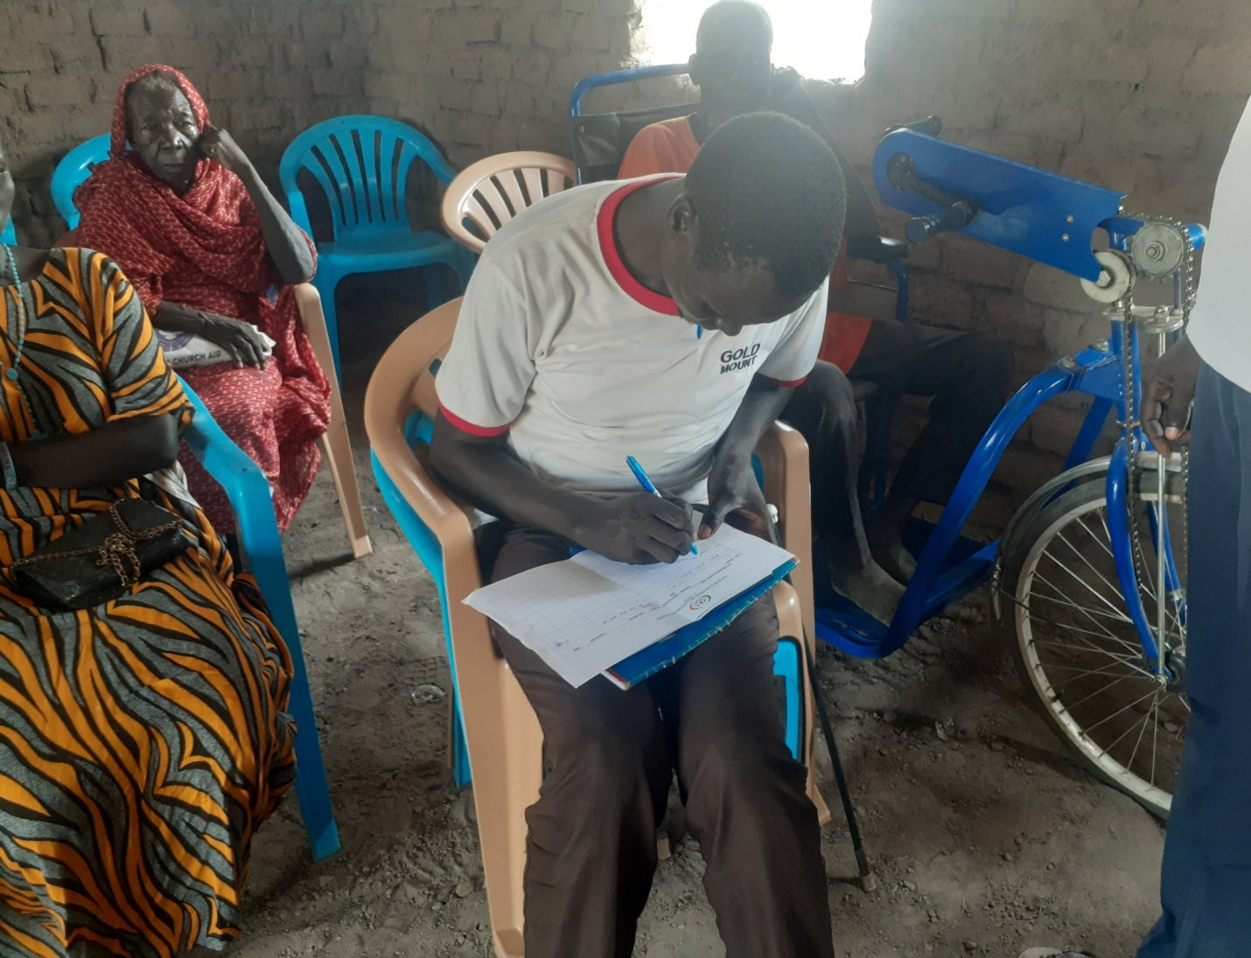
Picture showing Sultan Valentino Ayany signing for his attendance at the training that was organized by I-WIN in Tong North Payam.

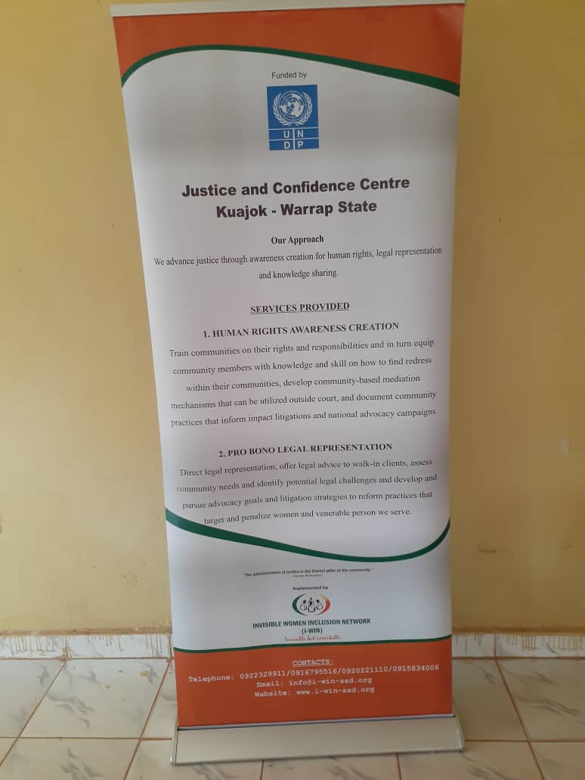The banner as part of the visibilities printed for the JCC project
S/N | Activities | Activity Dates  Month-1ST AUGUST-31ST AUGUST 2023 |  |  |  |  |  | Location | Responsible Actor | Expected Results from the Activity
S/N | Activities | Week1 | Week 2 | Week 3 | Week 4 | Week 4 | Week 5 | Location
 | Establishment of a JCC center at a designated place for vulnerable groups including women, girls, SGBV survivors, elderly and returnees to seek legal advice, psychosocial support and counselling and referral services in Warrap. | Date | Date | Date | Date | Date |  | KUAJOK COURT | A2J OFFICER- ANGELO | Establishment of JCC at Kuajok High Court with the intention of providing services mentioned earlier such as, legal advice and counselling to vulnerable groups of SGVB including girls, women elderly and returnees.  The space would be provided by the court whereby the IWIN will provide a table and a chair for the purposes of deliverance of the required and intended services mentioned-above.  The beneficiaries would easily access the help table without difficulty.
 | Pro bono legal aid services to 50 SGBV survivors’ elderly, women, and girls and other minority groups and ensure the cases are completed. |  |  |  |  | 24th July |  | KUAJOK | A2J OFFICER- ANGELO | - At least 15 SGBV survivors to receive legal aid this month.  - Photos, videos. Success stories
 | Legal advice/counseling/referral services at the JCC in Warrap to 300 people |  |  |  |  |  |  |  | A2J OFFICER- ANGELO | - At least 100 people to receive legal advice and counseling at the JCC center  - Photos, videos, reports, success story
 | Training of 20 members of Warrap High court (Judges, public prosecutors, court clerks, traditional court members) and members of the police force on victim redress mechanisms, and traditional chiefs including on courts, transitional justice and reparations. |  |  |  |  |  |  | 7th - 8th August in case the recommendation is adhered to as presented. | A2J OFFICER- ANGELO | - This area of the project needs an expert who could be a former or current justice of the supreme court to conduct the training to Judges, Public Prosecution Attorneys and other intended members of the High Court such as clerks and traditional court members) and members of the police force on victim redress mechanisms, and traditional chiefs.  - The idea is that Judges assume a higher position and when hierarchy is concerned, a judge or judges cannot be trained by a lawyer, but by a senior judge or justice and that is the reason I recommend this particular training to be conducted by an expert or (Justice of the Supreme Court).  - Reports, photos and videos
 | Conduct a Legal awareness on GBV, property rights, legal rights, available services at the JCC and human rights Warrap outreach campaigns. |  |  |  |  |  |  | 9th -10th August |  | - Reports, photos and videos  - Success story
 | Monthly radio talk shows with messages on availability of Legal aid services including legal representation, legal awareness and legal advice, and psychosocial support to vulnerable groups including women, girls, SGBV survivors, elderly and returnees in Warrap State. |  |  |  |  |  |  | 29TH August 2021 | Angelo-A2J Officer | - Audio and reports
 | Bi weekly meetings survivors’ and victims of SGBV to provide counseling and other mental health and psychosocial support at the JCC center alongside information on where victims of SGBV can get Clinical Rape Management (CRM) services |  |  |  |  |  | 14th & 17th August |  | A2J OFFICER- ANGELO | - Reports, photos and videos  - Success story
 | Three drama sessions with community members to raise awareness on GBV, property rights, legal rights, available services at the JCC |  |  |  |  | 18th August |  |  | A2J OFFICER- ANGELO | - Reports, photos, videos  - Success story

The summary of the progress to on Indicators is derived from the Performance Indicator Tracking Tool (PITT) attached to this template. Tracking for the indicators (through the PITT) is done monthly and consolidated quarterly.

