Project Title: ESTABLISHMENT OF VICTIM SUPPORT GROUP IN GREATER BAHR EL GHAZAL REION

Overview: Your details (Most of the information is available in the PRODOC)

Name of CSO | Invisible Women Inclusion Network (I-WIN)
Location of implementation | Bahr El Ghazal Region(Lakes, Northern Bahr el Ghazal, Western Bahr El Ghazal, Warrap and Abyei administrative Area)
Grant duration (beginning – ending) | June 2023 – December 2023
Reporting dates: month/year | 1st June– 15th December 2023
Name of reporting officer | MUIDIE Justin Maziga
Reporting to | Agang Judith Executive Director
Email contact | info@i-win-ssd.org
Telephone number | +211 927640607, +211984302452

- Context/Background (Word Limit: 1500 characters)
Progress (summary) on Indicators for the month
The history of South Sudan is marked by decades of conflict and subsequent post-conflict recovery. It’s impact on every sphere of people’s lives continues to be seen through dehumanization, deep distrust, divisions, and persisting diverging memories. Many victim-survivors still hold grievances by the past civil war, of sadness and loss (personal, physical and economic) and the lack of recognition of their identities as victims. A lack of communication among the community members continues to foster anger, and misunderstanding. Past human rights abuses remain unaddressed, social capital is lacking, trauma persists, and economic recovery is still very limited.
Historical background:
South Sudan has endured decades of multiple conflicts with Sudan over resources, power and identity. In addition, the country has grappled with internal ethnical and political divisions stoked by South Sudanese warlords. The multiple conflicts with reference to the 2013 and subsequently 2016 outbreak of war have left thousands of dead and displaced of over two millions people, many of whom remain refugees. They have also contributed to repression, deprivation and a resulting humanitarian crisis that has gripped the country since before the struggle for independence
Why transitional justice in Greater Bahr el Ghazal?
Chapter V of the ARCSS agreement establishes three mechanisms for transitional Justice (1) The commission for Truth, Reconciliation and Healing (CTRH); (2) The Hybrid Court of South Sudan; and (3) Compensation and Reparations Authority (CRA). Additionally, the agreement calls for the reform of several institutions, including the Bank of South Sudan, the Anti-Corruption Commission and the National Audit Chamber. Transitional Justice will therefore help South Sudan and (with Greater Bahr el Ghazal being one of the region that have greatly suffered inter communal conflict) heal from the atrocities committed during the conflicts and move forward peacefully.
Therefore, I-WIN’s overall objective for this project is to enhance the establishment and operationalization of the Victim Support Groups and Truth, Reconciliation and Healing Outreaches and Dialogues on Transitional Justice in Greater Bahr El Ghazal Region (Lakes, Northern Bahr el Ghazal, Western Bahr el Ghazal, Warrap, Lakes, and Abyei Administrative Area) through:
- Establishing and operationalizing sustainable Victim Support Groups (VSG) that can help and provide free confidential support to the most vulnerable members of society affected by all past human rights violations, crimes and traumatic events arising from the past or ongoing conflict and violence including offering advice, truth, reconciliation and healing awareness-raising, and psychosocial support to the affected vulnerable groups.
- Actioning, mobilizing and carrying out truth, reconciliation and healing awareness-raising outreaches for the most conflict affected members of society to enhance their understanding of transitional justice and act as a platform where such victims of past human rights abuses will be sensitized, prepared, and able to engage meaningfully with the Commission for Truth Reconciliation and Healing (CTRH) once it is established and effectively advocate for other mechanisms on reparations and criminal accountability.
- Organizing various and adapted truth-telling and community-based dialogues for Community-based organizations, community leaders and elders to encourage and support victims to come forward to share their stories as means of giving voice to the full scope and breadth of the atrocity with specific dialogues for women, youth and their leaders as well as that are intergenerational organized to create safe and targeted spaces that can enlist their views and experiences.

Indicator: (Pick these indictors from the assigned project Logframe) | Baseline(disaggregate by gender, disability, age, location, type…as appropriate. | This month’s Target (disaggregate by gender, disability, age, location, type…as appropriate) | This month’s actual (disaggregate by gender, disability, age, location, type…as appropriate. | Comment/Remarks (Comment can be on qualitative, quantitative, or complex indicators. In case of under/over achievement, please provide a brief explanation
Activity 1.1 Establishment of 30 VSG for vulnerable groups including women, girls, SGBV survivors, elderly, IDPs and returnees to help and provide free confidential support to the most vulnerable members of society affected by all past human rights violations, crimes and traumatic events arising from the past or ongoing conflict and violence including offering advice, truth, reconciliation and healing awareness-raising, and psychosocial support in Greater Bahl El Ghazal Region (Lakes, Northern Bahr el Ghazal, Western Bahr el Ghazal, Warrap, Lakes, and Abyei Administrative Area). | 0 | 900 PAX (510F, 390M) | 900 PAX (510 F, 390M) | 30 VSG groups have been established in locations of Aweil in NBGS (eight groups), Wau in WBGS (eight groups), Rumbek in Lake state (seven groups) and Kuajok in Warrap state (seven groups), each consisting of 30 members and two group leaders per group. These participants were consisting of SGBV Survivors, elderly, IDPs and returnees, women and girls.
Activity 1.2 Organize monthly community-based and intergenerational dialogues sessions for each target audience at county level on transitional justice broadly and the truth, reconciliation and healing process targeting Women, youth and IDPs/returnees and their leaders to enable them receive information and have the full understanding of transitional justice mechanisms and how to participate in the CTRH process. | 0 | 760 pax (464F, 296M) | 760 pax (464F, 296M) | The statistic captured represents Successfully reached audiences through the monthly intergenerational dialogues on truth, reconciliation and healing awareness raising in locations of; Wau (Western Bar el ghazal), Aweil (Norther Bar el Ghazal), Kuajok (Warrap State) and Rumbek (Lake State). In all the locations, the following groups were in attendance; Women leaders, youth leaders, VSG leaders, chiefs and representatives from the ministries, PWD, the elderly, women and girls, men and boys.
Activity 1.3 Carrying out monthly truth, reconciliation and healing awareness-raising outreaches for the most conflict affected members of society to enhance their understanding of transitional justice and act as a platform where such victims of past human rights abuses will be sensitized, prepared, and able to engage meaningfully with the Commission for Truth Reconciliation and Healing (CTRH) | 0 | 1500 pax (1027F, 473M) | 1500 pax (1027F, 473M) | During the implementation period, I-WIN has reached out to 1500 people through the outreach sessions with messages focused and targeted to the following; traditional leaders and chiefs, women leaders and youth leaders, SGBV groups of women and girls, men and boys, IDPs, returnees, PWD and other key stake holders within the community.
Activity 1.4 Biweekly VSG survivors’ and victims of SGBV meetings to provide counseling and other mental health and psychosocial support alongside information on where victims of SGBV can get Clinical Rape Management (CRM) services. | 0 | 900 PAX (510F, 390M) | 900 PAX (510F, 390M) | Forty-eight (48) sessions were conducted with the VSG members during the entire project period.  The biweekly VSG survivors’ meetings mainly were aimed at;  - raising awareness and orientation on Transitional Justice components as detailed in the chapter V of the R-ARCSS, its importance especially to the VSG members and how it functions.  - Providing trainings for the VSG members on their roles and participation as peace agents in their respective locations. The purpose of this is to Form and operationalize sustainable VSGs that can comfort and deliver free confidential support to the most vulnerable members of societies affected by all past human rights abuses even after the end of project and offering mental health & psychosocial support to the affected vulnerable groups.
Activity 1.5 Monthly drama sessions with community members to raise awareness on truth telling, reconciliation and healing process. | 0 | 450 pax (F78, M42) | 450 pax (F 270, M180) | Participants for these drama sessions were identified from the VSG groups formed. Each group had fifteen (15) participants and the female participation were more compared to the male.  NB: The statistics captured are of the direct participants of the drama, it is important to note that the recipients of these messages were over two million since these drama audios were relayed over the radios with a wide coverage,  It was also acted in schools intended to benefit both the students and teachers present, in open places like play ground with free access to all the audiences available.
Activity 1.6 Monthly radio talk shows with messages on truth telling, reconciliation and healing | 0 | Radio KPIs (can’t segregate the gender of the listeners | Radio KPIs (can’t segregate the gender of the listeners | Seven radio talk shows were successfully carried out on an interactive basis with listeners participating through calls. The talk shows considered the concept of Transitional Justice, communal peace and its benefits, the roles of the community members in disseminating the messages of peace and the commission of truth, telling, reconciliation and healing.  The purposes of these radio talk shows were to increase awareness and information on the commission for truth telling, reconciliation and healing

- Key results/Achievement observed from your intervention (Please report on key achievements for the reporting month: Note: Have a Serious reflection on where the project should be at this point of reporting, at least reporting on one achievement under each activity implement that month. Should be Evidence-based identification of the overarching results achieved = Bring data to back up your assessment on the results achieved. Be clear about WHO the project reached, WHERE, HOW MANY people were involved, WHAT the project has cleared delivered and, most importantly: The RESULTS of such deliveries, which leads to the SO WHAT question e.g., for a training a training activity “The project trained the youth and capacitated the local authorities…SO WHAT? What has happened with all these trainings? What is the main purpose of all of this, the bigger level change?
Activity 1. Establishment of 30 VSG for vulnerable groups including women, girls, SGBV survivors, elderly, IDPs and returnees to help and provide free confidential support to the most vulnerable members of society affected by all past human rights violations, crimes and traumatic events arising from the past or ongoing conflict and violence including offering advice, truth, reconciliation and healing awareness-raising, and psychosocial support in Greater Bahl El Ghazal Region (Lakes, Northern Bahr el Ghazal, Western Bahr el Ghazal, Warrap, Lakes, and Abyei Administrative Area).
30 Victim Support Groups each comprising of 30 participants of women, girls, SGBV survivors, elderly, IDPs and returnees were formed given it was the main objective of the project in Greater Bahl El Ghazal Region i.e Lakes state (Rumbek), Northern Bahr el Ghazal (Aweil), Western Bahr el Ghazal ( Wau), and Warrap state to provide more confidential support and trauma healing sessions for victims in these areas of implementation.
Criteria for selection of the Victim Support group (VSG) members
I-WIN worked through the area chiefs and local leaders like the youth and women group leaders to identify the following categories of people to be form a Victim Support Group in each of the locations;
- Women that have experience of the internal violence in the past
- Young girls who have dropped out of school due to domestic violence
- Asylum seekers and refugees.
- The elderly affected by war and of the minority e.g the disabled, elderly and young mothers.
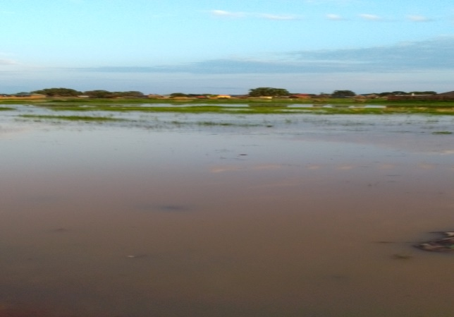
- The youths and PWD
one of the roads blocked by floods in Aweil, an outstanding challenge that affected accessibility to some locations within the state
Challenges faced during the group formation
- Resistance from some of the members to join the group, due to fear and luck of trust in associating with others
- Distances and difficulties in accessing some locations in terms of costs and floods during the implementation of planned activities.
- Poor time management; some beneficiaries take their own time to come for the session while at the session, some beneficiaries do not understand Arabic that could require translation into local languages such as Denga, Luo and Balanda.

Activity 1.2 Organize monthly community-based and intergenerational dialogues sessions for each target audience at county level on transitional justice broadly and the truth, reconciliation and healing process targeting Women, youth and IDPs/returnees and their leaders to enable them receive information and have the full understanding of transitional justice mechanisms and how to participate in the CTRH process.
The monthly community-based and intergenerational dialogue was among the outstanding activities that created great impact within the communities. The objective of the sessions was to enhance the effective understanding of the community about the chapter V of the R-ARCSS on transitional justice and how this mechanism can be adopted as a means of healing and reconciliation from past violence and abuses experienced in the community. Understanding that the Transitional justice mechanism paves ways of establishing the truth about what happened and why, acknowledges victims’ suffering, holds perpetrators accountable, compensates for past wrongs, prevents future abuses and promotes social healing,
the benefit of peaceful coexistence within the communities and the roles of every person in bringing peace and stability in the country.

During the sessions, participants were encouraged by the messages from the discussion and this prompted interactive as they shared contributing factors to lack of peace and reconciliation in their respective communities some of which were; land grabbing, cattle raiding and criminal acts such as rape (GBV) cases, theft and murder cases, Revenge attacks among others.
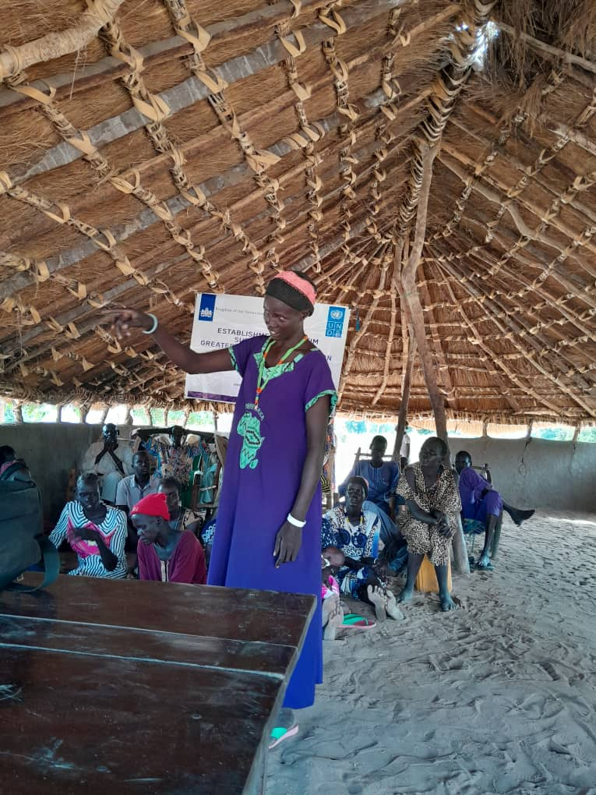
In Rumbek, Achol said she was grateful for the fact that the government have sought for peace and accepted through a binding document of country to compensate victims for their losses, she has also been empowered to speak up and she cannot wait for the final endorsement of the Commission for TRUTH, Reconciliation and Healing document. She also appreciated I-WIN for bring this awareness ahead of time to the community because now they are prepared knowing so well that their rights to truth telling protected.
During a community dialogue in Pathian Aweil North County NBGS, Bol Deng Madut who is an area chief said; this community dialogue is significant since it inspires peace and foster understanding he also said that he is very happy to see that even the youths are part of the sessions, saying in Aweil, the greatest number of crime rates are committed by the youths and at the same time they have a bigger influence in creating change within the community. He urged the youth leader to take note of these concerns raised and make it a priority in instilling good morals among the youths. He said the aspect of reconciliation in this transitional period of the country is of more benefits to the young generation because they are the future leaders and flag bearers of the country. He concluded by saying South Sudan is a beautiful country that can only be enjoyed when we learn to forgive and make peace a prioty.
On a similar dialogue held in Khartoum Jedit in Kuajok Warrap State, Mary Ayen appreciated I-WIN for this ingenuity of discussion between communities as she said “as the organization brings the message of peace, let us also think deeply about the lives of the IDPs and the returnees. If we have sympathetic feelings about how they suffer, then no single one of us will ever think of picking a gun and stating war against his or her brother again. Let us start from where I-WIN has stopped and extending these messages for peace further.”

Jennifer Achol a VSG member from Kuajok Warrap State appreciated I-WIN for bringing up this initiative because it supports peace as she said. “Ever since I-WIN started this awareness in our community, our houses and the whole communities are now in peace because of the message of peace that we get, mostly from our hearts we feel happy for such a productive organization that focuses more on poor people and more especially women. We are similarly happy for being chosen as part of VSG members in this community. Our communities also need skills so it’s my humble appeals that if only the organization can support us with other economic and income generating skills such as soap making and basket weaving, we will appreciate because our women are really suffering a lot in this community, our husbands are not working and our roofs are leaking and there is no money to buy iron sheet”.
Activity 1.3 Carrying out monthly truth, reconciliation and healing awareness-raising outreaches for the most conflict affected members of society to enhance their understanding of transitional justice and act as a platform where such victims of past human rights abuses will be sensitized, prepared, and able to engage meaningfully with the Commission for Truth Reconciliation and Healing (CTRH)

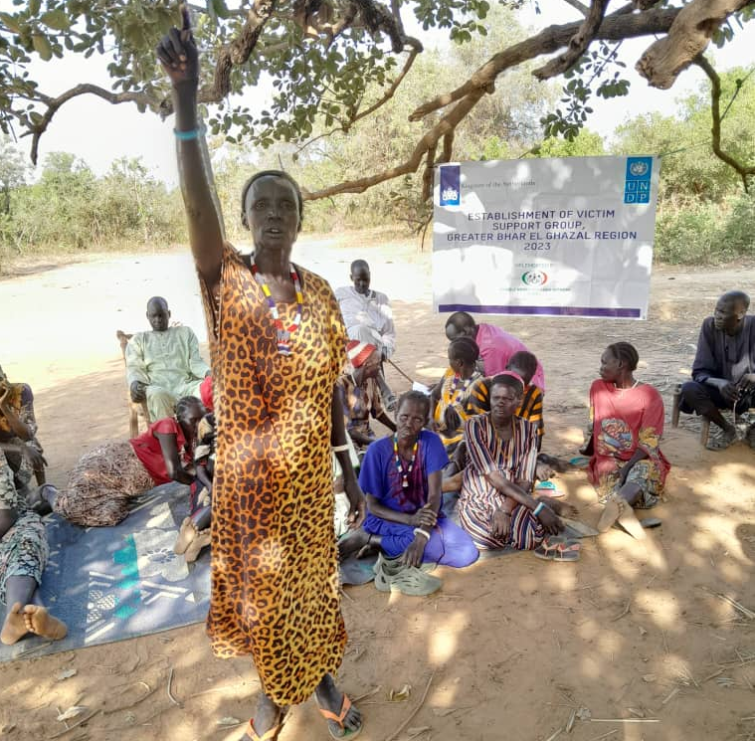
Similarly, these outreaches were intended to have an extensive awareness into the various Payams of the different states of implementation on the transitional justice mechanism, encouraging the community to confront the past occurrences by learning from the past mistakes and embracing peace, building trust and confidence in one another and restoring back each other’s dignity, building a participatory approach to democracy by accepting the concepts of the chapter V of the South Sudan Revitalized Peace Agreement, strengthening the courage among the communities to speak out on past human rights violation as a means of seeking justice.
Awareness was also created on the process of establishment of the Hybrid Court which grants security for victims and protects their rights on truth telling.
Emphasis was made on basis that peace is a collective responsibility that all South Sudanese play a role in achieving, traditional and religious leaders can support healing and reconciliation, Transitional justice can repair and restore communal relationships, forgive not to change the past but to change the future.
empowering women and girls to be involved in all peace processes, Traditional and Religious leaders can support healing and reconciliation, Transitional justice can repair and restore communal relationships, future and GBV awareness.
The outreaches awareness was for the most conflict affected members of societies to boost their understanding of transitional justice and act as a platform where victims can be informed ant to have everlasting peace in the communities.

Activity 1.4 Biweekly VSG survivors’ and victims of SGBV meetings to provide counseling and other mental health and psychosocial support alongside information on where victims of SGBV can get Clinical Rape Management (CRM) services.
I-WIN successfully conducted (48) sessions with the VSG members during the project implementation period.
The biweekly VSG survivors’ meetings mainly were aimed at;
- Raising awareness and orientation on Transitional Justice components as detailed in the chapter V of the R-ARCSS, its importance especially to the VSG members and how it functions.
- Providing trainings for the VSG members on their roles and participation as peace agents in their respective locations. The purpose of this is to Form and operationalize sustainable VSGs that can comfort and deliver free confidential support to the most vulnerable members of societies affected by all past human rights abuses even after the end of project and offering mental health & psychosocial support to the affected vulnerable groups.
Key results/achievements during the sessions
- Through the sessions a number of beneficiaries were in position to gain free psychosocial support and counseling.
- The VSG leaders have also played a vital role in extending these psychosocial supports to communities that were not part of the Victim Support Group.
- The session has also inspired members to accept reconciliation among themselves and adopt peaceful means of resolving issues. VSG members have also been seen acting as mediators for peace within the community upon being inspired from these sessions.
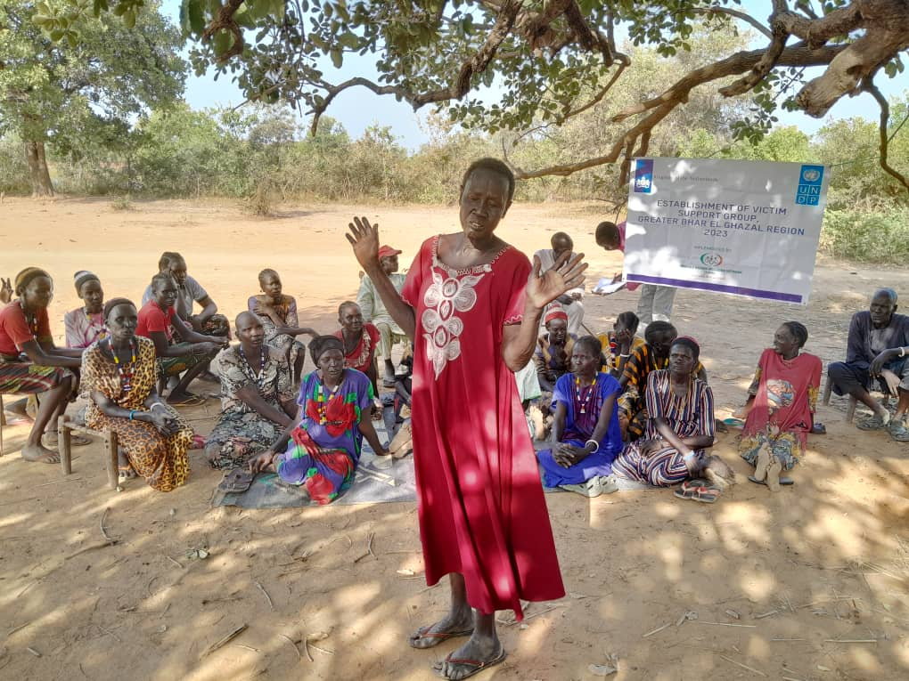
In one of the sessions at Hai Kosti in Wau Christine a VSG leader had this to say “Ever since I started attending to these sessions, I don’t like to hear any form of quarrel in my neighborhood because I will immediately intervene. As a matter of fact, I have need nicknamed “mama peace’ because I always reecho these messages each time, I encounter misunderstanding in my neighborhood. I am also glad that I have been chosen as a group leader because it is upon these power that I have been able to visit different homes and talk to them about peace and reconciliation, provide counseling to women like me and encourage them that time will come when there will be no more injustices because the government will put in place laws that offers
justice to all”

Activity 1.5 Monthly drama sessions with community members to raise awareness on truth telling, reconciliation and healing process.
These drama sessions conducted by the members of the victim support group. It was a way of displaying the lessons learnt from the VSG sessions and acting it in a more practical way for a bigger audience of the community.
The drama sessions were aimed at increasing the coverage and simplifying the understanding of the concepts of the transitional justice on truth, healing and reconciliation in the community.
It is also intended to create a visual impact of the message to the audience
For example, the drama session in Wau was acted to sensitize women on their rights even if their left as widows, to seek for justice from the right authorities and to understand that the government has a right to protect the rights of its citizens.
Similarly, to the drama session in Aweil, discouraging the cultural norms on forced marriage and guaranteeing every young girl access to education irrespective of whether they are married or not. It also explains that child marriage and forceful marriage impose on young girls is punishable by law and must be prohibited
Key messages of the drama sessions

- Equality is for all irrespective of gender, status or age.
- It is the role of the government to grant its citizens total security.
- Every person got the right to own property, freedom of movements and speech
- Restrain from revenge killings and avoid taking laws into individual hands.
- Revenge killing gives no room for reconciliation, peace and acceptance which is against the chapter five of the revitalized peace agreement
- Use right channels of resolving disputes

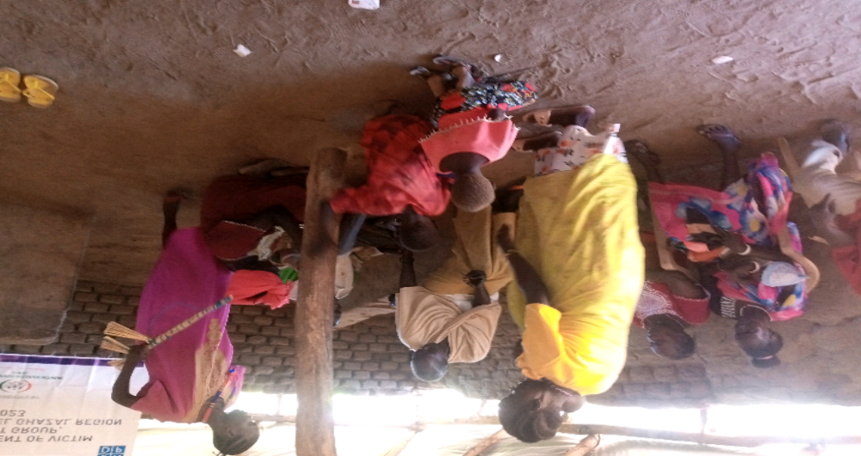
A drama session on rights and roles of women and children in fostering peace in the community, acted in Wau by VSG groups

Activity 1.6 Monthly radio talk shows with messages on truth telling, reconciliation and healing
The radio talk show was to adapt truth telling, reconciliation and healing and community-based dialogues for community leaders and Elders to encourage and support victims to come forward to stake their stories as means of giving voice to full scope and breathe of the atrocity. The radio talk was over the weekend because most people are at home listening to radios,
It was intended to reach those that missed out on the messages from the outreach sessions in the communities. The following were the key messages discussed over the radio;
- Peace is a collective responsibility that all South Sudanese play a key role in achieving
- For communities to reconcile, everyone must have a voice and all communities and individuals must participate in reconciliation
- Transitional justice has the power to contribute to just societies and peaceful coexistence
- Traditional and Religious leaders can support healing and reconciliation
- Transitional justice can repair and restore communal relationships
- Forgive not to change the past but to change the future
- Forgive to free yourself from anger and feeling of revenge
- Forgive to find peace
- To be strong is to forgive
- Anger brings violence, forgiveness brings peace
- To heal, you must forgive so that there must be no more victims.

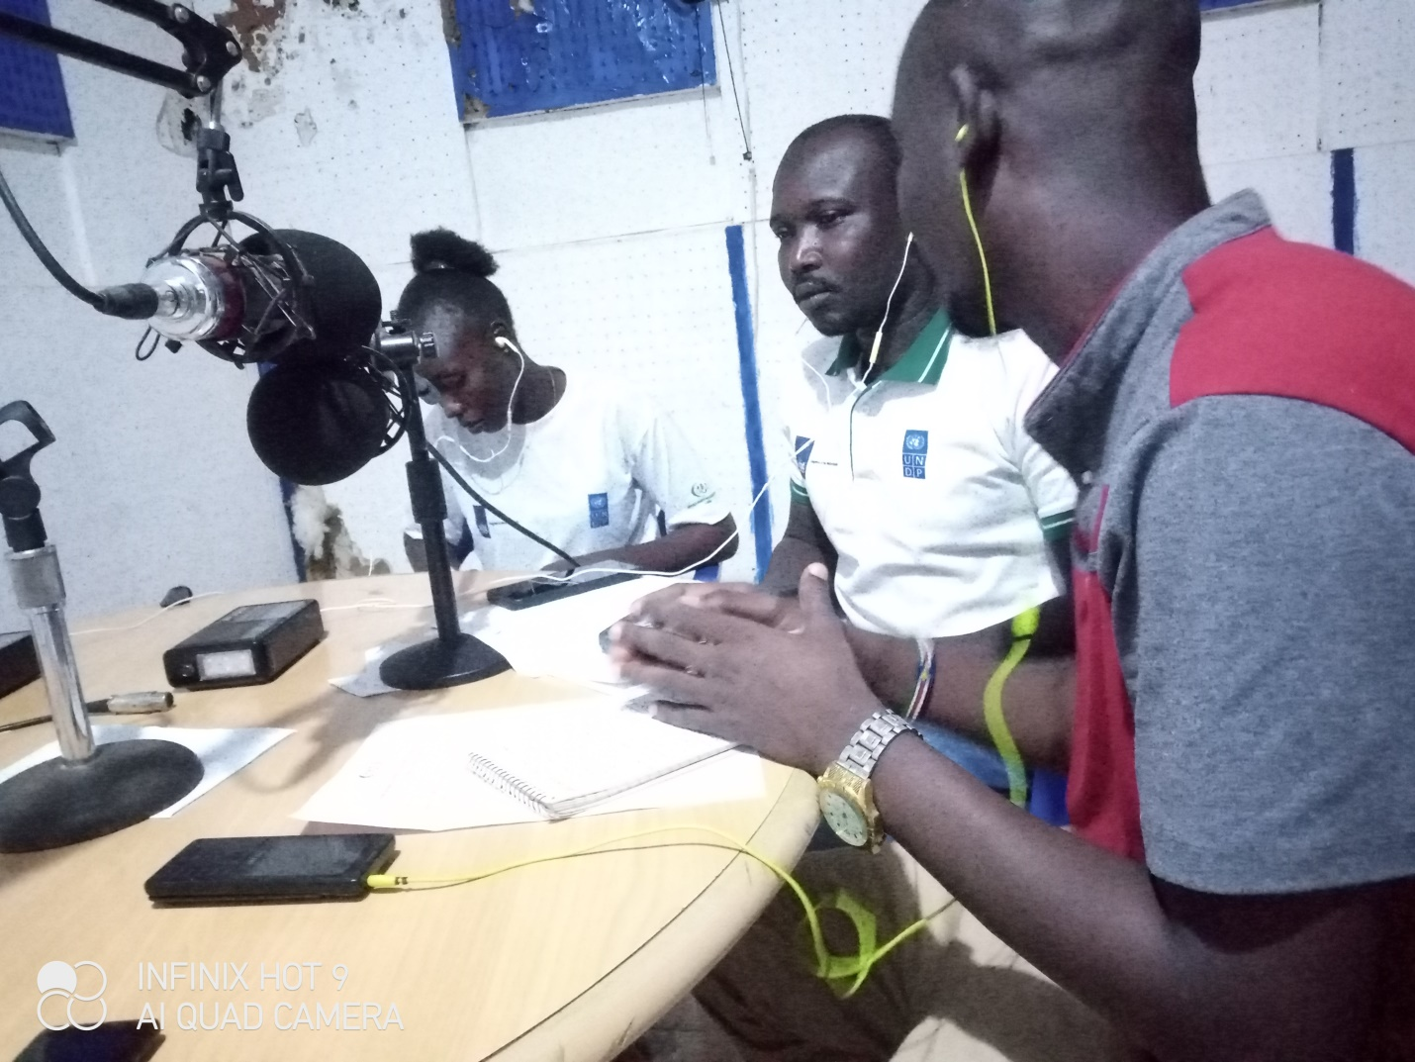
Talking Point: Transitional Justice on Truth Telling, Reconciliation and Healing and Crime Prevention as means of promoting a peaceful coexistence
Key results/achievements from the radio talk show include:
Challenges (Please state key challenges for the reporting month and the mitigation measure applied or planned to handle the challenges)

 | Challenges of the month | Mitigation measures applied/proposed
 | Mobility, rain and flood | The staffs in the field were flexible to the state of affairs; they could adjust according to the circumstances on the ground with the help of the community leaders.
 | High expectation from participants. The interest of the audiences met especially during the outreaches were more of getting financial aid | I-WIN has always involved the community leaders and local authorities on ground in the various sessions who played a great role in letting the community understand that these sessions were more of awareness raising and information sharing and not economic empowerment based.  These explanations from the authorities made it possible for I-WIN to successfully conduct the activities though request for financial support still surfaced during participants interaction sessions.
 | Short project duration yet communities have vigorously picked interest in benefiting from the awareness sessions | Right from the inception, I-WIN team has made known to the community the duration of the project and be part of the awareness raising team even in the absence of I-WIN after the project has ended.
 | Communal conflicts in some areas | Within the implementation period, some areas were in accessible due to emerging conflicts for example in the month of November, activities were interrupted in Rumbek and Tong North in Warrap.  In such instances, I-WIN team has always kept an ear on ground to monitor security of such places to avoid being victims of such occurrences.

- Cross-cutting Issues: Please describe briefly any cross-cutting consideration as may be applicable to the project including but not limited to Gender, Disability, Environment, Partnership etc. (1500 characters). Note: Please undertake brief analysis on the cross-cutting that are applicable to your location/project.

In a constitution-making process project, several cross-cutting issues need to be considered to ensure an inclusive and comprehensive approach. These cross-cutting issues are overarching themes that are intertwined with various aspects of the constitution-making process. Here are some key cross-cutting issues to consider:
1. Gender Equality and Women's Rights: One of the key role transitional justice plays is to respond to gender-based violations during conflicts and authoritarian rule is therefore very essential for ensuring justice for victims, combating women’s marginalization, and preventing future violations against women and other groups targeted for their gender.
2. Inclusivity and Diversity: Transitional justice can be measured a success where components of inclusivity and diversity are merged. Inclusion, diversity, victim-centeredness, broad consultations, community voices and participatory engagement have become key phrases that characterize the normative frameworks that guide policy developments.
3. Human Rights and Civil Liberties: Transitional Justice is rooted in Human Rights law. States have an obligation to provide victims of human rights violation with an effective remedy; satisfying their rights to truth, justice, and reparation. For the obligation to be met, and for transitional Justice to be able to effectively contribute to sustainable peace and reconciliation.
4. Socio-Economic Rights: A transitional approach must also look at addressing socio-economic rights because it forms the core of the conflicts the country is set to transform. Therefore, presenting socioeconomic root causes of conflict as historical context leaves policy change to the discretion of political leaders, while presenting them as rights violations makes redress and reform a political imperative.
5. Environmental Sustainability: Environmental considerations and sustainable development should be integrated into a transitioning society, recognizing the importance of protecting natural resources, promoting environmental conservation, and addressing climate change.
6. Rule of Law and Good Governance: It is important to establish a framework for the rule of law, transparency, accountability, and effective governance. This includes mechanisms for checks and balances, an independent judiciary, and effective anti-corruption measures.
7. Youth Engagement and Intergenerational Equity: Youth are frequently among the primary foot-soldiers in conflict, the victims of violence and the instigators of efforts to advance justice and transformative structural change whether as former child soldiers, recruits into armed groups, target of security force abuses or through voluntary participations in the protest. The youths play a key role in transforming a society through the meaningful participation, creativity and agency of men and women in enhancing and potentially improving transitional justice processes, practices and outcomes.
8. Constitution Making process. The 2018 Revitalized Agreement on the Resolution of the Conflict in South Sudan (ARCSS), which replaced the prior August 2015 Agreement, marked the culmination of efforts by the regional intergovernmental Authority on Development (IGAD) to bring to end the conflict that erupted in December 2013 in South Sudan. The Agreement provides that several activities be conducted during the Transitional period including; the establishment of the Revitalized Transitional Government of National Unity (RTGoNU), the implementation of transitional security and humanitarian assistance arrangements, institutional reform, transitional justice arrangements and the commencement of the permanent Constitution-making process.

Did you collect any media and/or publications about the project this month?
(Media includes newspaper articles, radio advertisements and presentations, advertisements, brochures/pamphlets, promotional material, photos)
Type of media | Key messages/description of photo | Online link or publication details
Banners and T-shirts | Establishment of Victim Support Group, Greater Bhar El Ghazal Region | N/A
Radio Talk Shows | Awareness on truth, reconciliation and healing and crime prevention | N/A

- Summary of total beneficiaries
Number of Beneficiaries / Participants per location
Major activities | State | County | Adult Male | Adult Female | Boys | Girls | Total
Activity 1.1 Establishment of 30 VSG for vulnerable groups including women, girls, SGBV survivors, elderly, IDPs and returnees to help and provide | Western Bahr El Ghazal, Northern Bahr el Ghazal, Warrap, and Lake | Wau, Kuajok, Rumbek and Aweil | 300 | 410 | 90 | 100 | 900
Activity 1.2 Organize monthly community-based and intergenerational dialogues sessions for each target audience at county level on transitional justice broadly and the truth, reconciliation and healing process targeting Women, youth and IDPs/returnees and their leaders to enable them receive information and have the full understanding of transitional justice mechanisms and how to participate in the CTRH process. | Western Bahr El Ghazal, Northern Bahr el Ghazal, Warrap, and Lake | Wau, Kuajok, Rumbek and Aweil | 266 | 416 | 30 | 50 | 760
Activity 1.3 Carrying out monthly truth, reconciliation and healing awareness-raising outreaches for the most conflict affected members of society to enhance their understanding of transitional justice and act as a platform where such victims of past human rights abuses will be sensitized, prepared, and able to engage meaningfully with the Commission for Truth Reconciliation and Healing (CTRH) | Western Bahr El Ghazal, Northern Bahr el Ghazal, Warrap, and Lake | Wau, Kuajok, Rumbek and Aweil | 400 | 727 | 73 | 300  1500 pax (1027F, 473M) | 1500
Activity 1.4 Biweekly VSG survivors’ and victims of SGBV meetings to provide counseling and other mental health and psychosocial support alongside information on where victims of SGBV can get Clinical Rape Management (CRM) services. | Western Bahr El Ghazal, Northern Bahr el Ghazal, Warrap, and Lake | Wau, Kuajok, Rumbek and Aweil | 300 | 410 | 90 | 100 | 900
Activity 1.5 Monthly drama sessions with community members to raise awareness on truth telling, reconciliation and healing process | WBGS, NBGS, Warrap and Lakes state | Wau, Aweil, Kuajok and Rumbek | 33 | 58 | 9 | 20 | 450
Activity 1.6 Monthly radio talk shows with messages on truth telling, reconciliation and healing in  Greater Bahr el Ghazal | WBGS, NBGS, Warrap | Wau, Aweil, Kuajok | Radio KPIs (can’t segregate the gender of the listeners | Radio KPIs (can’t segregate the gender of the listeners | Radio KPIs (can’t segregate the gender of the listeners | Radio KPIs (can’t segregate the gender of the listeners | Radio KPIs (can’t segregate the gender of the listeners
- Success/Impact Story (1500 characters): Note: in a few sentences, explain whether the project has had a positive human impact. It may include direct quotes where possible or link to strategic communication pieces.

Success stories
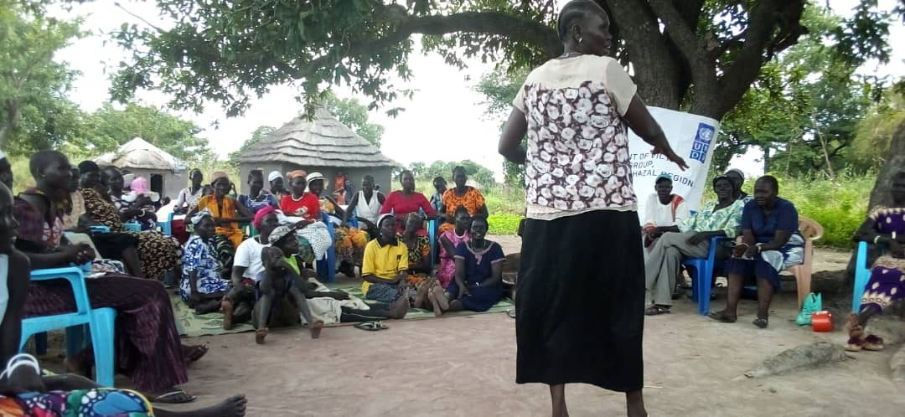
Ayuel Mading a VSG member in Malual Rumbek County area appreciates I-WIN for the establishment of VSG in the area and says “I am very happy to be here and to get all the peace messages that encourages people to live in harmony, am also happy that I have been consoled and received counseling from the organization that cares about PWDs people and women. I have been holding a grudge against my brother’s wife for over two years now but from the sessions I learnt to forgive. I felt guilty holding her hostage in my heart yet am a beneficiary of these peacebuilding sessions that talks about reconciliation. For the first time in two years, I walked to her compound to ask for forgiveness even when I have been wanting her to beg me instead. Now we are friends and planning on celebrating the festive season together. I am grateful to I-WIN for making me see the benefits of reconciliation because now I feel my heart is at peace.”
Similarly during an outreach in Gogrial East ( Warrap State) Adau Amer expressed her gratitude to the organization saying. “When we were first invited for this session, I thought it was something to do with giving us money for business because we were told I-WIN’s main focus is empowering particularly women and girls but after getting the message on Truth telling, healing, reconciliation, compensation, and reparation I felt rich at heart because we are tired of living in fear of insecurity at all times. If the Hybrid court is established together with the Commission for Truth, Reconciliation and Healing as said now, we will be at peace because we know that our perpetrators will be punished and our freedom as women will be granted. Thank you, I-WIN and UNDP, for bringing this awareness on ground, we will be readily waiting for these laws to start functioning in our community. Enough to suffering, war, and unlawful attacks on us.”

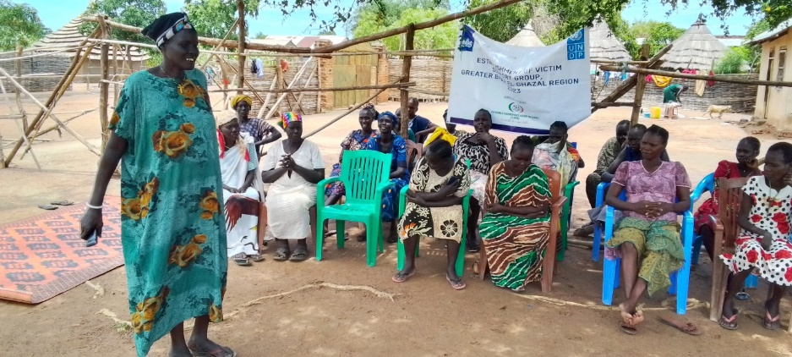
The Community dialogue session had a prolific impact, a testimony from Jur Atong Mawien, a community member in Kuajok center expresses her gratitude for I-WIN to come and tell the truth. That is what our leaders should be doing. Jur is a widow with seven children she survives on daily casual works of laundry services and cleaning environments to people for survival and to pay school fees for her children, “I have learnt a lot from this session and most significantly on how to regulate my fury as a woman, with my children, my neighbors, or even with the relatives I stay with, because fury is the root cause of evil and conflict”. Jur said.
Meanwhile on the same session, Nakigudde Jennifer a pregnant woman who is a Uganda bread seller and married to a South Sudanese said there are a lot of challenges that they face as Ugandans in this county but this session has given her courage and hope to live here because her husband comes from this community. “I now know my rights and if am faced with some issues I know where to channel them” Nakigudde said.

- Any other issues as may be applicable. (Work limit: 500 characters)

- Pictorials Note: Include photos with captions. May consider to sending any high-quality photos of videos via email

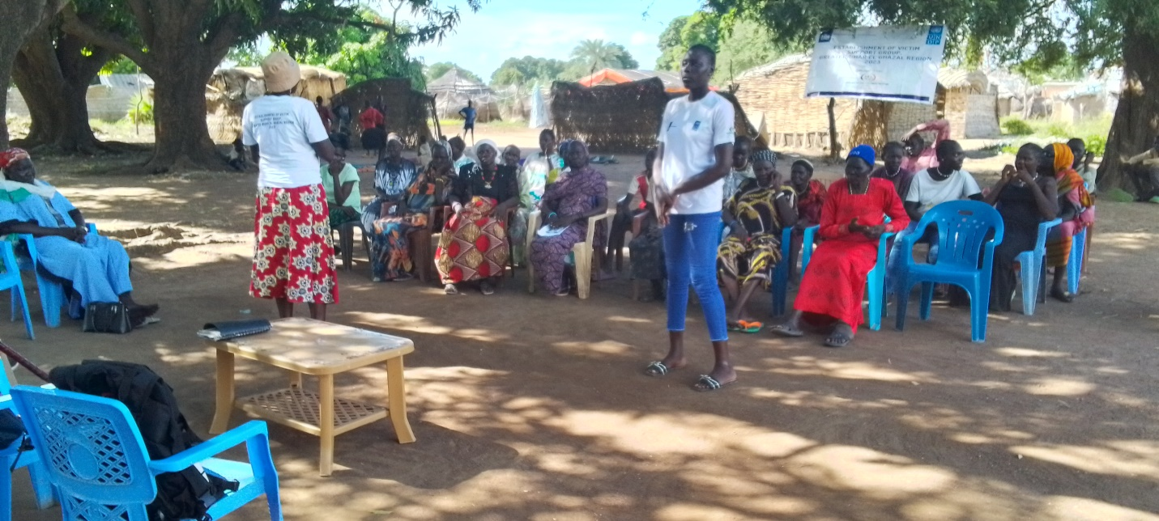
Figure 1 Community leadergiving speech during dialogue session on Truth, Reconciliation and Healing in Hai Jezira- Wau County South
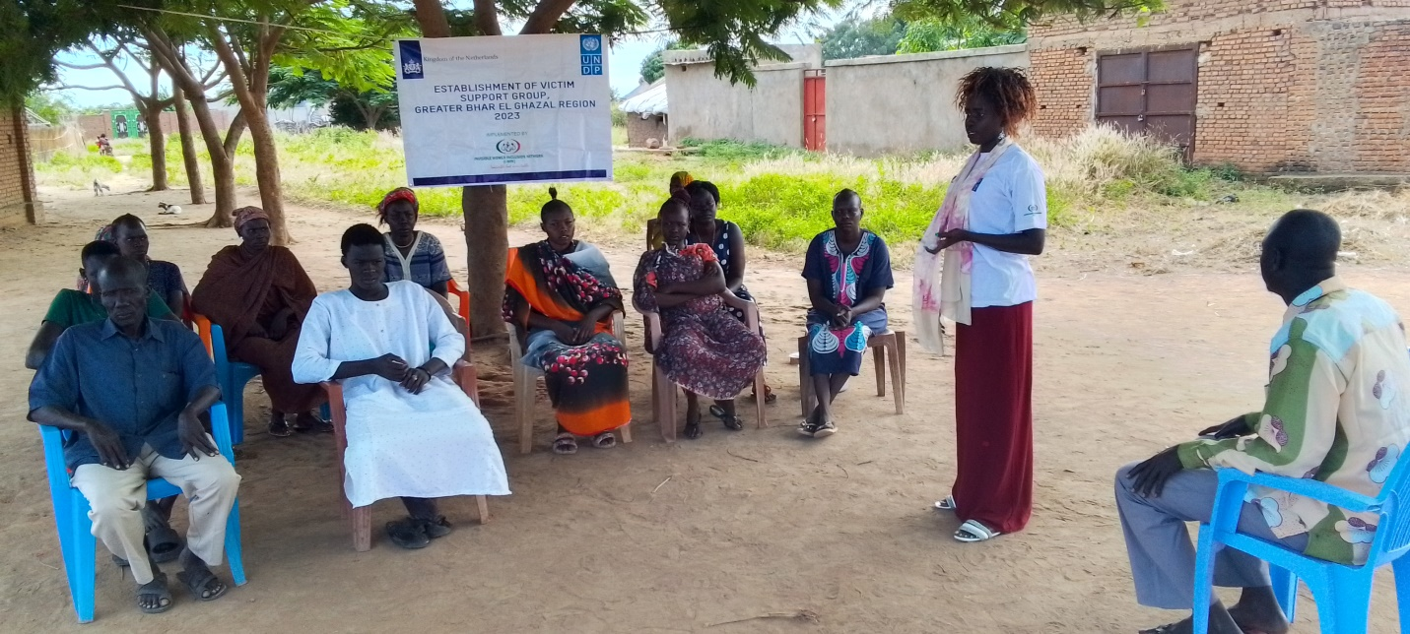 VSG leader giving words of encouragement during outreach session in Aweil.
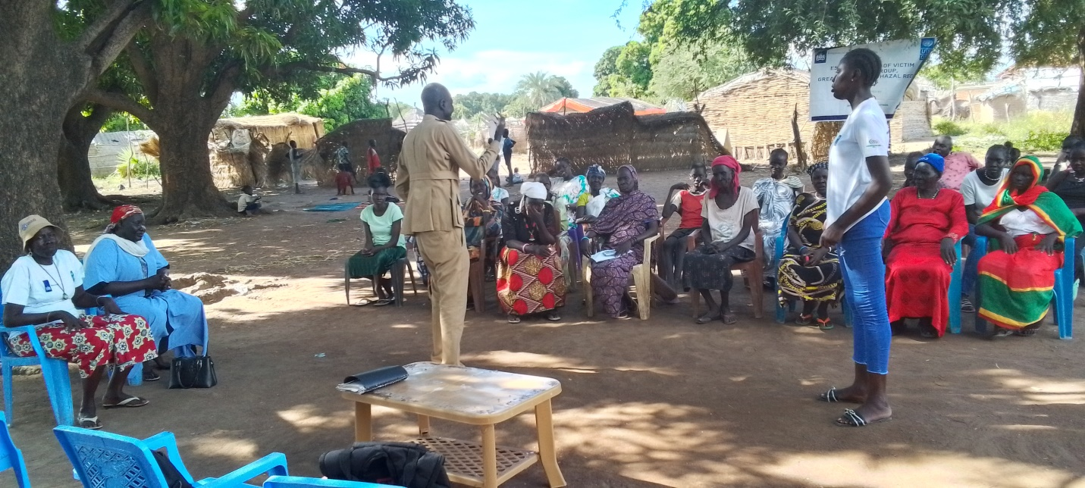
Paramount Chief giving speech during Community dialogue in Ayuong Aweil, he thanks i-WIN for the good program and encourage the the staff to continue with the same program in all of Ayoug Areas

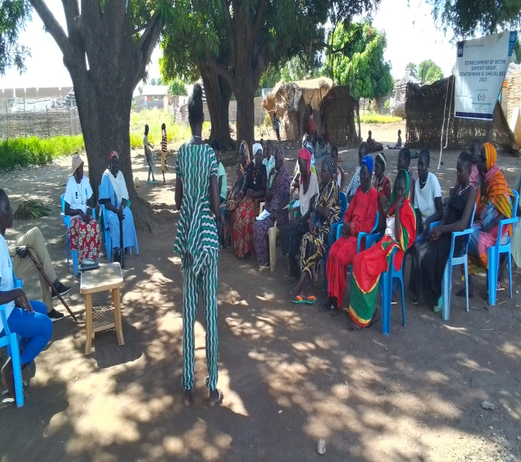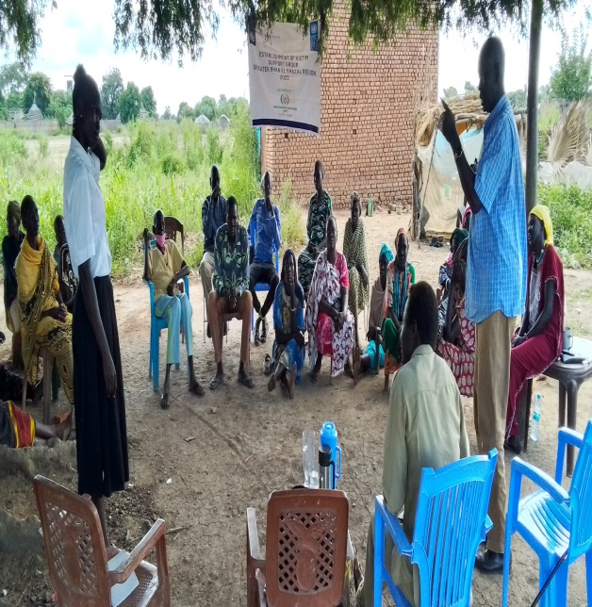I-WIN staff during the VSG Kuajok
Area Chief in Naivasha expressing his gratitude towards I-WIN and UNDP for having this project implemented in the county saying, “The ultimate goal of the people of Mathiang and Aweil is peace but with program of Justice, it should not end here, it has to be extended to all the counties of NBGS and its payams and Bomas. I thank you I-WIN and UNDP for this project initiative and our expectation is to have stability in this country please, extend it deeper to the communities for everyone to knowl about the transitional justice.

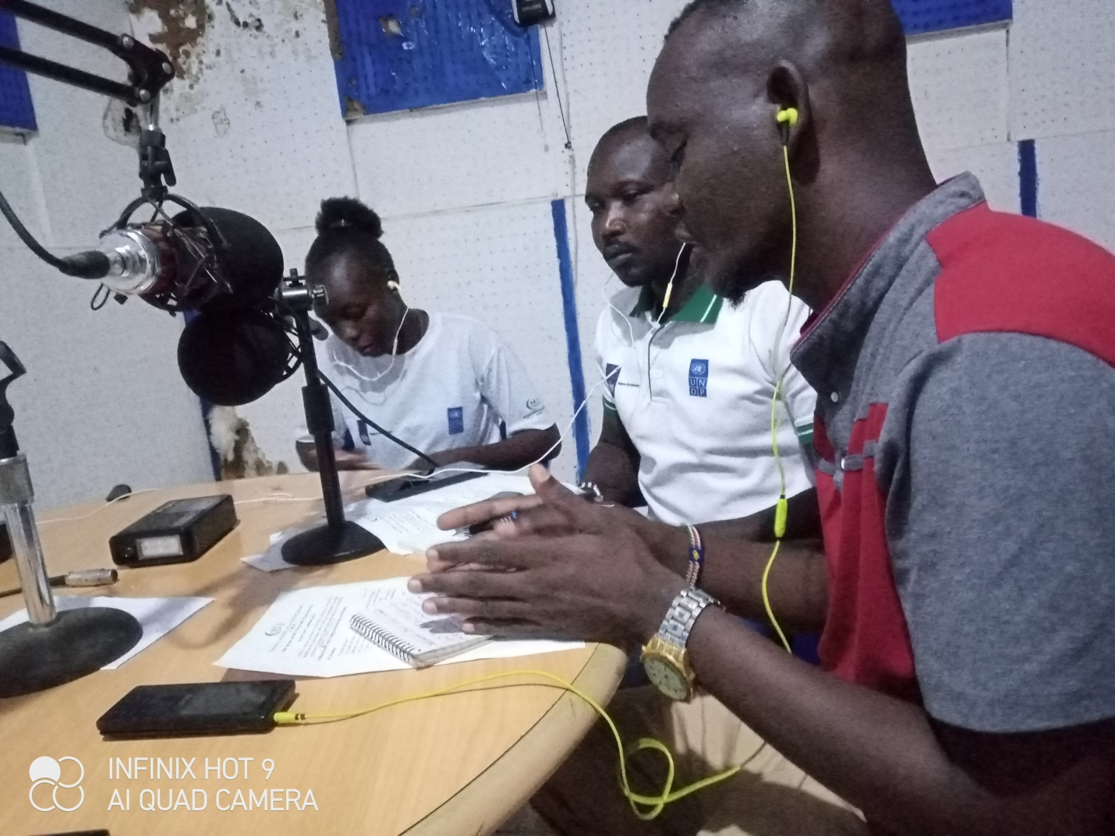

Figure 6 I-WIN Regional Coordinator and other members during a radio talk show on a local Radio 96.5 FM into adapt truth telling, reconciliation and healing and community-based dialogues for community leaders and Elders to encourage and support the victims

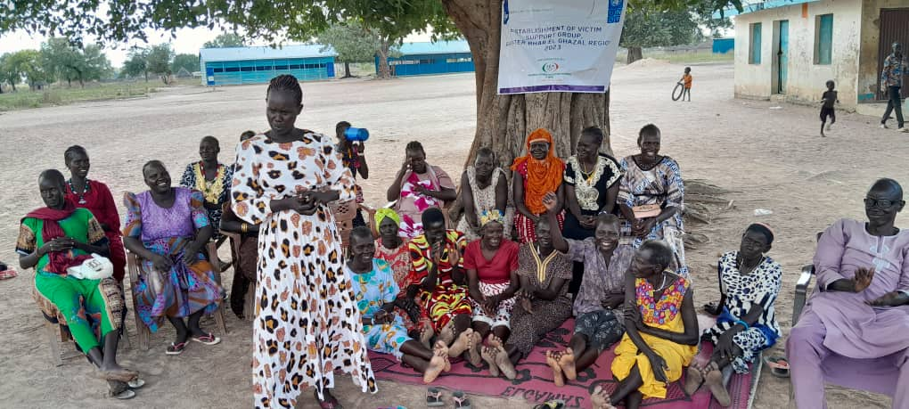
Women actively participating during a VSG session in Wau
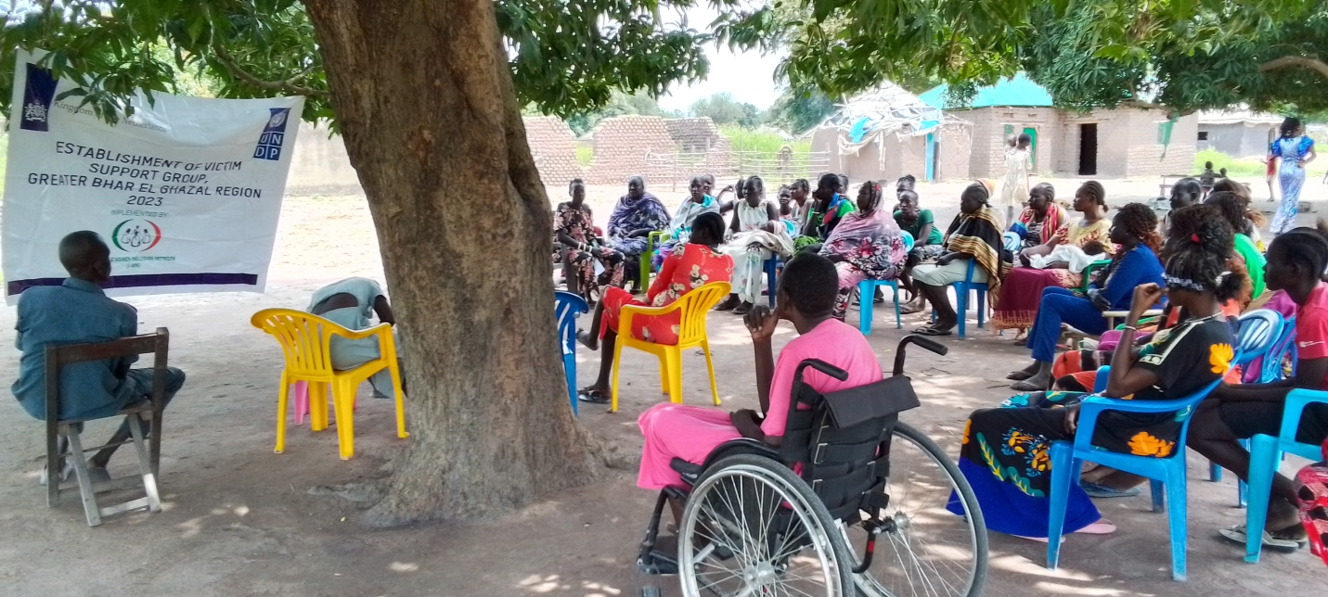
participants during an intergenerational dialogue session in Aweil

The summary of the progress to on Indicators is derived from the Performance Indicator Tracking Tool (PITT) attached to this template. Tracking for the indicators (through the PITT) is done monthly and consolidated quarterly.

