Project Title: implementing a justice and confidence center in Warrap State

 | Overview: Your details (Most of the information is available in the PRODOC)

Name of CSO | INVISIBLE WOMEN INCLUSION NETWORK (I-WIN)
Location of implementation | WARRAP STATE, KUAJOK
Grant duration (beginning – ending) | 01 January 2024-31ST Dec 2024
Reporting dates: month/year | 1ST – 30th SEPTEMBER 2024
Name of reporting officer | ANGELO MAYAR WOL
  Reporting to
  IMMACULATE ACHIRO
Email contact | info@i-win-ssd.org, wol.iwin2023@gmail.com
Telephone number | +211 925914488/ +211 922 329 911

- Context/Background (Word Limit: 1500 characters)
South Sudan attained its independence in 2011; before the independence, South Sudan promulgated Transitional Constitution of Republic of South Sudan 2011 as will of people which sets standards and rules how they can be governed under the principle of rule of law.
Part II of the Transitional Constitution of South Sudan, 2011 (as amended) provides for the Bill of Rights starting from Article 9-34. The fundamental rights are enshrined in the constitution and among the Article provided in the Constitution are: Equality before law, right to litigation and fair hearing. These provision revolves around the notion of access to justice. Despite of the fundamental rights enshrined in the Constitution, Access to Justice still remains a hard rock because of lack of proper legal policy framework in order to administer justice to every persons regardless of their sex, gender, ethnic origin, religious and political affiliation, race, color and social status. https://ssrn.com/abstract=4437931
Access to Justice challenges in Warrap state
During an inception/ consultative meeting with the community members, traditional leaders and authorities, a number of obstacles/ challenges to Access to justice in Warrap State were shared. These challenges include:
Legal Empowerment and Awareness:
There is a lack of legal awareness and empowerment among the population, particularly vulnerable groups. Many individuals are unaware of their rights, legal processes and proceedings, and available avenues for seeking justice. This knowledge gap hampers their ability to address legal issues effectively.
Limited Legal Aid Services:
The availability and accessibility of legal aid services are limited in Warrap State. Vulnerable groups often lack financial resources to access legal representation, impeding their ability to navigate the justice system and seek redress for the violations committed against themselves and their rights. As a result, many cases go unaddressed, perpetuating impunity and a sense of powerlessness. This has resulted in lack of confidence and trust in the legal system which they see as an alien system to them.
Psychosocial Support and Counseling:
The psychosocial needs of vulnerable groups, especially survivors of SGBV and returnees, are often overlooked. The lack of specialized support and counseling services leaves survivors without proper healing and reintegration mechanisms, hindering their recovery and impeding their access to justice.
Establishing a justice and confidence center in Warrap State, South Sudan is a significant project aimed at promoting the rule of law, ensuring access to justice, and restoring confidence in the judicial system within the region. This center would serve as a central hub for legal services, dispute resolution, and community engagement, addressing the pressing issues faced by the local population.
Objectives and Importance:
The primary objectives of the justice and confidence center include:
- Enhancing access to justice: The center would provide legal assistance, advice, and representation to individuals who lack resources or knowledge to navigate the legal system effectively.
- Resolving disputes: By offering alternative dispute resolution mechanisms, such as mediation and arbitration, the center can help resolve conflicts in a timely and fair manner, reducing the burden on the formal justice system.
- Building public trust: By providing transparent and impartial services, the center would work towards restoring public confidence in the justice system, which has been affected by years of conflict and instability.
- Creating awareness on legal proceedings and private rights of the beneficiaries: by offering trainings on human rights, women rights and the child rights, the general public would be enhanced with sufficient knowledge on legal issues, rights and legal procedures before the courts of law.
Services Offered:
The justice and confidence center offered a range of services to meet the diverse needs of the community. These services include:
- Legal advice and assistance: Trained legal professionals provided guidance on legal rights, obligations, and procedures to individuals seeking assistance.
- Court facilitation: The center assisted individuals in preparing and filing legal documents, navigating court processes, and representing themselves in court if necessary.
- Mediation and arbitration: Trained mediators facilitated negotiations between parties involved in disputes, aiming to reach mutually acceptable agreements outside of court.
- Legal awareness and education: The center conducted outreach programs, workshops, and training sessions to educate the community about their legal rights and responsibilities.
- Victim support services: Specialized support e provided to victims of GBV/SGBV, included counseling, referrals to other support agencies, and assistance in accessing justice.
Rationale for Establishing a JCC:
Recognizing the urgent need to address these challenges, the United Nations Development Programme (UNDP) in partnership with Invisible Women Inclusion Network (I-WIN) works towards establishing a Justice and Confidence Centre (JCC) in Warrap State. The JCC aims to provide a comprehensive range of services to vulnerable groups, promoting access to justice, psychosocial support, and legal empowerment.

Progress (summary) on Indicators for the month

Indicator: (Pick these indictors from the assigned project Log frame) | Baseline (disaggregate by gender, disability, age, location, type…as appropriate. | This month’s Target (disaggregate by gender, disability, age, location, type…as appropriate) | This month’s actual (disaggregate by gender, disability, age, location, type…as appropriate. | Comment/Remarks (Comment can be on qualitative, quantitative, or complex indicators. In case of under/over achievement, please provide a brief explanation
Conducted a launch and Project brief with stakeholders on Justice Confidence Centre in Warrap | 0 | 50Pax (15M, 35F) | 50Pax (15M, 35F) | On 19th April 2024, the project inauguration was steered to brief stakeholders, community leaders and chiefs, women leaders, youth leaders and targeted beneficiaries on the intended outputs of the project in Warrap state
Pro-bono legal aid services to 50 SGBV survivors’ elderly, women, and girls and other minority groups and ensure the cases are completed. | 0 | 50 Pax (18F, 32M) | 50 Pax (18F, 32M) | From the consciousness raising through radio talk-shows, outreaches and other gatherings, the services rendered between May 30th to Aug 25th 2024, I-WIN became known and within the project historical, 50 victims were in position to obtain more pro bono legal aid services and represented.
Legal advice/mental health/referral services at the JCC in Warrap | 0 | 316Pax (152F, 164M) | 316Pax (152F, 164M) | During the project interval, from 3rd May to 20th Aug, Legal advice and counseling including referrals were provided to over 300 victims and GBV/SGBV from the JCC points and other major towns within Warrap State. These have empowered several victims to speak out and seek aid and counseling from I-WIN team as well as understanding the numerous referral pathways in case of any form of abuse experienced.
Training of 50 SGBV survivors on victim redress mechanisms, including on courts, transitional justice and reparations | 0 | 50PAX (26F, 24M) | 50 PAX (26F, 24M) | On 25th June 2024, a total of 50 SGBV survivors were skilled on victim redress mechanisms, including on courts, transitional justice and reparations. The training touched the Bill of Rights, Women Rights, property Rights and other international conventions such as UDHR and CEDAW respectively to empower them with skills and ability to train more of the communities that are not able to access this kind of service directly from I-WIN
Training of 30 members of Warrap High court (Judges, public prosecutors, court clerks, traditional court members) and members of the police force on victim redress mechanisms, and traditional chiefs including on courts, transitional justice and reparations. | 0 | 30 PAX (10F, 20M) | 30 PAX (10F, 20M) | On 18 July 2024, 30 members of Warrap High Court mainly Judges, Public prosecutors, Court Clerks and traditional court members, women leaders were skilled on victim redress mechanisms, and traditional chiefs including on courts, transitional justice and reparations processes.
Monthly Legal awareness on GBV, property rights, legal rights, available services at the JCC and human rights Warrap outreach campaigns. | 0 | 190 PAX (112F, 78M) | 190 PAX (112F, 78M) | Throughout the month of May to Aug. 190 people were reached out to during the outreach sessions implementation and over 2.5million people were targeted through the radio talk-shows which is an estimated figure of people that directly listen to Kuajok FM and other radio station such as the Don Bosco Catholic radio.
Conduct Bi-weekly visitation to the police and prison and detention centers to identify | 0 | 147 PAX (60F, 87M) | 147 PAX (60F, 87M) | From 29th April to 22nd Aug 2024, Regular visits were conducted to the numerous prisons and detention hubs and cases identified by I-WIN for a close follow-ups and legal consideration were visited to offer awareness services on the legal procedures and transitional justice apart from the services rendered through legal aid and pro bono services
Bi weekly meetings survivors’ and victims of SGBV to provide counseling and other mental health and psychosocial support at the JCC center alongside information on where victims of SGBV can get Clinical Rape Management (CRM) services | 0 | 330 PAX (183F, 147M) | 300 PAX (183F, 147M) | Eight counseling sessions were conducted from the month of Amay to August with the whole for the project period covering a total of 147 males and 183 female in various places including at I-WIN JCC point.  The biweekly meeting measured the issues pertaining to sexual gender-based violence which include among other things, the sexual abuses, rapes, forceful and early child marriage including marital rape.  Other things include legal advice and consultations, legal representation by pro bono lawyer, psychosocial support and referral services available at JCC.  Besides these, the audiences were educated on reporting mechanism of sexual related cases, and how to advocate and prevent the sexual gender-based violence.  The victims were highlighted on protective measures such as: outdoor together with people when on a long-distance journey, screaming lauding for help when attacked, and reporting the act to the legal authorities and medical authorities for early medical intervention to remedy the STDs in time.  .
Three drama sessions with community members to raise awareness on GBV, property rights, legal rights, available services at the JCC | 0 | 45 pax (25F, 20M) | 45 pax (25F, 20M) | Three drama sessions were conducted in May, July and August within the project implementation period with each comprising of 15 participants. Topics acted upon were legal advice in cases of rape especially to women and girls  Disadvantages of taking laws into individual hands.  Rights of a girl child to attend school and role of parents in child upbringing as an element to reducing criminal acts in the community. Right to own property, land grabbing and equal participation in the communities by everyone regardless of their status.
Monthly radio talk shows with messages on availability of Legal aid services including legal representation, legal awareness and legal advice, and psychosocial support to vulnerable groups including women, girls, SGBV survivors, elderly and returnees in Warrap. | 0 | Radio KPIs (can’t segregate the gender of the listeners | Radio KPIs (can’t segregate the gender of the listeners | Bi-weekly radio talk show were successfully conducted in Warrap State, Kuajok from April to August 2024 on Kuajok FM and Don Bosco Catholic radio. The target audience were reached given that over 2.5million people listen to this radio.  The increased number of people seeking legal advice from JCC and a number of testified they heard about these services through the radio talk shows conducted

- Key results/Achievement observed from your intervention (Please report on key achievements for the reporting month: Note: Have a Serious reflection on where the project should be at this point of reporting, at least reporting on one achievement under each activity implement that month. Should be Evidence-based identification of the overarching results achieved = Bring data to back up your assessment on the results achieved. Be clear about WHO the project reached, WHERE HOW MANY people were involved, WHAT the project has cleared delivered and, most importantly: The RESULTS of such deliveries, which leads to the SO WHAT question e.g., for a training a training activity “The project trained the youth and capacitated the local authorities…SO WHAT? What has happened with all these trainings? What is the main purpose of all of this, the bigger level change?
Activity1: Conducted a launch and Project brief with stakeholders on Justice Confidence Centre in Warrap
In the month of April 19th 2024 at Atana Hotel – Kuajok – Warrap State, the project inauguration was steered to brief stakeholders, officials from the State Ministry of Gender, Child and Social Welfare, representatives of RRC, The State Director of Legal Administration, UNMISS Rule of Law and Human Rights representatives community leaders and chiefs, women leaders, youth leaders and targeted beneficiaries on the intended output of the project.
Activity’s Goal
To enlighten the stakeholders on the availability of the Access to Justice Project funded by UNDP and implemented by Invisible Women Inclusion Network (I-WIN), it was crucially important to call for a consultation meeting with the vulnerable groups including women, girls, SGBV survivors, elderly, traditional chiefs’ court members, judges, public prosecutors, court clerks, religious leaders, Human Rights Commissioner, representatives from the state ministry of education and instruction, state ministry of gender, child and social welfare, state ministry of youth, culture and sports, women union among other invitees for the following objectives:-
The Objectives
1. The objective of this consultation meeting was to highlight the stakeholders and beneficiaries about the extension of the access to justice project funded by UNDP.
2. The participants to deliberate on the mechanisms of implementation as well as discussing the challenges and gaps that need to be addressed by this project.
3. Carrying out awareness on victim’s redress mechanisms, including on courts, transitional justice, and reparations.
4. Trained them on human rights, an attempt to persuade them to improve the conditions of inmates or those in detention centers awaiting trial.
5. Raising of awareness on Sexual Gender Based Violence, land and property right.
The outcome of the inception:
Initially, the opening remarks were made by the government official representing the state legal administration after prayers were observed. It was followed by individual introduction and the introduction of the consultation summit as per the program. The (I-WIN) Organization was introduced as well as the mechanism of the project implementation, the importance of access to justice in the free society, the re-establishment of justice confidence Centre, the available legal services that are offered at justice confidence Centre, and the expectations of the stakeholders in addition to the challenges that will be faced during the course of the project implementation and how to tackle such challenges at the organizational level and the stakeholders’ level. Besides this, the roles of the stakeholders in making the process of project implementation easy were collectively considered. The objectives of the Project were explored, the geographical locations and area of focus were unveiled by I-WIN’s officer, how long the project shall be running, who I-WIN works with and all other work I-WIN is doing in the other states were properly highlighted.
Clearly, the participants were made aware that the project was for the whole of Warrap State which would include but not limited to the state headquarters, but all six Counties of Warrap State, Payams, and Bomas.
Interestingly, all the participants grabbed the message clearly because the inception was majorly elaborated in Dinka dialect for those who did not listen, but every participant appreciated. Other subtopics considered in the training included; Human Rights, Access to Justice and SGBV victim redress mechanism, and legal procedure and proceedings, introduction to JCC, right to appeal and its procedures, and the bailing process.
Participations:
The general participation was high since 15 people had a chance to share their opinions within the meeting which allow I-WIN to clearly take some of applicable advice and opinions in this project. The Women Union’s Chairlady pledged to work closely with (I-WIN) in term of cases referral to JCC center as well as assisting in carrying out awareness in their localities. As the meeting was wound off, the participants exchanged contacts with the (I-WIN) team with promises of liaising with us in the nearer future.
Key messages include:
1. Evade harmful cultural practices such as forced and child marriage as forms of sexual gender-based violence (SGBV).
2. Respect and protect the children from harmful cultural practices
3. The participants to own and disseminate the message of existence of JCC at Kuajok police headquarters, in addition to available legal services offered therein
Achievements.
Having met and discussed the areas of implementation with the stakeholders, the following achievements were made,
- The areas of implementation of the project were discussed to isolate ambiguity in the services that are provided by IWIN and other implementing partners.
- The contributions and opinions of the stakeholders and beneficiaries were heard, and critical advice would be considered during the implementation such as reporting of cases and its confidentiality based on the victims interest.
- The overwhelming majority of the participants immensely learned about the area of establishment of JCC, its duration and who implements it.
Activity 2: Establishment of a JCC center at a designated place for vulnerable groups including women, girls, SGBV survivors, elderly and returnees to seek legal advice, psychosocial support and counselling and referral services in Warrap.

Prior to the formal approval of the JCC project in the month of April 24th for I-WIN by the authorities, I-WIN successfully established two (2) JCC centers one being within its office and the other one within the Ministry of Gender, Child & Social Welfare (MoGCSW) space to provide free counseling, seek legal advice and psychosocial support as well as provide referral services to the victims. The JCC were fully equipped,
Through the JCC, I-WIN was in position to offer free legal assistance especially to the poor and vulnerable groups of people who had no access to hire a legal personals/lawyer.
Within the centers several counseling and meetings were conducted like lega4l and human rights awareness, advice and assistance to and refer cases for legal considerations and general guides on referral pathways especially for SGBV survivors.

However these legal aid provided and the justice granted mainly depended on the specific needs and request of the survivor or victim using a survivor-centered, trauma informed approach.

Activity 3: Probono legal aid services to 50 SGBV survivors’ elderly, women, and girls and other minority groups and ensure the cases are completed.

Through I-WIN’s JCC, a number of free legal services were rendered including counseling and other mental health and psychosocial support to victims both at the center as well as during the weekly visits to the prisons and detention centers.
Through I-WIN’s legal advisor and representation, I-WIN successfully represented 50 victims from various town within Warrap State by appealing in court for their cases to be speeded in the court that majority of it have done since some cases were minor.
In the same note, twelve victims were granted bail at Kuajok detention center/ prison in the month of July. Whereas more cases are still being closely monitored at the court by our legal Advisor as its presented for ruling.
Other referrals in relation to SGBV other than counseling have been made to a one-stop center within Kuajok hospital, formerly run by TOCH Organization.
In the interest of space, the below table shows samples of pro bono legal aid services of 50 SGBV survivors represented during the project period.
S/NO | NAME OF ACCUSED PERSON | DATE OF ARREST | SEX AND AGE |  | CHARGES UNDER SECTION OF LAW | STAGES OF PROCEEDINGS
 | Diing Madau Madut | 28/04/2024 | Male | 25 yrs | 238 PCA,2008 | File referred to the court for hearing.
 | Makerakoc Duar Duar | 30/04/2024 | Male | 48 yrs | 225/236 PCA, 2008 | Under investigation, bail and outside court settlement recommended
 | Diing Majok Diing | 28/04/2024 | Male | 45 yrs | 293 PCA, 2008 | Bail was issued, and case papers transferred to the court for trial.
 | Amet Akol Amet | 27/04/2024 | Male | 25 yrs | 246 PCA, 2008 | Under bail and case file has been referred to the court for trial.
 | Athok Arol Gum | 30/04/2024 | Female | 36 yrs | 225/236 PCA, 2008 | Under investigation
 | Nyang Maluil Nyang | 30/04/2024 | Male | 38 yrs | 225/236/245 PCA, 2008 | Under investigation
 | Athok Yai Wol | 29/04/2024 | Female | 34 yrs | 217 PCA, 2008 | Under investigation

S/NO | NAME OF ACCUSED PERSON | DATE OF ARREST | SEX AND AGE |  | CHARGES UNDER SECTION OF LAW | STAGES OF PROCEEDINGS
 | Achuil Magon Dumic | 28/04/2024 | Male | 25 yrs | 238 PCA,2008 | File referred to the court for hearing.
 | Makol Deng Dielic | 30/04/2024 | Male | 48 yrs | 225/236 PCA, 2008 | Under investigation, bail and outside court settlement recommended
 | Malok Ader Nyang | 28/04/2024 | Male | 45 yrs | 293 PCA, 2008 | Bail was issued, and case papers transferred to the court for trial.
 | Maluak Madok Marial | 27/04/2024 | Male | 25 yrs | 246 PCA, 2008 | Under bail and case file has been referred to the court for trial.
 | Deng Muoter Kuochath | 1/06/2023 | Male | 16 yrs | 293 PCA, 2008 | Under investigation
 | Alaboc Mathon Wol | 30/04/2024 | Male | 16 yrs | 206 PCA, 2008 | Under investigation
 | Maring Aleu Ater | 29/01/2024 | Male | 11yrs | 217 PCA, 2008 | Under investigation
 | Deng Kok Anei | 01/04/2024 | Male | 15 yrs | 247 pca,2008 | Under trial
 | Maguek Mading Kuc | 02/04/2023 | Male | 12 yrs | 293 PCA,2008 | Convicted by the court
 | Mayen Chiman Mayen | 02/04/2024 | Male | 12 yrs | 293, PCA 2008 | Convicted by the court
 | Majur Muordong Machar | 01/02/2024 | Male | 25 yrs | No charges | Remanded without investigation
 | Major Chol Diu | 01/02/2024 | Male | 26 yrs | No charges | Remanded without investigation
 | Bol Machok Malueth | 01/02/2024 | Male | 20 yrs | No charges | Remanded without investigation
 | Mathou Maror Mayai | 01/02/2024 | Male | 20 yrs | No charges | Remanded without investigation
 | Maduok Deng Akot | 12/03/2024 | Male | 45 yrs | Convicted on vicarious liability | Detained under execution
 | Mayom Chol Mayom | 10/03/2024 | Male | 40 yrs | Under chief court | Under trial

S/No | Parties | Type of Proceeding | Level of Proceeding | Court | Remarks
1. | Bith Kondok Ring-Complainant  Vs.  Kuanyin Mabior Wek-Accused Person | Criminal proceeding under section 247(2) of Penal Code Act, 2008 | Decided and accused convicted | High Court | SGBV: Complainant is a father of a victim (16 years old girl) who was defiled by accused. Case decided and adequate compensation awarded to victim.
2. | Kuot Majok Achuil-J.C  Vs.  Mayen Anei Akoon-J.D | Execution | Judgment debtor was in prison | High Court | Judgment debtor was represented as pauper after notification from prisons warders calling for his help. Execution was stayed and he was released.
3. | Akol Mawien-Complainant  Vs.  Garang Deng Abekjok-Accused Person | Section 247(2) of Penal Code Act, 2008 | Pending Trial | High Court | SGBV: 17 years old victim is being represented.
4. | Baak Bol Baak-Complainant  Vs.  Mayar Makuch Malou-Accused Person | Criminal proceeding under section 206 of Penal Code Act, 2008 | Pending trial | High Court | Accused person is being represented he spent more than two years without court hearing as we were notified by prisons warders to give him legal representation.
5. | Muordit Akok Dhel-Complainant  Vs.  Chan Bak Malith-Accused Person | Section 247(2) of Penal Code Act, 2008 | Pending Trial | High Court | SGBV: Legal representation for 14 years old victim.
6. | Abuk Ajiec-Complainant  Vs  Maluil Wek Wek-Convict | Convicted under section 293 of Penal Code Act, 2008 for one years as from 05/12/2023 | Application for Mercy determined and he was released. | High Court | Application for Mercy to High Court on behalf of convict was made and it was accepted and he was released
7. | Wek Adep Anyuon-Complainant  Vs.  Akec Yor Lual-Accused Person | 264 of Penal Code Act,2008 | Pending trial | County Court | Legal representation of accused person who has spent 4 months in detention without bail while the alleged offence is bailable offence.
8. | Deng Uchan Akuar-Complainant  Vs.  Deng Madut- Accused Person | Section 293 of Penal Code Act, 2008 | Decided | County Court | Legal representation was given accused person and he was found innocent and acquitted
9. | Chol Mawien Mawar-Appellant  Vs.  Deng Wol Mawar-Respondent | Civil/Customary case: Recovery of bride wealth after divorce | Pending final decision | County | Legal representation of a person with special needs (old man/appellant)
10 | Athuai Aguek Nuer-Complainant  Vs.  Athuai Deng Wol- Convict | Convicted under section 305 of Penal Code Act,2008 for ten years since 2019 | Pending decision on Application for Mercy filed by Advocate on behalf of convict | High Court | Application for mercy is made on behalf of Sick convict to him go for further treatment.

S/No | Parties | Type of Proceeding | Level of Proceeding | Court | Remarks
1. | Malong Aguang Aguang-Complainant  Vs.  Mawut Ater Lual-Accused Person | Criminal proceeding under section 281 of Penal Code Act, 2008 | Hearing | County Court | Legal representation of Accused who was in need of pro bono legal service.
2. | Joseph Kanac Akol-Appellant  Vs.  Tak Kalap -Respondent | Civil Appeal | Pending final decision | High Court | Appellant was represented as pauper plaintiff.
3. | Madut Mawien Deng-Complainant  Vs.  Agany Agany Akook & Other-Accused Persons | Section 206 of Penal Code Act, 2008 | Pending Trial | High Court | Legal of representation of the family of deceased who was detained in container and died as a result of suffocation.
4. | Lual Atem Lual-Complainant  Vs.  Elizabeth Akec Tong-Accused Person | Criminal proceeding under section 238(2) of Penal Code Act, 2008 | Pending trial | High Court | 7 years old twins (victims) and their father (complainant) are being represented and given legal representation from Police, PPA & Court. they were burned with heat knife by accused causing them severe pain and serious injuries
5. | Adup Nyang-Complainant  Vs.  Aker Machook Majok  & Adut Machook Majok--Accused Person | Section 48/225/237 of Penal Code Act, 2008 | Pending police investigation | Police investigation | Legal representation of lactating mother and her 15 years old sister.
6. | Manyuat Akol Ayiik-Complainant  Vs.  Akol Manyuat Akol-Accused | under section 255/245 of Penal Code Act, 2008 | Mentally disturbed accused person was reconciled with his father (complainant) | Police Station | Involvement with pro bono lawyer, complainant has accepted reconciliation and accused was released.
7. | Magai Anei-Complainant  Vs.  Majok Garang Chan -Accused Person | 293 of Penal Code Act,2008 | Parties reconciled with help of pro bono lawyer | Police Station | Accused accepted to refund the missing techno phone and they were reconciled.
8. | Rou Akuien Rou-Judgment Creditor  Vs.  Ajang Akok Wieu-Judgment Debtor | Execution | Decided | High Court | Legal representation of old man who heard pro bono legal service of I-WIN on Radio Talk Show. He was facing difficulty in getting blood compensation of his deceased brother.
9. | Ayuel Deng Ayuel-Appellant  Vs.  Maror Aguek Chol-Respondent | Civil Appeal for Recovery of bride wealth after divorce | Decided | High Court | Legal representation of a person with special needs (old man/appellant) who faces difficulty in accessing justice.
10 | Achan Ariik Malueth-Plaintiff  Vs.  Ngor Kut Achuil-Defendant | Civil Suit | Pending final decision | County Court | Legal representation of woman (plaintiff) who was denied access to her children by the brother of her husband.
Activity 4: Legal advice and representation /counseling/referral services at the JCC in Warrap

As Justice Confidence Centre became recognized by many beneficiaries, the services of legal nature such as legal advice has continuously been provided to the GBV/SGBV survivors, and further addressed the legal proceedings and other minor legal procedures before the court. The victims who are well aware of their legal rights and legal proceedings and or procedures were systematically advised on how to follow up their cases before the court except those who know nothing about court proceedings and other necessary procedures have been represented before the court, As a result over 300 survivors were in position to benefit from these services.

Achievements;
- Increased access to legal advice, counseling, and referral services for individuals in need, this has enlighten the general public on legal issues as many people have learned about legal advice available at JCC.
- Improved understanding of legal rights and options among the community members, it has also help in changing the hostile mentality of revenge killing and conflict between the family of the culprits and the family of the victims
- Enhanced capacity building to address legal issues and navigate the justice system effectively without leaving anyone behind.

Activity5: Training of 50 SGBV survivors on victim redress mechanisms, including on courts, transitional justice and reparations

The objective of the training was to equip the SGBV victims with appropriate information on reporting of cases, enlightenment on Human Rights from the Universal Declaration of Human Rights 1948, the Bill of Rights under Article 9 of the Transitional constitution of South Sudan 2011 as amended, rights of Litigation and presumption of innocent in summary, the fair trial procedures.
Achievements included.
- Participants understood clearly the concepts and principles of access to justice and it components on the rule of law (fair trial, rights and due process of the law) which describes how citizens should have an equal access to the legal system.
- It also provided legal advice to beneficiaries on how to seek and obtain a legal remedy through formal or informal justice system for the grievances in line with international human rights standards.
- The session emphasized on article 9 of the Transitional Constitution of South Sudan 2011 and Article 14 which calls for equality before the Law.
- Survivors were empowered with knowledge about victim redress mechanisms, including the use of the formal and informal justice system and alternative dispute resolution mechanisms. Strengthened survivors’ ability to seek justice and redress for abuses they experienced
- Increased awareness of available support system and resources for survivors.
- It also created an open Forum for participation from the public through asking questions for example.
Malual asked; The issues of citizens being detained illegally in the prisons and police cell is common, there are prisoners that have been there for years without any trial so what is I-WIN going to do about that since the Project is talking about Human Rights?
Angela asked- For cases that deal with divorce and land ownership as well as child marriages, the traditional chiefs normally preside over it and sometimes they unjust decisions tends to favor the male than the female litigants. How will I-WIN influence the traditional system of ruling and attain justice for such victims?
Responses from I-WIN to the questions.
The Access to Justice Officer thanked the participants for their queries and said the project is not aimed at eliminating the role of chiefs and traditional leaders in the community to seek for a just way of resolving conflicts as supported by the Transitional Constitution of South Sudan, the constitution also gives power to traditional rulings but only on basis where human rights are not violated. Thus, the main purpose of I-WIN inviting the traditional leaders for the session is to educate them on some of these laws and how they are expected to pass judgements on an informed point of view without violating the rights of anyone.
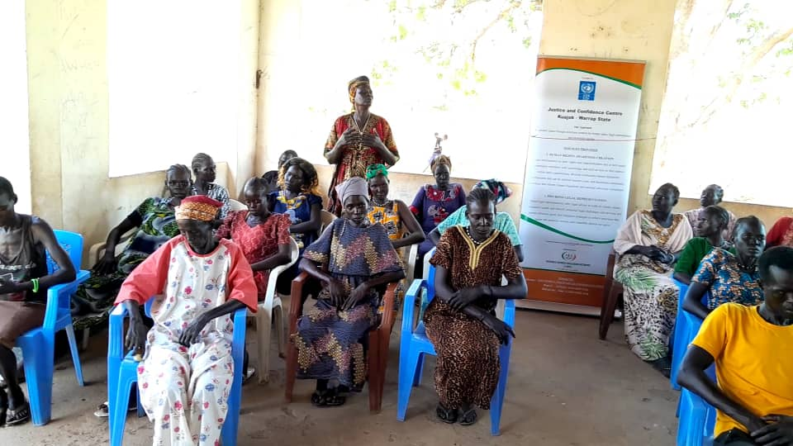

During the session, Vivian had this story to share
saying sometimes back, she witnessed a Nuer woman who was attacked, beaten by a certain wife of a general at the market. When the matter was said to be referred to the police, the general intervened and said that the case should be referred to his office for settlement. The woman insisted and she got arrested by the orders of General however, it didn’t end there, the victim was supported by the neighbors, and she went to the police station and had her case opened against the wife of general. In the process of arrest, the general insisted and forcefully resisted the arrest of his wife which resulted into a very big chaotic situation. On the resist of the arrest, the judge ordered for summon of the general and he was punished by the court for his behaviors. Viviana said, had it not been the chaos caused by the public, the victim would have not received the justice she deserved because I was a case against a General official. On attending our training on Access to Justice and Legal Proceedings, she said that she had found a rightful training which teaches her about her rights and what to do when her rights are violated/abused. She appreciated I-WIN for the training and wished for more of such trainings to be conducted.

Activity 6: Training of 30 members of Warrap High court (Judges, public prosecutors, court clerks, traditional court members) and members of the police force on victim redress mechanisms, and traditional chiefs including on courts, transitional justice and reparations.
On 18th July 2024, a training consisting of judges and prosecutors, chiefs and traditional court members, police as well as investigators was conducted at Atana Hotel-Kuajok. The training was facilitated by the UNMISS Human Rights Officer as an expert of law in the field of Human Rights and Transitional Justice. The training brought participants from different background with an aim of training them on Victim Redress Mechanism, transitional Justice, Human Rights and Access to Justice under JCC.
During the interactive sessions, a number of questions were asked by participants which were answered concurrently and these were.
- Sultan Akook Akook Mabuk on behalf of traditional Court members asked this question, “Since the JCC project is expected to run for six (6) months only, and given the fact that cases are slow before the High and county court, how will I-WIN ensure the continuance and completion of the cases within six months and even after the term of the project has ended”?
The answer to this question is that I-WIN’s contracted lawyer will ensure the completion of the cases entered under the JCC to the end even after the elapse of the term of the project. In other situations, every law firm has a public policy that allows the law firm to support the general public specifically the paupers who are unable to pay advocate fees for their cases to be followed up before the court. Through pro bono services, the I-WIN lawyer would still help the needy beneficiaries with an eye towards finishing all the cases received ion the name of I-WIN.
- Brig. General of South Sudan Prison Service Agoth Wol Agoth asked this question, “Mindful of the fact that the prison is full of the remands and inmates, in addition to the fact that few people are released from the prison and more remanded, how would I-WIN contribute to speedy trial and release of the remands especially women and young children”?
I-WIN did her best through access to a justice to advocate and promote speedy trial and proceedings to all persons remanded and those pending trials. It is worth noting that I-WIN lawyer has been visiting the Police and Prison detention facility to familiarize himself with the situation taking place in those detention facilities. It is at the same time of significant importance that all sectors related to Justice System should work cooperatively to raise questions to every UN agencies, CBOs and other government institutions to take the issues of lack of judges as a serious matter that needs urgency and quick response from the Judiciary of South Sudan because if we have many judges, the deadlock of cases can be reduced and acquittal of those arrested and tried for a very long time can be shorten. It is a collective responsibility of all Justice System to promote and work closely with Human Rights institutions to address the issue of long trial and free up space in the prison.
- John Akot Deng, a police investigator asked, “It is an established fact that the police especially the criminal department and investigation are facing an abuse of power from the government of the state who sometimes order for the arrest of the accused persons without a proper legal procedures which result into overstaying of such suspects in the Police Detention Facility, what will I-WIN contribute to making sure that such challenges are addressed”? hope some
As a matter of fact, the law says that no person shall be detained without due legal process, and therefore, when the government arrests anyone at their will and remands such people, it is the duty of police department to reject keeping of such detained individuals and advice the government to consult the Public Prosecution Attorney who is by law, the only authorized person to issue an arrest warrant. If the issue is reported to PPA, it will be handled as per the law, but not as per the interest of the government officials
- Asunta Adut Akeen on behalf of women leaders asked this question, “What will I-WIN offer the vulnerable elderly people and young children who sometimes become a victim of other offenses committed on them by criminal”?
I-WIN works closely through JCC with the variety of Justice System in Warrap state and therefore, it is within the interest of I-WIN to see justice being fulfilled and promoted. All the beneficiaries of JCC will have a lot of services such as legal representation, legal advice, and pro bono psychosocial support for the victim of rape and other crimes and referral to one stop center for further consultation
Activity 7: Monthly Legal awareness on GBV, property rights, legal rights, available services at the JCC and human rights Warrap outreach campaigns
I-WIN successfully conducted numbers of outreach sessions in all counties of Warrap state which explained the quantified number of people physically encountered. The topics discussed during the sessions were:-
- Human Rights as part of Rule of Law in South Sudan
- The legal procedures and proceedings before the Courts of law
- Right of the parents to discipline of the child and its limit
- Dinka Customary Law and the Modern Legal System and how they harmonize
- The lawful authority before whom the cases should be opened
All the above legal aspects were intensively considered, and different citations were brought to the light to capture a greater picture in the minds of the participants and the beneficiaries. On the right to chastisement, the facilitator brought up the two incidents where in Tonj, a young girls’ eyes were pierced by her father while in a belief to have been disciplining his daughter which in fact was beyond the right to chastisement. Other occasion was the case of a young girl whose feet were nailed by her mother to justify disciplining her.
During an outreach session in Tong South, Brig. General Agoth lamented that there is shortage of judges with only one Hight Court Judge, and this has created a delay in addressing providing and justice for minor cases. This has created too many pending cases that could take years to be heard resulting into accumulating hundreds of remands and convicts’ cases in the courts.

While in Tong East, Mrs Nyibol Agot, also cited that society has shaped women to think that reporting cases of Domestic Violence is uncalled for complain, most women term silence to being submissive to their husbands and therefore will rather choose silence in such violence rather than reporting. Women are only focused on keeping their marriage irrespective of the violence they are undergoing. She also thanked I-WIN team for extending this outreach session to Tong East, saying that they are always neglected when it comes to such helpful sessions yet their women desire to be strengthened through such helpful sessions, more efforts needed to enable grassroot women understand their rights.
In Gogrial Payam of Gogrial West County. The participants comprised of women leaders, Chiefs, youths and persons with disability. Besides this, in the attendance were traditional chief court members who were represented by Chief: Ajak Atur Ater. Speaking at the opening of the training, he applauded the efforts of I-WIN and UNDP for availing funding which allowed such activities to be carried out.
Mrs. Ajok Majok Kuel On her part of the remarks, she was glad and thankful to I-WIN for organizing such initiative which has informed them about the concept of Human Rights, women rights as enshrined in CEDAW Convention 1979, legal procedures, how and before which authority the case should be opened and Access to Justice for the victims of war, rape and other separate cases where the access to Justice was either denied by arbitrary detention or delayed legal proceedings.
The impact and feedback on the outreaches-
The positive impact of the training on the participants can be summarized into the following:
- The participants learned more about the human rights and respect of child right.
- They learned more on the rightful authorities before which the case can be opened
- The participants learned more on what constitutes the discipline of the child and which one is beyond it, and how to discipline the children without harming them.
- They asked for more and regular sessions to be conducted in other payams or bomas of Gogrial West County to disseminate the legal awareness to the larger audience and reach more people.
Activity 8: Biweekly meetings with survivors’ and victims of SGBV to provide counseling and other mental health and psychosocial support at the JCC center alongside information on where victims of SGBV can get Clinical Rape Management (CRM) services
Similarly to the legal advice services, I-WIN conducted bi-weekly sessions with the survivors and victims of SGBV to provide counseling and other mental health services to the victims. More emphasis was put on referral pathways and reporting in cases of SGBV. Contact details were also shared with the team in cases where SGBV is identified.
This is a critical and important session because it gives the survivors a higher physical functioning, lowers levels of depression, it strengthens self-esteem among the survivors and decreases level of exposure to future abuses given that survivors are empowered and act as agents of change advocates in their community.
During one of the sessions, Achuil, the payam women leader commented on how women are suffering in the villages in the hands of men who have become addicted to alcohol saying that most women are subjected to SGBV for example being forced to have sexual intercourse with a drunk husband either when sick or tired is a silent rape that most women don’t even report on yet they are psychological tortured in the event. She emphasized that women should speak and not sit on their pains.
The impact and feedback on the sessions: -
The positive impact of the training on the participants can be summarized into the following:
- Participants condoned the act of SGBV and took it upon themselves to act as messengers of peace in homes where GBV is seen as a normal practice.
- Psychosocial supports and counseling were given and the number of participants are seen to be increasing in every session, which means the previous participants are conveying positive messages about the session
- The participants have learned more about the human rights and respect of child right, the right to chastisement and its limitations.
- They learned more on the rightful authorities before which the cases either civil or criminal case can be opened.

Activity 9: Conduct Bi-weekly visitation to the police and prison and detention centers to identify.
Visitations to the police, prison and detention centers was one of the key elements to the project. I-WIN’s main objective of conducting the bi-weekly visits to Police Detention Facility and prisons where the detained accused persons were counseled, enlighten inmates on their Human Rights as well as legal procedures necessary to be followed either before Public Prosecution Attorney or before the Court of competent jurisdiction.
A general observation in all the detention centers was that;
Majority of the accused persons could not find a way to access justice through ligations. The offences committed and charges made on the accused persons require a re-examination and or re-investigation for a fair arraignment as a matter of rightful procedures required by the law in a fair trial.
Besides this, there is a greater need for a competent judge of High Court to try the cases because of lack of jurisdiction of the present judge of County Court to conduct a trial on cases under section 206, 305 and 247 of the Penal Code Act, 2008 respectively.
Figure the below Photo taken during a session with prisoners at Tonj South County Prison
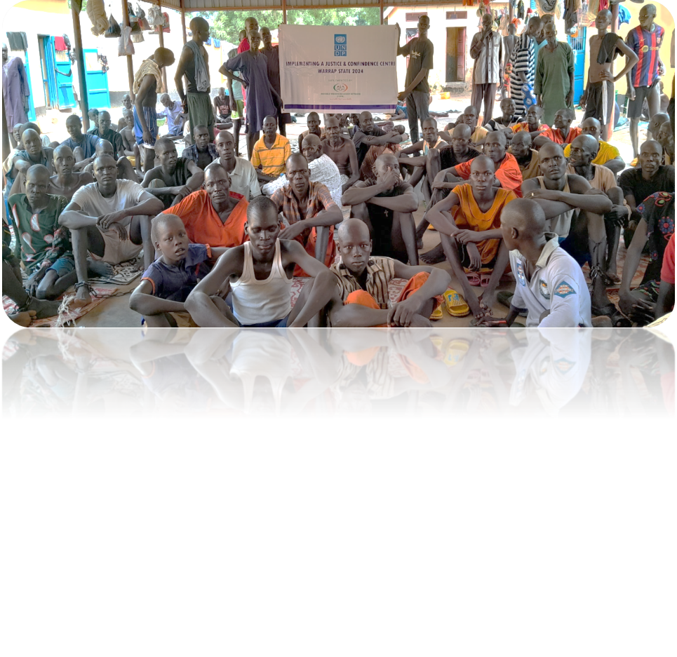
- Capacity of the prison (Over-population): a prison which is meant to contain a capacity of 150 members is overcrowded with over 300 prisoners
- Lack of bail on bailable offences: Cases of theft and intimidation are considered or categorized as misdemeanor cases on which the court could grant bails for the accused persons based on the subject-matter of the theft and or under strong bail in exceptional situation. Because there is no High Court judge there, those legal procedures can’t be granted to reduce the number of inmates, and therefore, the prison facility continues to suffer congestion.
- Absence of the complainants: In most of the cases brought against the accused person by the complainants, the complainants chose to abstain themselves in order to add into the suffering of the accused person. Even when the accused person is taken to the court of law, the judge would not proceed with the case in the absent of the complainant, forcing the court to adjourn the session for another time and date.
- Lack of High Court Judge on the Ground: In the presence, there is only one High Court Judge at the state headquarters who sees cases which are exclusively under the jurisdiction of the High Court, meanwhile in Tonj South County and other counties in Warrap State, there is a judge of County Court of Second Grade who is barred by the jurisdiction to entertain cases under section 206, 226, 247 and 305 Penal Code Act, 2008. Sadly, the majority of the remands and prisoners have been charged under these sections of law making their cases harder and exceptional to be heard because of exclusive jurisdiction. Because of this, the prison keeps loaded from one time to another without any remand or inmate released.
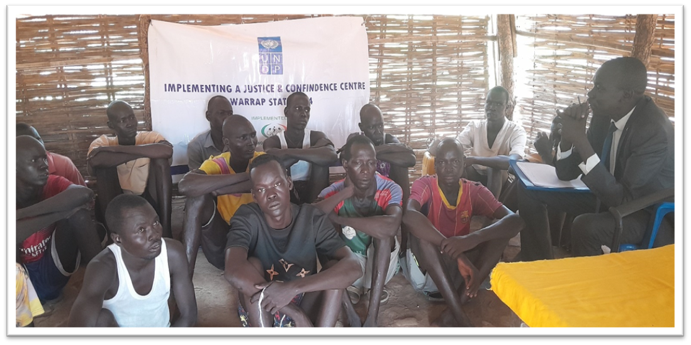 Recommendations:
As the situation unfolded on our eyes while at the prison, it is worth mentioning that the following among other things need to be considered to avail justice to the remanded prisoners:
- To find a way of availing justice, there is a need to formulate or establish a special court to adjudicate these hundreds of the accused remanded prisoners
- Transfer them to Kuajok Central Prison for their cases to be heard, but nevertheless, it would add up the overpopulated Kuajok Prison and cause a chaotic situation.
- The Kuajok High Court Judge to schedule days on his calendar to hear cases in Tonj South on weekly or monthly basis
- Kuajok High Court Judge together with State Legal Administration to make a joint statement and reports asking for the formation of special court in Tonj South County and any other measures necessary to remedy the situation that can be considered.
Activity 10: Three drama sessions with community members to raise awareness on GBV, property rights, legal rights, available services at the JCC
The drama sessions were conducted to summarize the key topics of awareness on human rights, legals procedures to be followed in cases where these rights are being violated. This is also aimed at creating a visual and memorable impact as an attempt to pass strong messages on Access to Justice through the Justice and Confidence Center.
These drama sessions were also important because it catered for all groups of people even PWD i.e, the deaf were able to follow the actions as they outspread and the blind listened directly to the message being acted.
Topics acted upon were legal advice in cases of rape especially to women and girls
Disadvantages of taking laws into individual hands, property rights, legal rights, available services at the JCC and human rights
Rights of a girl child to attend school and role of parents in child upbringing as an element to reducing criminal acts in the community.

Activity 11: Monthly radio talk shows with messages on availability of Legal aid services including legal representation, legal awareness and legal advice, and psychosocial support to vulnerable groups including women, girls, SGBV survivors, elderly and returnees in Warrap.
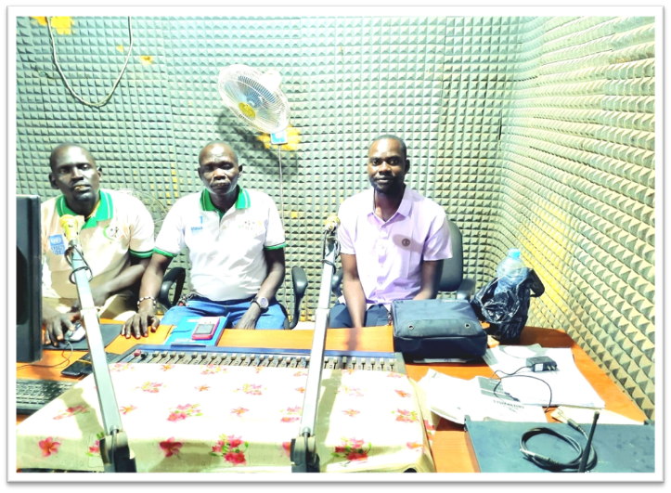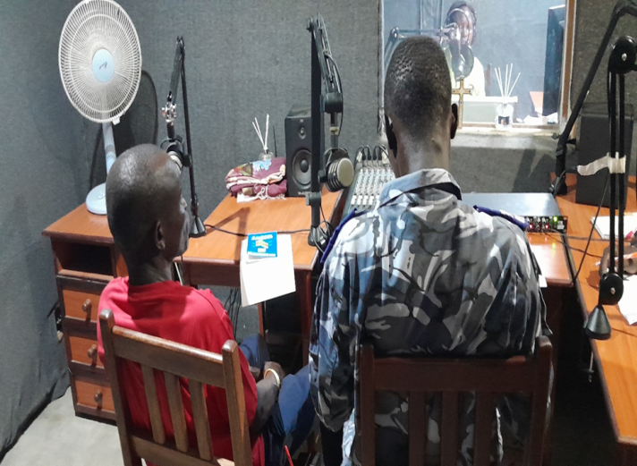
In order to advocate and promote Human Rights, Access to Justice and SGBV victim redress mechanism, and legal procedure and proceedings, introduction to JCC, right to appeal and its procedures, and the bailing process, it is cordially importance to approach the radio talk show where the bigger audience can be reached. I-WIN Monthly radio talk shows with messages on availability of Legal aid services including legal representation, legal awareness and legal advice, and psychosocial support is of significant important to the beneficiaries of Warrap State. It is through this talk show that many audience would access the availability of Legal Services mentioned above at the JCC which intends to promote legal awareness and human rights.
Talking points include:
- Introduction to JCC project
- Services offered at the JCC to the beneficiaries which included among other things, the following:
- Pro bono legal services, counselling and psychosocial support.
- The concept of Access to Justice and its benefits
- Legal representation and legal awareness and advice, free services at JCC
- The Concept of Human Rights as enshrined in the Transitional Constitution of South Sudan, 2011 as amended.
- Child Rights and access for such inalienable rights
- Harmful habits of forced and child marriage
- Legal procedures and proceedings

- Challenges (Please state key challenges for the reporting month and the mitigation measure applied or planned to handle the challenges)

 | Challenges of the month | Mitigation measures applied/proposed
 | Cultural and linguistic barriers | I-WIN employed staffs who are fluent in local languages and familiar with local customs
 | Gaining the trust and awareness among the community can be a challenge | I-WIN collaborated with local leaders, to gain their support and involvement.
 | Delayed approval of the Access to Justice Project from the Local Authorities (RRC and State Legal Administration) | The I-WIN access to Justice Officer having been a licensed lawyer, has taken some cases and provided pro bono legal services and awareness on how to follow up the legal procedure in the proceedings before the court. Some of the cases have been appealed while others are in the hearing stages currently.

- Cross-cutting Issues: Please describe briefly any cross-cutting consideration as may be applicable to the project including but not limited to Gender, Disability, Environment, Partnership etc. (1500 characters). Note: Please undertake brief analysis on the cross-cutting that are applicable to your location/project.

1. Gender Equality and Women's Empowerment:
The JCC promotes gender equality and addresses the specific legal needs and challenges faced by women. It provides equal access to justice, prioritize services for survivors of gender-based violence, and empower women to assert their rights and participate fully in the justice system.
Created awareness on the bill of rights, right to litigation, right to fair trial as well as women rights to own the properties and to participate on daily aspect of life.
2. Child Protection:
I-WIN has incorporated child-friendly practices and procedures within the JCC to ensure the protection and well-being of children accessing its services. This includes maintaining privacy, sensitivity, and specialized support for child victims, witnesses, or offenders involved in legal processes.
3. Accessibility and Inclusivity:
I-WIN Ensured that the JCC is physically accessible to people with disabilities, accommodating their specific needs. Implementing inclusive practices to make the center welcoming and sensitive to the needs of individuals from different ethnic, religious, linguistic, and cultural backgrounds.
4. Conflict Sensitivity:
This includes incorporating conflict sensitivity into the design and implementation of the JCC. Considering the local context, dynamics, and potential conflicts within the community to ensure that the center's activities do not unintentionally exacerbate tensions or contribute to further disputes.
5. Community Participation and Ownership:
We Foster community participation and ownership in the JCC project by involving local stakeholders, community leaders, civil society organizations, and grassroots groups in decision-making processes. This ensures that the center's services align with the community's needs, values, and priorities.
6. Ethical Standards and Professional Conduct:
I-WIN Upholds high ethical standards and professional conduct within the JCC. We Train and monitor staff to ensure they adhere to principles of integrity, impartiality, confidentiality, and respect for human rights throughout their interactions with service users.
7. Data Protection and Privacy:
Establishing robust data protection and privacy measures to safeguard the personal information and confidentiality of individuals accessing the JCC's services. Complying with relevant data protection laws and regulations, ensuring secure storage and appropriate use of sensitive information.
8. Monitoring, Evaluation, and Learning:
I-WIN Incorporates a robust monitoring and evaluation framework to assess the impact and effectiveness of the JCC's services. We regularly collect feedback from service users and stakeholders, identify areas for improvement, and adapt strategies accordingly.

- Media and publications

Did you collect any media and/or publications about the project this month?  (Media includes newspaper articles, radio advertisements and presentations, advertisements, brochures/pamphlets, promotional material, photos) |  | There are photos of the project done and published on our facebook and twitter page
Type of media  Facebook page in the names of Invisible Women Inclusion Network  Twitter page; @I-WINetwork | Key messages/description of photo  Some of messages in the photos were;  Radio talk show on Kuajok FM  A visit to Tong South prison  A meeting with SGBV groups in kuac North Payam of Gogrial West County of Warrap state  NB: More to all the activities conducted are captured promptly on the Facebook and twitter page | Online link or publication details  https://www.facebook.com/share/v/N8uDxHb8E4eCpR2h/?mibextid=qi2Omg
Banners and T-shirts | Implementing a justice and confidence center in Warrap State | Banners and T-shirt have been produced for purposes of visibilities.
Posters and Fliers | Access to justice for all | I-WIN has produced two posters fixed at its JCC location at the MoGCSW and the other at the junction for identification and awareness.
Legal Representation | Access to Justice and legal representation | Legal representation has been done on specific cases while major part was covered under legal advice on legal proceedings as detailed in the reports.

- Summary of total beneficiaries
Number of Beneficiaries / Participants per location
Major activities | State | County | Adult Male | Adult Female | Boys | Girls | Total
Conducted a launch and Project brief with stakeholders on Justice Confidence Centre in Warrap | Warrap | Kuajok | 35 | 15 |  |  | 50 pax
Establishment of a JCC center at a designated place for vulnerable groups including women, girls, SGBV survivors, elderly and returnees to seek legal advice, psychosocial support and counselling and referral services in Warrap. | Warrap | Kuajok | N/A | N/A | N/A | N/A | 2 pax
Probono legal aid services to 50 SGBV survivors’ elderly, women, and girls and other minority groups and ensure the cases are completed. | Warrap | Kuajok, Tong South, Tong North, Gogrial | 23 | 22 | 5 |  | 50 pax
Legal advice /counseling/ referral services at the JCC in Warrap | Warrap | Kuajok, Tong South, Tong North, Gogrial, Tong Eat | 164 | 152 | 0 | 0 | 316 Pax
Training of 50 SGBV survivors on victim redress mechanisms, including on courts, transitional justice and reparations | Warrap | Kuajok, Gogrial East | 30 | 20 | 0 | 0 | 50 PAX
Training of 30 members of Warrap High court (Judges, public prosecutors, court clerks, traditional court members) and members of the police force on victim redress mechanisms, and traditional chiefs including on courts, transitional justice and reparations | Warrap | Kuajok | 20 | 10 |  |  | 30 Pax
Monthly Legal awareness on GBV, property rights, legal rights, available services at the JCC and human rights Warrap outreach campaigns. | Warrap | Kuajok, Tong South, Tong North, Gogrial, Tong Eat | 68 | 90 | 10 | 22 | 190 pax
Conduct Bi-weekly visitation to the police and prison and detention centers to identify | Warrap | Kuajok, Tong South, Tong North, Gogrial, Tong Eat | 70 | 60 | 7 |  | 147 pax
Bi weekly meetings survivors’ and victims of SGBV to provide counseling and other mental health and psychosocial support at the JCC center alongside information on where victims of SGBV can get Clinical Rape Management (CRM) services | Warrap | Kuajok | 147 | 183 |  |  | 330 pax
Three drama sessions with community members to raise awareness on GBV, property rights, legal rights, available services at the JCC | Warrap | Kuajok  Gogrial | 15 | 30 |  |  | 45
Monthly radio talk shows with messages on availability of Legal aid services including legal representation, legal awareness and legal advice, and psychosocial support to vulnerable groups including women, girls, SGBV survivors, elderly and returnees in Warrap. | Warrap | Kuajok | Radio KPIs (can’t segregate the gender of the listeners | Radio KPIs (can’t segregate the gender of the listeners | Radio KPIs (can’t segregate the gender of the listeners | Radio KPIs (can’t segregate the gender of the listeners | Four radio talk shows conducted.
- 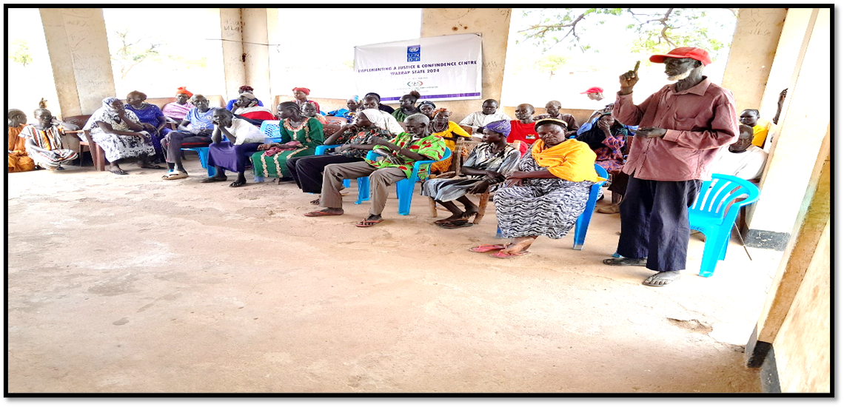Success/Impact Story (1500 characters): Note: in a few sentences, explain whether the project has had a positive human impact. It may include direct quotes where possible or link to strategic communication pieces.

One of the best successful stories ever told was narrated by Chief Amet Deng during the bi-weekly meeting whose photo is attached in activity four below. He said that a man fought with his wife at home and out of anger and depression, the man left his house from Awan and he was moving along the road going to an unknown place, and when he reached Wunkuel in Kuac Area, he accidently found another man who was being chased by his wife as they quarreled and fought. The man looked at the other man running, and his wife was after him with a lot of insults and cursing words.

Out of astonishment and disbelieve, the man settle down and he slept, and early in the morning, he went to the house of that man who was chased off by his wife to ask what the problem was, but as he reached to the house, he found the same man sleeping in his house after he returned last night, so, he asked about how did he returned last night after such terrible quarreling. The man replied that the house fight needs to be settle every now and then by peaceful means such as apology, mediation and reconciliation, not by abandoning your children and wife all together.
The man who had left his house blamed himself for doing so, and he told them his part of story, and promised them that he was returning to his house immediately and that he would never repeat the things he had done.
From this story, the participants learned that family problems are always there, in addition to these problems, family quarrels are also there in every family. In adds that the couples may not be the same in characters, but one has to be peaceful and reasonable if the other one is annoyed and angered, and by so doing, the households can live peacefully and raise their children while inculcating in them such good characters and attitude that they would richly benefit from in their parenthood times.
The other success stories heard in the session include the one narrated by Makuac Majok Kuel, the chief
of Man-deng area of Gogrial Town.
He appreciated the I-WIN for hiring a lawyer to provide pro bono legal services to the vulnerable
people of Warrap State who can’t afford the expensive legal services by themselves.
He added to the participants to take the message of the session seriously and apply it in their daily
life, but also to take this message to the people who were unable to attend the session because of
other activities that they have got engage in.
He called upon the people of Gogrial Town to embrace peace, promote and support the rule of law
by reporting the SGBV, rape cases to the police authorities so as the legal procedures are initiated
and the court to pass its verdict which in most cases settle the problems and allows the prevalence
of peace within the community.
2. Attached Next Month Workplan
Next Month Work-plan-July 202

- Any other issues as may be applicable. (Work limit: 500 characters)

- Pictorials Note: Include photos with captions. May consider to sending any high-quality photos of videos via email.

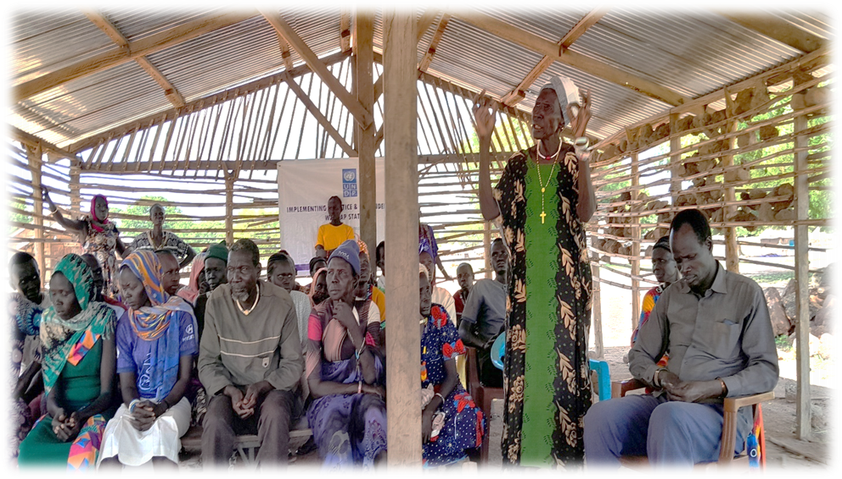

pictures of participants from Gogrial East county during monthly legal awareness
Picture showing Sultan Valentino Ayany signing for his attendance at the training that was organized by I-WIN in Tong North Payam.

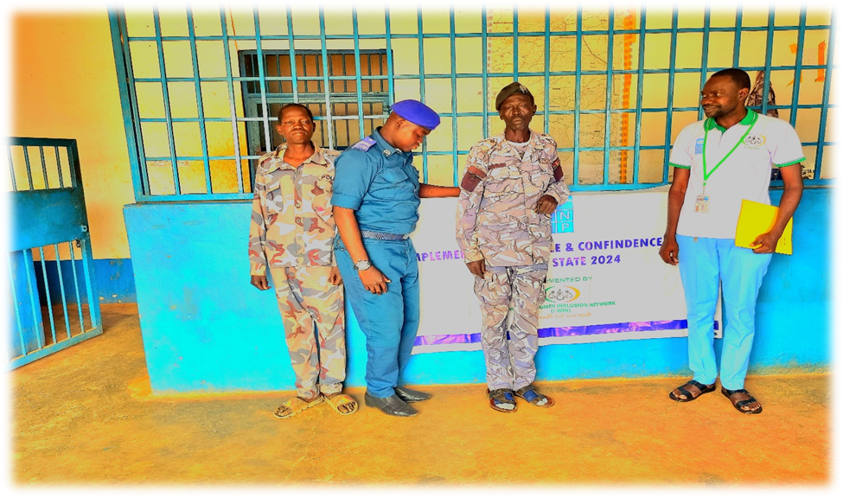
The photo for the biweekly visitation conducted on April 30th, 2024 at the police detention custody where many detained accused were offered legal advice, counseling and representation
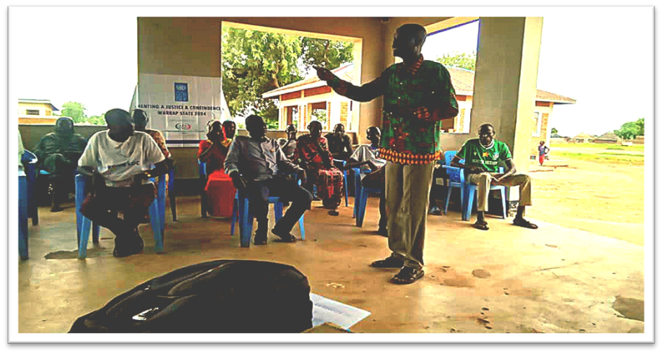Chief Ajiek Deng Agoth addressing the participants during the training of members of Warrap High court, court clerks and traditional court members on April 18th 2024.

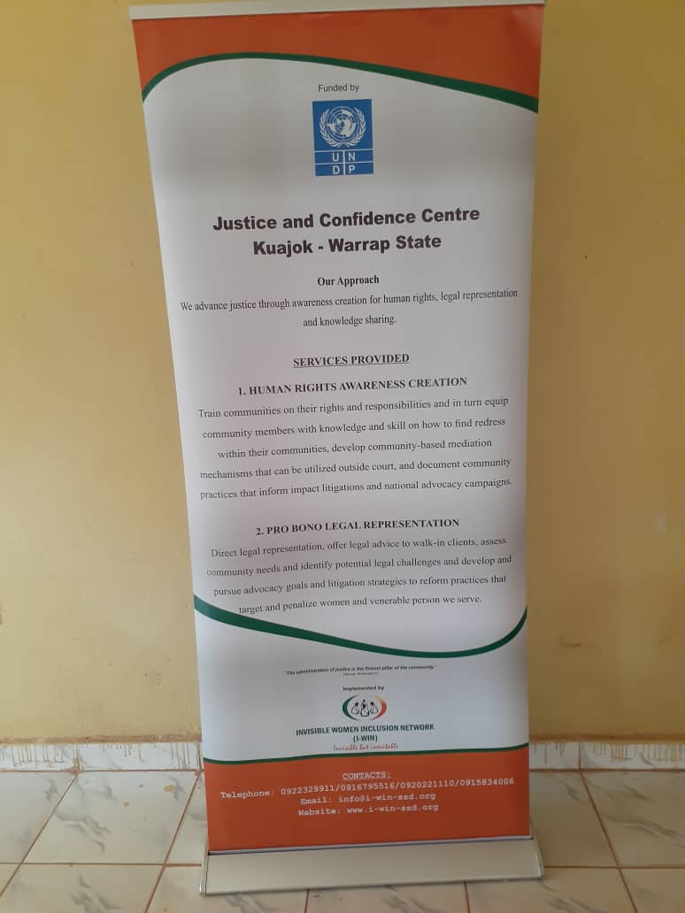The banner as part of the visibilities printed for the JCC project.
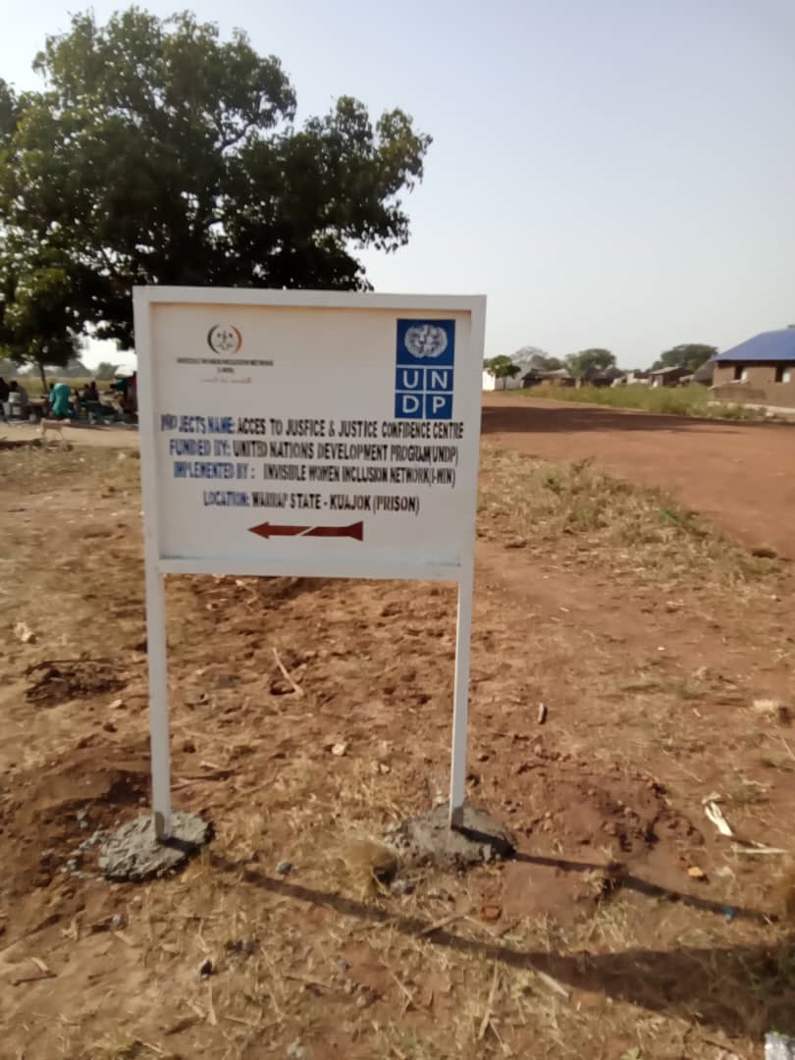

Being one of I-WIN's JCC sign post fixed adjacent to the road towards the prison JCC Center for directives to community members

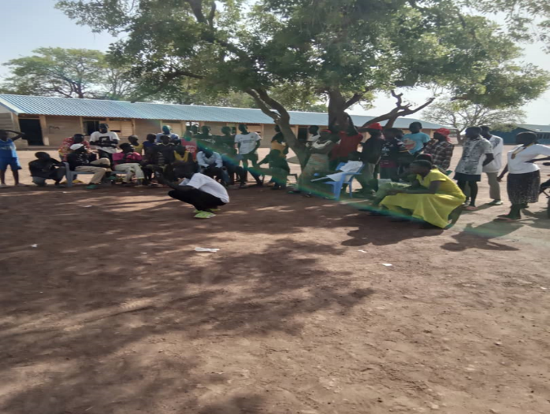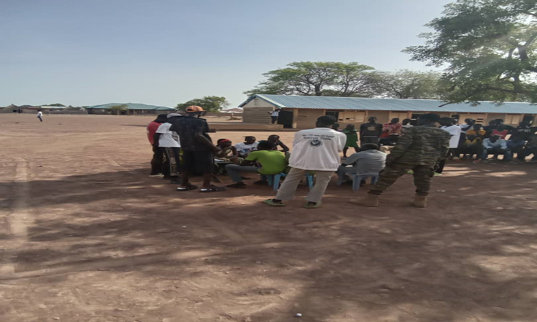

The drama sessions with community members to raise awareness on GBV, early and forceful child marriage, on 30th of May, 2024 at Mathiang Monyjoc Boma of Kuac North Payam
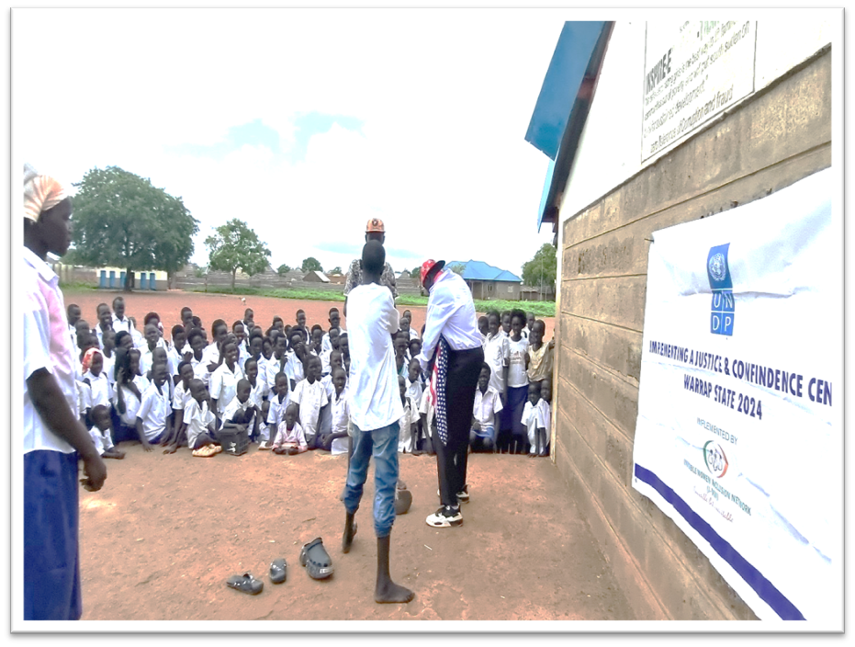
Photo showing drama session conducted on 23rd July, 2024 at Emmy Robbin primary School attended by the whole school which has had an impact on the pupils, teachers and the acting team on GBV, property rights, legal rights

________________________________The End _________________________________________

The summary of the progress to on Indicators is derived from the Performance Indicator Tracking Tool (PITT) attached to this template. Tracking for the indicators (through the PITT) is done monthly and consolidated quarterly.

