
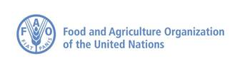

Tonj North County, Warrap State – I-WIN South Sudan Monthly Narrative Report September 2023

NAME OF “SERVICE PROVIDER | Invisible –Women Inclusion Network South Sudan  (I-WIN)
Letter of Agreement (LoA) No. | SS-033-2023
PROJECT TITLE | South Sudan Emergency Livelihoods Response Programme
PROJECT LOCATION (State - County level) | Tonj North County, Warrap State
PROJECT AMOUNT | 57, 372.00 USD
PROJECT DURATION | 6 months
REPORTING PERIOD | May – October 2023
DATE OF SUBMISSION | 31st October 2023
TYPE OF REPORT | Monthly Progress Report
TYPE OF REPORT | Quarterly Interim Report
TYPE OF REPORT | X Final Narrative and Financial Report
TYPE OF REPORT | Other (mention the type of report):
CONTACT PERSON | Manyiel Paul Adiar
EMAIL AND PHONE NUMBER | Aliaibob721@gmail.com Phone: 0926450045

The Service Provider has submitted the following required documentation, appendices along with the narrative report:
Information and documentation required | FORMAT | SUBMITTED
Mobilization/Sensitization certified meeting minutes and participants attendance lists with their contact details. | Soft copy (incl. in narrative report) | YES
Beneficiary registration electronic forms. Contact information of chief, boma/payam administrators and RRC/RRAs for each distribution centre | Electronic/web form | YES
Certification of receipt of goods form | Certified scanned colour copy | YES
Signed copy of waybills | Certified scanned colour copy | YES
Beneficiary distribution list | Certified scanned colour copy | YES
Gender safety audit | Certified scanned colour copy | NO
Distribution list | Certified scanned colour copy | YES
Summary distribution report of FAO for provided livelihood kits (must accompany all narrative reports) | Excel format and Web form | YES
Results description of rapid post-distribution monitoring (PDM) | incl. in narrative report | YES
Photographic evidence of distribution, trainings, demonstration plots and other field activities, indicating clearly the date, place, GPS coordinates. | Photos (jpeg), GPS coordinates, maps (soft copy). | YES
Monthly progress reports | Word Format | YES
Quarterly interim reports | Word Format | YES
Final financial report | Word Format | YES
Complete web reporting | Online | YES
Description of guidance to the beneficiaries on best use of agriculture and aquaculture inputs | incl. in narrative report | YES

Overall Background in the area where the Service Provider is Implementing the Project
The area continued to suffer from the chronic insecurities related to cattle raiding and communal fighting among the neighboring communities of Tonj North itself and parcel of Tonj East County. The insecurity trends are moderately subsiding with support from government and intervention from other organizations.
However, with a good well distribution of rainfall, the few crops are a bit doing well, only that the cultivation was not enough because of insecurity which force the host communities.
Currently, the community is now being alerted/informed and coached by I-WIN and FAO through intensive trainings on good agricultural practices and aquacultural practices, skill strengthening to local farmers. The farmers who have received crops and vegetables kits had planed and they have adapted the modern technic of farming as they are being trained and stationed at demonstration sites for show and later disembark to their original farms for actual farming and cultivation
The displaced community of Rualbet, Kirik, Marial-lou and Akop will be voluntarily returning to their originally homes following the government intervention to restore peace and stability in the county. The 65% of Tonj North population who predominantly depend on subsistence farming are estimated to be food in secure in the subsequently.
Overall Progress up to Date:
The safety audit for the selection of distribution points with the women, girls, men and boys to assess the possible risk factors regarding the protection of women and girls was conducted. The recommendations from the safety audit recommended that the secondary transportation of supplies should be provided to the distribution points. This is to reduce distances, and to eliminate the fear of looting and rape of the young women and girls.
Different community representative committees were formed to address issues affecting the targeted population, gender disparities, resolving issues related to the provision of the services in areas where community management committees are not in existence. These committees support in the identification of beneficiaries and registration and support during distribution of livelihood kits.
Initial meetings with community leaders, chiefs, local administrators and project management committees were always initiated at each Boma and payam. Representatives of community vulnerable groups (women, elders, widows, handicapped or chronically ill, IDP, refugee, youths at risk were also involved in the meetings
Overview of Progress Towards Expect Results
The below table clearly describes and defines the key deliverables, performance indicators and activities performed and successfully achieved as per outputs

List of the deliverables, key performance indicators as per LOA | Activities Performed | Previously achieved | Actual achieved (Progress Made) | Dates of the activities
Conduct Safety Audit, Formation and Training of AAP Committees | Conduct Safety Audit, Formation and Training of AAP Committees | 6 AAP committees were formed and trained in six payams | 6 AAP committees were formed and trained in six payams | 10/07/2023
Mobilization and sensitization of communities at county/payam level | Mobilization and sensitization of communities at county/payam level | Sensitization of communities was done in six payams prior to the project start. | Six sentization community meetings were done. | 03/07/2023
Beneficiaries identification and registration | Beneficiaries identification and registration | 3000 (1800 F, 1200 M) beneficiaries were registered and supported with livelihood kits. | 3000 (1800 F, 1200 M) beneficiaries were registered and supported with livelihood kits. | 03/07/2023
Collect Emergency Livelihoods Kits from FAO storage hub and transport to distribution areas | Collect Emergency Livelihoods Kits from FAO storage hub and transport to distribution areas | 3000 (1800 F, 1200 M) HHs received Emergency Livelihoods Kits collected from FAO storage. | 3000 (1800 F, 1200 M) HHs received Emergency Livelihoods Kits collected from FAO storage. | 18/07/2023
Formation and Strengthening of Farmer Groups 6 groups (Crop Production, Vegetable Production, Post-harvest Handling and Management) and fisheries groups. | Trainings on good agricultural and aquaculture practices, including precision and timing of field operations e.g planting, weeding, and harvesting, Provision of Basic Training and Activities on Good Agriculture and Aquaculture Practices , | 200 (120 F, 80 M) beneficiaries farmers and fisheries were trained on good agricultural and aquacuture practices in Tonj North County | 200 (120 F, 80 M) beneficiaries farmers and fisheries were trained on good agricultural and aquacuture practices in Tonj North County | 23/08/2023  18/09/2023  11/10/2023
Establishment of six Crops and Vegetables Production demonstration Plots | Construction and establishment of (6) demonstration plots in the six identified Bomas/Payam | 6 demon plots are established in six bomas of the six payams slected were 180 beneficiares were trained and benefitted. | 180 beneficiaries trained in six demo plots. Out of these 120 are women and 60 are men respectively. | 19/07/2023

Please summarize the following (maximum half page):
Description of activities achieved:
Initially, the beneficiaries’ farmers were identified among community members and targeted for training on good agricultural practices and aquacultural practices. The topics covered were; including precision and timing of field operations e.g., planting, weeding, and harvesting

The extent to which outputs are being achieved – Overall project implementation progress
The training participants were put into groups to discuss their ideas and thoughts over the sessions covered, they therefore present their findings and inter-changed skills and knowledge on well yielded crops and crops which did not grow well due to late seasons pests present.
Key programmatic achievements (of major activities of each output)

The five percent (5%)of identified beneficiaries willing to act as extension workers, were included as active participants in the demonstration plots and share knowledge with their community. Each demonstration plot’s membership was comprised of 30 people and COVID-19 preventive measures were all adhered to throughout the sessions to mitigate the risks of COVID-19 transmission. Membership selection was based on meeting a basic set of criteria agreed upon with community leaders and according to the LOA.
The likelihood that the outcome will be achieved

The six demonstration plots were erected/established in the six identified payams in such a way that both community leaders and beneficiaries agreed on the point of the site according to the criteria and guidelines therefore stipulated. All the demonstration farms were established by selected groups of interested farmers all are located in public places and well frequented locations are somehow act like as showcase areas.
These plots are fenced and have gates in order to protect it from animals, and these were done by demonstration farm members at their own cost, however little cost was incurred by I-WIN to motivate them. The demonstration sites/plots are currently being managed and established using the training module provided by FAOMost of the trainings conducted were;
- Formation and Training of AAP Committees
- Training in crop/vegetable production
- Training in establishing sunken bed
- Training in row planting & number of seedling
- Training in preparing nursery and nursing techniques
- Training in water conservation techniques (i.e. mulching)
- Training in pest and disease control
- Training in harvesting techniques
- Training in sundry preservation techniques
- Training in vegetable preparation and utilization through fields of fishing
- Training in net making
- Training in fish preservation techniques (i.e. sundry, smoking and dry salting)
- Key management and financial issues

The demonstration plots management was organized in such a way that the community themselves select 30 members among beneficiaries of crops and vegetables to manage and work on the demo plots within the agreed time not more than the project life span. The beneficiaries’ composition is composed of 20 women and 10 men beneficiaries making of a total of 30 members. In this group, they had to appoint some people to lead their groups, they appoint chairpersons or team leaders, secretaries and finance personnels (leadership) to deal with the affairs of work related issues. Initially, the community is supposed to be working voluntarily but because of the scarce materials for construction of the demo plots, the organization has to incur a little cost not more than incentive of 3000 SSP weekly or after the entire work in the demo plots.
Required follow-up actions

In all the demo plots constructed in each Boma/Payam need to be supervised and monitored closely by:
An extension worker periodically visit, this is to ensure smooth running of the activities inside the demo plots before the farmers embark to their original farms.
- Demo team leader to follow up on daily attendance and reporting time for work completion
- Demo plot workers/members themselves to account on any un accomplished activity inside the demo plot.
- Guard nominated by the demo plots members, preferably someone who is closed to the site to protect planted crops and vegetables.

Any changes to project design:
Yes, there were some slide changes in the project design, what happens is that Alabek and Kirik payam IDPs were supported in Warrap town instead of their original payam centers, this was because of insecurity which happens immediately after selection and registrations, therefore they community leadership decided to have their distribution done in Warrap town where they have settled temporarily. They are currently settled with the host community of Awul payam.

As a result, the demo plot for Adinydou Boma, Alabek payam is erected/constructed in Warrap town near Tonj North Agriculture office in Awul Payam. Their trainings took place here following the agreement made the project management committees comprised of community elders, chiefs and administrators including RRC supervisors.

KEY ACHIEVEMENTS & STREGNTHS:

OUTPUT 1: FOOD PRODUCTION CAPACITY OF FOOD-INSECURE/VULNERABLE HOUSEHOLDS IS ENHANCED
Indicators | Targets | Achievements/Strengths
Number of households receiving crop kits through direct distribution (disaggregated by gender, age, type (IDPs, refugees, returnees, host) | 2800 HHs | List of Biometric Registrations,  Web Reporting system completed using the provided link
Number of households supported with vegetable kits through direct distribution (disaggregated by gender, age, type (IDPs, refugees, returnees, host) | 1960 HHs | List of Biometric Registrations,  Web reporting system completed using the provided link
Number of households supported with fishing kits through direct distribution (disaggregated by gender, age, type (IDPs, refugees, returnees, host) | 1680 HHs | List of Biometric Registrations,  Web reporting system completed using the provided link
Quantity of assorted crop seeds distributed – 100% of target | 39 MT | Summary Distribution Report (BDLs) provided,  Web reporting system completed using the provided link
Quantity of assorted vegetable seeds distributed – 100% of target | .19 MT | Summary Distribution Reports (BDLs),  Web reporting using the provided link
Quantity of assorted fishing gear distributed – 100 % of target | 1680 kits | Summary Distribution Report, Web reporting using the provided link
Quantity of assorted tools distributed – 100% of target | 3000 pieces | Summary Distribution Report, Web reporting using the provided link
Post-distribution monitoring conducted and report submitted to FAO | 1 | PDM data submitted to FAO server  PDM Report

OUTPUT 2: Skills and knowledge of households and farmers’ groups in agricultural production and aquaculture strengthened
Indicators | Targets | Achievements/strengths
Number of demonstration plots established at payam level by type  Crop production, vegetable production or crop and vegetable production | 6 Demo plots (1 per payam) | Group members list.  Table with all demo plots established (disaggregation by payam, boma, group, crop, etc)  GPS Coordinates  Photos
Number of farmer groups established by type:  Crop producer, Vegetable producer, and Fish producer. | 18 (6 crop, 6 veg, 6 fish) | Group Membership List  Table with all the established farmer groups (disaggregation by payam, boma, group, activity, gender, age, etc)  Biometric beneficiary registration
Number of Feddans cultivated (crop and vegetable production) | 1 Ha per demo | IP Narrative Reports  GPS measurement of area  Table with area cultivated by crop, group, boma, etc
Number of households and farmers receiving training on crop production (i.e. GAP, IPPM, post-harvest preservation methods/techniques) | 120 (72F, 48M) | Web reporting using the provided link  Training Report  Attendance Sheet  Photos  Biometric beneficiary registration
Number of households and farmers receiving training on vegetable production (i.e. preparation, utilization, post-harvest handling) – desegregated by age, gender, HH type | 120 (72F, 48M) | Web reporting using the provided link  Training Report  Attendance Sheet  Photos  Biometric beneficiary registration
Number of households and fisher folk receiving training on fish production (i.e. Fishing, net making, fish preservation techniques - sundry, smoking and dry salting) – desegregated by age, gender, HH type | 150 (87F, 63M) | Web reporting using the provided link  Training Report  Attendance Sheet  Photos  Biometric beneficiary registration

Beneficiary Training Plan for Main Season (Vegetables and Crops farmers including fisheries groups):

County | Payam | Boma | # Farmer Groups (Crop) | # Farmer Group (Crop)  members | # Farmer Groups (Veg) | # Farmer Groups (Veg)  members | # Fishery Groups | # Fishery Groups  members
Tonj North | Akop | Acholok | 1 | 15 | 1 | 15 | 1 | 25
Tonj North | Alabek | Adinydou | 1 | 15 | 1 | 15 | 1 | 25
Tonj North | Aliek | Patei | 1 | 15 | 1 | 15 | 1 | 25
Tonj North | Kirik | Achiir | 1 | 15 | 1 | 15 | 1 | 25
Tonj North | Rual-bet | Achol | 1 | 15 | 1 | 15 | 1 | 25
Tonj North | Marial-lou | Puolbar | 1 | 15 | 1 | 15 | 1 | 25
Total |  |  | 6 | 120 | 6 | 120 | 6 | 150

Demonstration Plots Construction Table
County | Payam | Boma | Location | Demo Plot Type | # Demo Plots | # Demo Groups | # Demo Group Members
Tonj North | Akop | Athieng-puol | Athieng-puol | Vegetables Group | 1 | 1 | 30
Tonj North | Alabek | Adiny-dou | Ayak-akat | Group | 1 | 1 | 30
Tonj North | Aliek | Patei | Adhor | Group | 1 | 1 | 30
Tonj North | Kirik | Achiir | Yel-kiel | Group | 1 | 1 | 30
Tonj North | Rual-bet | Kuany-nyal | Kuanyal | Group | 1 | 1 | 30
Totals |  |  |  |  | 5 |  | 150

BENEFICIARIES:

The project is designed to response to emergency food security populations in Tonj North County, Warrap state, initially the project on the six Payams which include Kirik, Akop, Marial-lou, Rualbet, Aliek and Alabek respectively. The total beneficiaries supported within this reporting period is 3000 HHs in 6 Payams as mentioned above in their respective geographical coverage. See the beneficiaries’ breakdown as tabulated below per HHs in each category.
 | Households Reached
CATEGORY | Female-headed | Male-headed | Female Child-headed | Male Child-headed | Total
Refugees | 187 | 124 | 91 | 63 | 465
Returnees | 223 | 188 | 101 | 83 | 595
Internally displaced people | 258 | 178 | 140 | 54 | 630
Host communities | 435 | 355 | 105 | 95 | 990
Other affected people | 163 | 73 | 32 | 52 | 320
TOTAL | 1266 | 918 | 469 | 347 | 3000
People with disabilities (PWD) out of the total
 | 34 | 19 | 11 | 9 | 73

CROSS CUTTING ISSUES
People Indirectly Targeted by the Project
GUIDANCE (delete when completed): Please quantify and briefly describe the people who will benefit indirectly from project activities, for example from awareness/information campaigns, expansion of service delivery capacity, etc. If the project has multiple sectors, differentiate between people indirectly targeted in each sector.
During the project start up workshop conducted at County Headquarters attended by Payams administrators from different payams including other government officials from different Departments, the information dissemination was done intensively by community stakeholders to the entire public. In as estimate 59% was reached with the information through community meetings, no massive were conducted. 67% benefitted indirectly from the project support. For instance, as the beneficiaries’ category indicated, a good number of people with disabilities were reached and directly in the implementation of the project. This account 39% in the total coverage
Accountability to Affected People (AAP):
GUIDANCE (delete when completed): Please describe how crisis-affected people (including vulnerable and marginalized groups) were involved in the design, implementation and monitoring of the project. Please highlight the modality used to involve all groups in all project phases and how feedback might have led to the agencies adapting the project design as required.
The Tonj North I-WIN team did communication and mobilization with the community leaders of Tonj North County, Warrap State. This official communication involves coordination and mobilization for the meeting dates and venues including the targeted populations in each payam.

In this way, the team conducted safety audit meetings with leaders before the selection of distribution points; the meeting includes women and girls, men and boys to assess the possible risk factors regarding the protection of women and girls during registration and distribution. The safety audit was guided by the Gender Assessment Safety Audit Tool provided in the LOA.

The recommendations from the safety audit was used as a mean to determine the selection of the distribution points. In the safety audit results, some of the information captured were on distances and routs to the distribution points, and the right time of the day for carrying out distribution. All these were put into consideration and the exercise of registration and distribution were successfully done without deviations.

AAP Feedback and Complaint Mechanisms:
GUIDANCE (delete when completed): Please describe the feedback or complaint mechanism implemented and accessible to targeted groups during the project implementation period, including aspects of confidentiality, accessibility and follow-up.

After having met with the local authorities and chief, the I-WIN Team form some community representative committees per each payam to address issues affecting the targeted population, gender disparities, resolving issues related to the provision of the services.

However, in areas where community management committees are in existence and established by other NGOs, the I-WIN liaises with these committees, for example in Aliek were World Vision established fishing group committee. This committee was validated and continue to be named fishermen group.

The function of this committee was to support beneficiary identification and registration and support during distribution of livelihood kits and fishing kits respectively. These committees were directly trained in six payams by I-WIN South Sudan.

The methodology of assessing and addressing this was made closely in line with FAOs guidelines on Accountability to Affected Populations which was filled during the distribution and certified. Therefore, a clear complaint mechanism and feed back to communities’ scheme was established with support from Payam administrators and the I-WIN provide details of the meetings such as meeting minutes and participants’ attendance lists with their contact details if any as carried out with the stakeholders.
Prevention of Sexual Exploitation and Abuse (PSEA):
GUIDANCE (delete when completed) please describe the mechanism used to record and handle Sexual Exploitation and Abuse (SEA)-related complaints, including aspects of confidentiality, accessibility and follow-up?
During the entire project implementation, there were no records of sexual exploitation and sexual abuse related (SEA) However, there was a report of some women and children abducted in Kirik payam, at the cattle camp near Achiir Boma by the cattle raiders from Awul Payam. The incidence was peacefully managed by the county commissioner and the community police leaders and finally return them back to Kirik Payam safely, no sexual abuse or exploitation reported, (Source: The County Director for Gender and social welfare, Tonj North County)
People with Disabilities (PWD):
GUIDANCE (delete when completed) please describe how the project met the essential needs and ensured PwD accessibility and inclusion. Further, explain how the project addressed the specific risks and promotes protection and safety for PwD, in particular women and girls with disabilities?
Throughout the project implementation, the project team has been very conscious in considering the special attention to the people with disabilities (PwDs) in such a way that blind ones and the crippled ones who hardly unable to walk by themselves were put first to be registered and served fist during distribution. They are being given special care in order to promote the goal of inclusivity and invisibility.
Households which are led by the disable heads were throughout given a special attention where they should not queue up in the lines waiting for service.
Protection:
GUIDANCE (delete when completed): please explain how protection of all affected persons and at-risk was mainstreamed in the project implementation and highlight all integrated protection outcomes obtained under this project?

During the project implementation, the aspect of protection concerns was included in the project activities right from beneficiaries’ identification and selection were the poor, disabled persons, IDPs and pregnant mothers considered first and supported and directed by the project management committees to directions followed during the phases of services delivery right from registration and distribution. The project team also has a goal model of selecting them and putting them into groups to have their voices heard in the discussions and decisions-making. Entirely, this project has supported 39% of the total population of the six targeted payams in Tonj North County.

PROBLEMS ENCOUNTERED AND ACTIONS TAKEN
Comment on problems encountered during implementation (i.e. non-execution, delays or implementation of unforeseen activities) and actions taken to resolve them.
Problem and/or Challenge encountered | Action taken | Lessons Learned | Recommendations
Mobilization and sensitization of communities at county/payam level was difficult (no Network coverage) | Communication was done through letter writing to local leaders to pass information | Communication should not be channeled to telephones and emails | Use handwritten letters were there is no network  Person to person Communication.
Poor road connections during beneficiaries identification/registration. | Use of hired bikes which are too costly instead of public transport | Organization should either buy one bike for inter-field activities or allocate more budget for transport
Collect Emergency Livelihoods Kits from FAO storage hub and transport to distribution areas
Distribution of inputs
Trainings on good agricultural and aquaculture practices
Technical trainings
Rapid Post-distribution Monitoring (PDM)

FOLLOW-UP ACTIONS AND REMAINING ACTIVITIES
Summarize (bullet points) follow-up actions to be looked at by FAO and remaining activities under this project.

PHOTOGRAPHIC EVIDENCE OF ACTIVITIES
For each major activities undertaken, please include the photographic evidence. Indicate date, place, GPS coordinate. Attach photographs in the JPEG format or share via WeTransfer (https://wetransfer.com/) or Dropbox (https://www.dropbox.com/?landing=dbv2)

SUCCESS STORIES
In no more than 1,000 words, please share two success stories (one with the midterm report and one with the final) that focus on first-person narratives and illustrate the benefits of the intervention and the challenges overcome. The content needs to include direct quotes and be accompanied by pictures of the beneficiaries in question.
First Success Story:
The success story for one of the Fishermen in Patei Boma, Aliek Payam of Tonj North County, Warrap State was captured during the project’s Mid-term Reporting period.
An interview with the fishing net-maker Mr. Santino Makau Madut, the interview was hosted by an extension worker for fisheries Mr. Mareng Akol Mareng at Patei Boma, Aliek Payam
The story goes:
Santino Makau Madut is one of the fishermen from Patei Boma, Aliek payam. He is one of the best net maker among all the fishermen in Aliek Payam. He had good skills in net-making. He started practicing swimming exercise and fishing at the age of 12 years before he got married. After
Soon after having had this skill of being a good fisherman and well experienced swimmer, he acquired more wealth with some little support from his parents and had a chance to get married. His fishing skills started advancing in 2007. He continues to use to fish in the streams of Nyin-kot, Nyin-weth and Rak-chok of Aliek river connected to Mashara-achol (Akop River)
Currently, Mr. Santino had a family of seven members and lived in Patei Boma. His living conditions continue to benefit from fishing services. He is usually hired by some fishermen who doesnot know how to make nets to make nets for them and get little motivation in form of some fishes, money, some sorghum, chicken or even a goat.
During the heavy rainy seasons where the rivers overflow, the fishing become difficult and therefore, fishing boats are necessary. In this case, he requested I-WIN South Sudan to provide them with fishing boats during this season. This boat will be collectively used by the group of fishermen headed by Mr. Gong Majok Chol, deputized by Mr. Majok Madut Anei. This group usually live nearby river throughout season and therefore net some little support for buying mosquito-net because of prevalence of malaria transmission.
The nearby markets for selling fishes are Aliek, Makuac-rual and Achier-cok and their prices are cheaper since they are very close to the river side where the supply is bulk. In this case, they also ask for a transport to easily transport their supplies to Warrap and Wau market which are expensive and they fresh fishes may reach before they are rotten. This was best supported by the other organization which has just left the area (not sure of the name)
Since he was among the fishing kits beneficiaries’ distribution, he furthermore, thanks and appreciates the little support he got from the I-WIN South Sudan in collaboration with the FAO South Sudan and State Ministry of Agriculture & Forestry, Warrap State.
The second Success Story:
Content guidance:
Introduction and Beneficiary background
The second success story was taken at Adiny-dow Boma Demonstration farm in Alabek Payam, Tonj North County, Warrap state. The eneficiary,s name is Ms: Angau Ariik Akoon She is one of the vegetables beneficiaries who directly benefitted from I-WIN seed distribution in July-August distributions in Alabek Payam, In an interview with FSL officer Mr. Manyiel Paul, she did mentioned that she has received different kind of seeds which include, sorghum in variety (Gedem-amam), maize, beans, hoe (moloda), and different types of vegetable seeds. In her response she has disclosed that she tested all seeds in her farm and they all do well except sorghum which truly germinated and it was affected by the field pests and diseases. She has now been nominated by the community chiefs to participate in the demonstration plots farm where she has also been appointed as deputy chaired person at the demo plot site.
In another note, she erected a small kitchen garden at her house and stationed her children to monitor it as she is currently busy at the site with farm activities. From her kitchen garden, she is currently getting her small income from, the sale of vegetables she produced. This is supporting her in paying school fees and family meals including treatment costs,

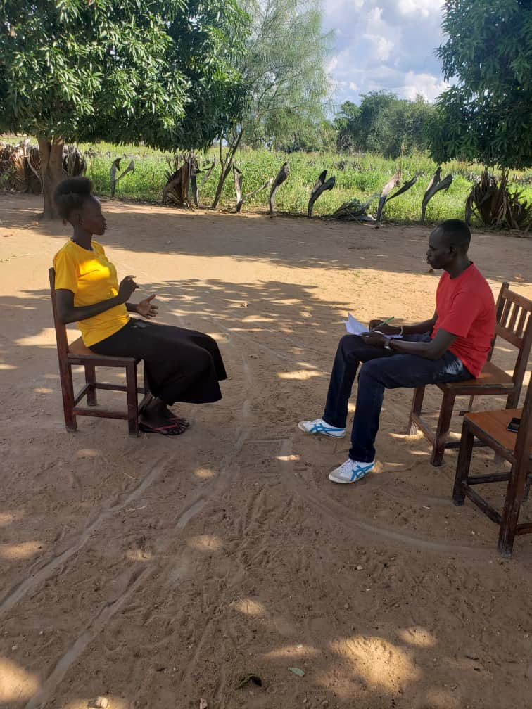
Being a photo of farmer beneficiary Mrs Angau Ariik Akoon interviewed by I-WIN's staff

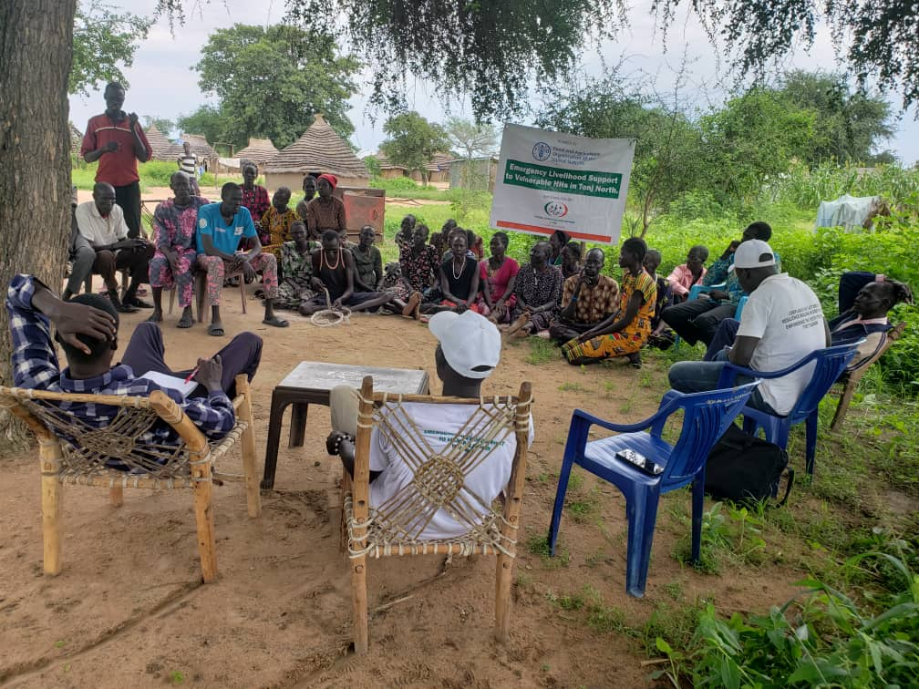
Figure 1 Beneficiaries in Aliek payam being trained on crop and vegetable production

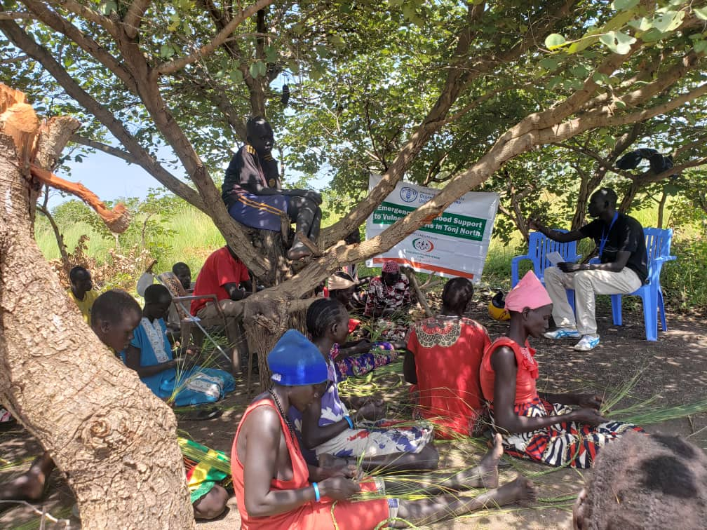
Figure 2Being a training on vegetable production and fishery in Kuanyal Boma of Rual-bet payam

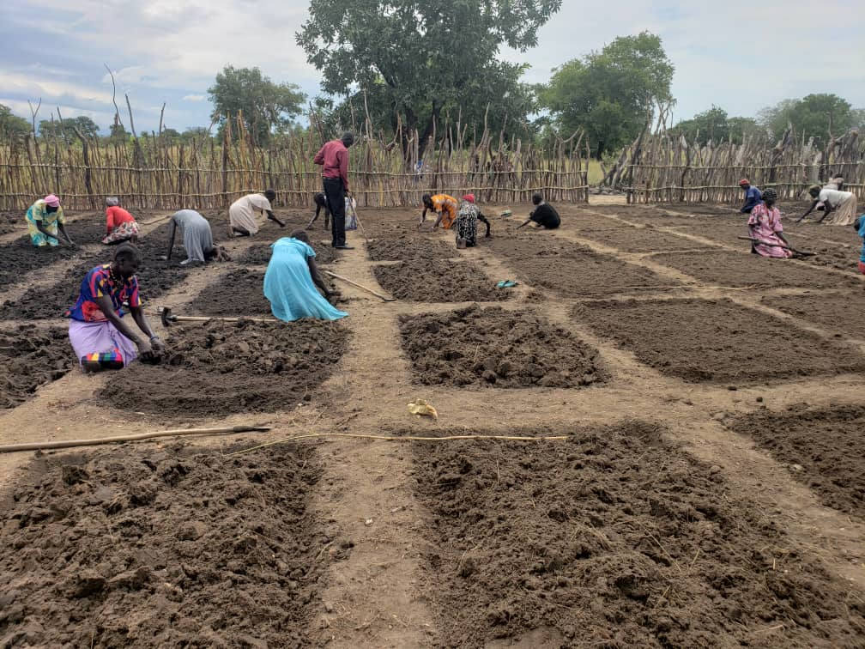
Figure 3 Beneficiaries of Achiir participating in preparation of demo-plots for seeds plantation

